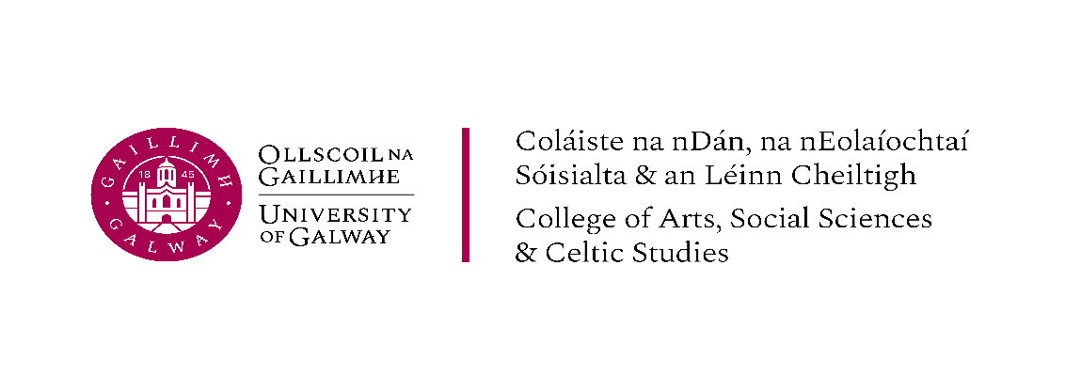
Visiting Fellowship Scheme – Seed Funding for Research Collaboration
- Overview
The College of Arts, Social Sciences & Celtic Studies (CASSCS) at the University of Galway invites applications for its Visiting Fellowship Scheme, supported through the College’s Funding the Future programme.
This scheme is intended as seed funding to support short research visits that foster new or developing collaborations between researchers at the University of Galway and colleagues internationally, while also encouraging engagement with the rich archival and library collections of the James Hardiman Library
Galway, on Ireland’s Atlantic coast, is a vibrant cultural and intellectual hub, celebrated for its creativity, festivals, and global outlook. At the heart of the city, University of Galway offers a dynamic environment where scholars collaborate on questions of global significance.
The CASSCS fosters interdisciplinary research through its Signature Research Areas, exploring cultural, social, and societal challenges (see Fig. 1). Visiting Fellows join a welcoming and inclusive academic community, engaging in innovative research, intellectual exchange, and meaningful collaborations with communities, policymakers, and cultural institutions. Galway’s distinctive setting offers both inspiration and connection, making it an ideal place to advance your research.
Visiting Fellows will have the opportunity to engage with the College’s vibrant research community, contribute to seminars and discussions, and explore opportunities for future collaborative research. Fellows are particularly encouraged to connect with the College’s Signature Research Areas, which represent established clusters of interdisciplinary collaboration. These areas reflect the College’s commitment to “connective expertise” — distinctive research strengths that generate collaborations across disciplines and with partners beyond academia.

Fig. 1
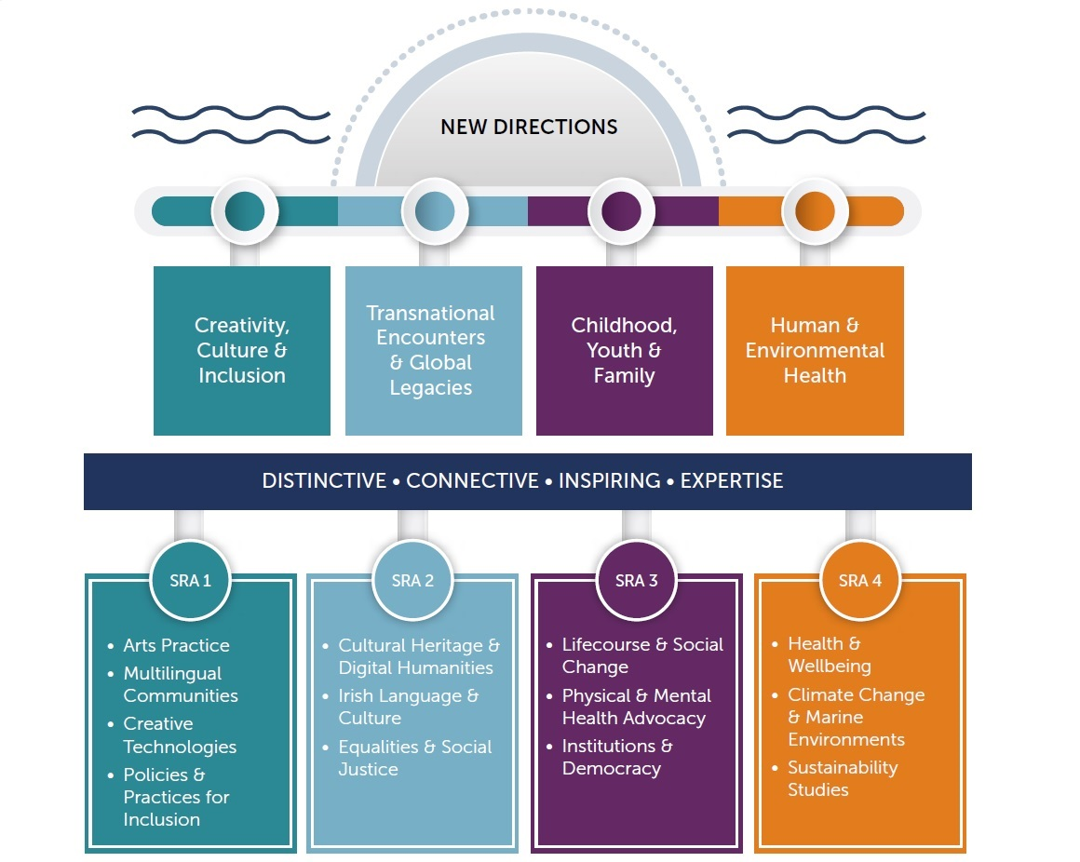

Fellowships support short research visits between May and September and provide reimbursement of travel and accommodation costs up to €2,500.
During their visit, fellows will be invited to:
- Contribute to the College’s research environment through a seminar or informal research exchange.
- Meet with colleagues to explore shared interests and future collaboration opportunities.
- Engage, where possible, with students and early-career researchers.
- Draw on the library and archival collections to support their research interests (where relevant).
Applicants must identify an academic member of staff as their sponsor within the CASSCS who will facilitate the visit and support engagement with the research community. A full list of our academics is available in the University’s Current Research Information System (CRIS).
Applications should include a short proposal outlining the purpose of the visit, proposed activities, and potential for future collaboration.

2. Eligibility
All applicants must hold a PhD or have a substantial profile in practice or performance. EU and non-EU citizens are eligible to apply. Awards are subject to the successful meeting of visa and any other requirements which are the sole responsibility of the applicant to organise in advance of their visiting fellowship.

3. Assessment Criteria
Applications will be assessed based on the following:
- Alignment with Signature Research Areas
- Quality and feasibility of the proposed visit
- Strength of proposed collaboration
- Contribution to the College’s research environment

4. Award Terms & Conditions
- Fellowships must be taken up during the period May – September 2026.
- The Fellowship term is to a maximum of one month. There is no stated minimum.
- The amount of the award will vary according to the length of proposed stay and the available overall budget, typically in the range €500–€1500 and occasionally up to a maximum of €2500 (to cover reasonable travel and living expenses only, which will be paid after the Fellow’s stay by the reimbursement of expenses with receipts). These awards are a contribution towards the Fellows expenses for the duration of their stay.
- During the research period, fellows are expected to have a significant presence in the relevant School to which they are affiliated.
- Fellows will be asked to deliver one seminar and to be available to meet with students at undergraduate and/or postgraduate level.
- On completion of their Fellowship, Fellows will be required to provide a one-page summary of their research visit.
- Fellows are asked to credit ‘the College of Arts, Social Sciences & Celtic Studies at the University of Galway’ in any publication or other outcome pursuant to the award.

5. Application Form Template
See Appendix 1 for Template Application Form.
Appendix 1 – Application Form
College of Arts, Social Sciences & Celtic Studies
Visiting Fellowship Scheme Application Form
Applicant Information
Name:
Current Institution:
Position/Title:
Email Address:
Country:

Academic Sponsor at University of Galway
Name of Sponsor:
School/Discipline:
Email Address:

Proposed Timing of Visit
Proposed dates of visit (between May–September):
Estimated duration of visit:

Alignment with Signature Research Areas
Please indicate which Signature Research Area(s) your visit aligns with:
☐ Creativity, Culture and Inclusion
☐ Transnational Encounters & Global Legacies
☐ Childhood, Youth and Family
☐ Human & Environmental Health
Please briefly explain the connection.
(Approx. 150–200 words)

Purpose of the Visit
Please describe:
- The research interests or project you wish to develop during the visit
- How the visit will contribute to collaboration with researchers in the College
- Any planned outputs or longer-term outcomes
(Approx. 300 words)

Proposed Activities During the Visit
Please outline the activities you expect to undertake during your visit (e.g. seminar, meetings with research groups, engagement with students, use of library collections).
(Approx. 150–200 words)

Budget
Estimated travel costs:
Estimated accommodation costs:
(Total reimbursement available: up to €2,500)

Supporting Documents
Please attach:
- Short CV (max. 2 pages)
- Email of support from academic sponsor

Completed application form to be submitted to CASSCSResearch@universityofgalway.ie by Friday, May 1, 2026.

