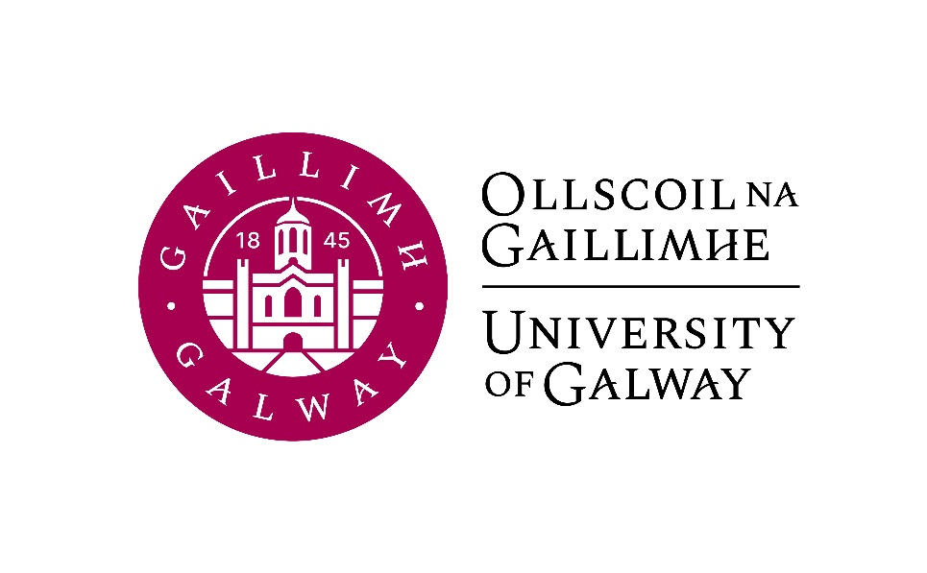

First Year Arts
Beginners German
Course Booklet

2024-2025

First Year Co-ordinator: Dr. Jeannine Jud, Room AMB-2001
Email: jeannine.jud@universityofgalway.ie
Language Lecturer: Mr. Vincent O’Connell, Room AMB-2005
Email: vincent.oconnell@universityofgalway.ie
Head of Discipline: Dr. Deirdre Byrnes, Room AMB-2003
Email: deirdre.byrnes@universityofgalway.ie
Discipline Administrator: Natalie Nevin, Room AMB-2006
Email: natalierebecca.nevin@universityofgalway.ie

Discipline of German website: https://www.universityofgalway.ie/german/

 | Academic Year 2024 -2025
2024 (Semester 1)
Start of teaching – 1st years | Monday 16th September
End of teaching all years | Friday 29th November
Study Week | Monday 2nd December - Friday 6th December
Semester 1 Exams | Monday 9th December – Friday 20th December
Christmas Holidays | Start Saturday 21st December
2025 (Semester 2)
Start of Teaching | Monday 13th January
End of Teaching | Friday 4th April
Field Trips | Monday 7th April to Thursday 10th April
Study Week | Friday 11th April to Thursday 17th April
Easter | Good Friday 18th April to Easter Monday 21st April
Semester 2 Exams | Tuesday 22nd April – Friday 9th May
Autumn Repeat Exams | Tuesday, 5th August to Friday 15th August
Holidays | St. Brigid’s Day: Monday 5th February 2024
 | Easter: Good Friday 18th April to Easter Monday 21st April
 | Bank Holidays: Monday 28th October 2024 /Monday 3rd February 2025/ Monday, 17th March 2025/ Monday 5th May 2025/ Monday 2nd June 2025 / Monday 4th August 2025

Please note: The modules on this course (GR1101 and GR1103) are only for students with no previous knowledge of German.

GR1101  German Language and Culture  (Beginners)  15 ECTS | Semester 1 and Semester 2
GR1103  Skills for Studying German  (Beginners)  5 ECTS | Semester 1 and Semester 2

Important notice for visiting students:
Visiting students wishing to take the module German Language and Culture (Beginners) should register for GR130 (Semester 1) and for GR131 (Semester 2).

Important information about in-house assessments:
Both GR1101 and GR1103 contain graded in-class tests. A medical certificate or the approval of an Extenuating Circumstance is required for a student to be able to sit the in-class test at a later date. More information regarding the Extenuating Circumstance Scheme can be found here: https://www.universityofgalway.ie/colleges-and-schools/arts-social-sciences-and-celtic-studies/student-information/studentformsandlinks/

GR1101 German Language and Culture (Beginners) (5 hours per week)

Lecturer: Vincent O Connell
Course description: This course is specifically aimed at students with no previous knowledge of German. Students will acquire basic language skills and a broad insight into cultural aspects of the German-speaking countries. At the end of the course, students will be able to discuss familiar topics such as their hobbies and interests, their living situation, family and friends. They will also be able to write short postcards and e-mails and fill in basic forms in German.
In Semester 1, language work in the multi-media laboratory will help students to improve their pronunciation and to gain confidence in their communicative skills.
In Semester 2, one class per week will be devoted to the study of literary texts. This class will focus on developing reading skills in German. Reading and discussion of short poetry and prose texts, mostly from the 20th and 21st centuries, will introduce students to various aspects of German literature.

Approach to learning and teaching: The GR1101 course follows an action-oriented, communicative approach in language learning and teaching. Students are encouraged to actively participate and interact to develop the full range of language skills - speaking, writing, reading, and listening - based on elementary grammatical structures. Students should spend a minimum of four hours per week practising outside of the classroom. The lecturer will provide exercises and learning strategies for self-conducted studying.
All content and grammatical progression comply with the requirements of level A1 of the Common European Framework of References for Languages.

Core texts:
Menschen A1.1 Kursbuch (ISBN 978-3193019011) for Semester 1
Menschen A1.1 Arbeitsbuch (ISBN 978-3193119018) for Semester 1
Menschen A1.2 Kursbuch (ISBN 978-3-19-561901-1) for Semestser 2
Menschen A1.2 Arbeitsbuch (ISBN 978-3-19-511901-6) for Semester 2
Menschen Glossary (ISBN 978-3-19-051901-9)
The texts are available for purchase in the campus bookshop.

Assessment (Semester 1):
Written examination (GR1101-1) at the end of Semester 1: 50%
Oral examination and listening test: 25%
Continuous assessment: 25% (weekly assignments and tests covering grammar, writing and reading comprehension)

Assessment (Semester 2):
Written examination (GR1101-2) at the end of Semester 2: 50%
Oral examination and pronunciation recording: 15%
Literature test (in-class test): 10%
Continuous assessment: 25% (weekly assignments and tests covering grammar, writing and reading comprehension)

A language cannot be learned by proxy. Therefore your personal attendance in class is of utmost importance.

GR1103 Skills for Studying German (Beginners) (1 hour per week)

Lecturer: Jeannine Jud
Language of instruction: English
Course description:
The course explores the basis for effective ways of studying in general and studying a foreign language and culture specifically.
In Semester 1, the focus is on individual learning techniques and self-motivational skills, group learning, efficient exam preparation, memory and retention, tools for reading, speaking, writing and listening comprehension, basics of German grammar terminology and phonetics.
In Semester 2, the focus is on enabling and encouraging students to interpret literature or other cultural products. It introduces relevant literary terms, reading strategies, narratology and genre theory. The final course segment introduces students to film analysis and aims to convey awareness regarding approach and terminology while discussing examples from German film history.
In both semesters, continuous engagement with course materials through an online learning journal is essential and will help to prepare for the in-class exam at the end of term.
Assessment (Semester 1):
Learning journal: 40%
In-class exam: 60%

Assessment (Semester 2):
Learning journal: 40%
In-class exam: 60%

Learning materials: handouts, videos, online articles
Learning outcomes:
If you engage continuously with this class, you will find out which learning strategies come easier to you, and in which areas you will have to put in more work. You will develop professional study methods, as well as strategies to approach literary texts and films.

Essay Guidelines: All essays which form part of the assessment of any module within the BA German programme must adhere to the format and the referencing system laid out in the discipline’s essay guidelines, available on the Discipline of German website (Section: Undergraduate Programmes).

