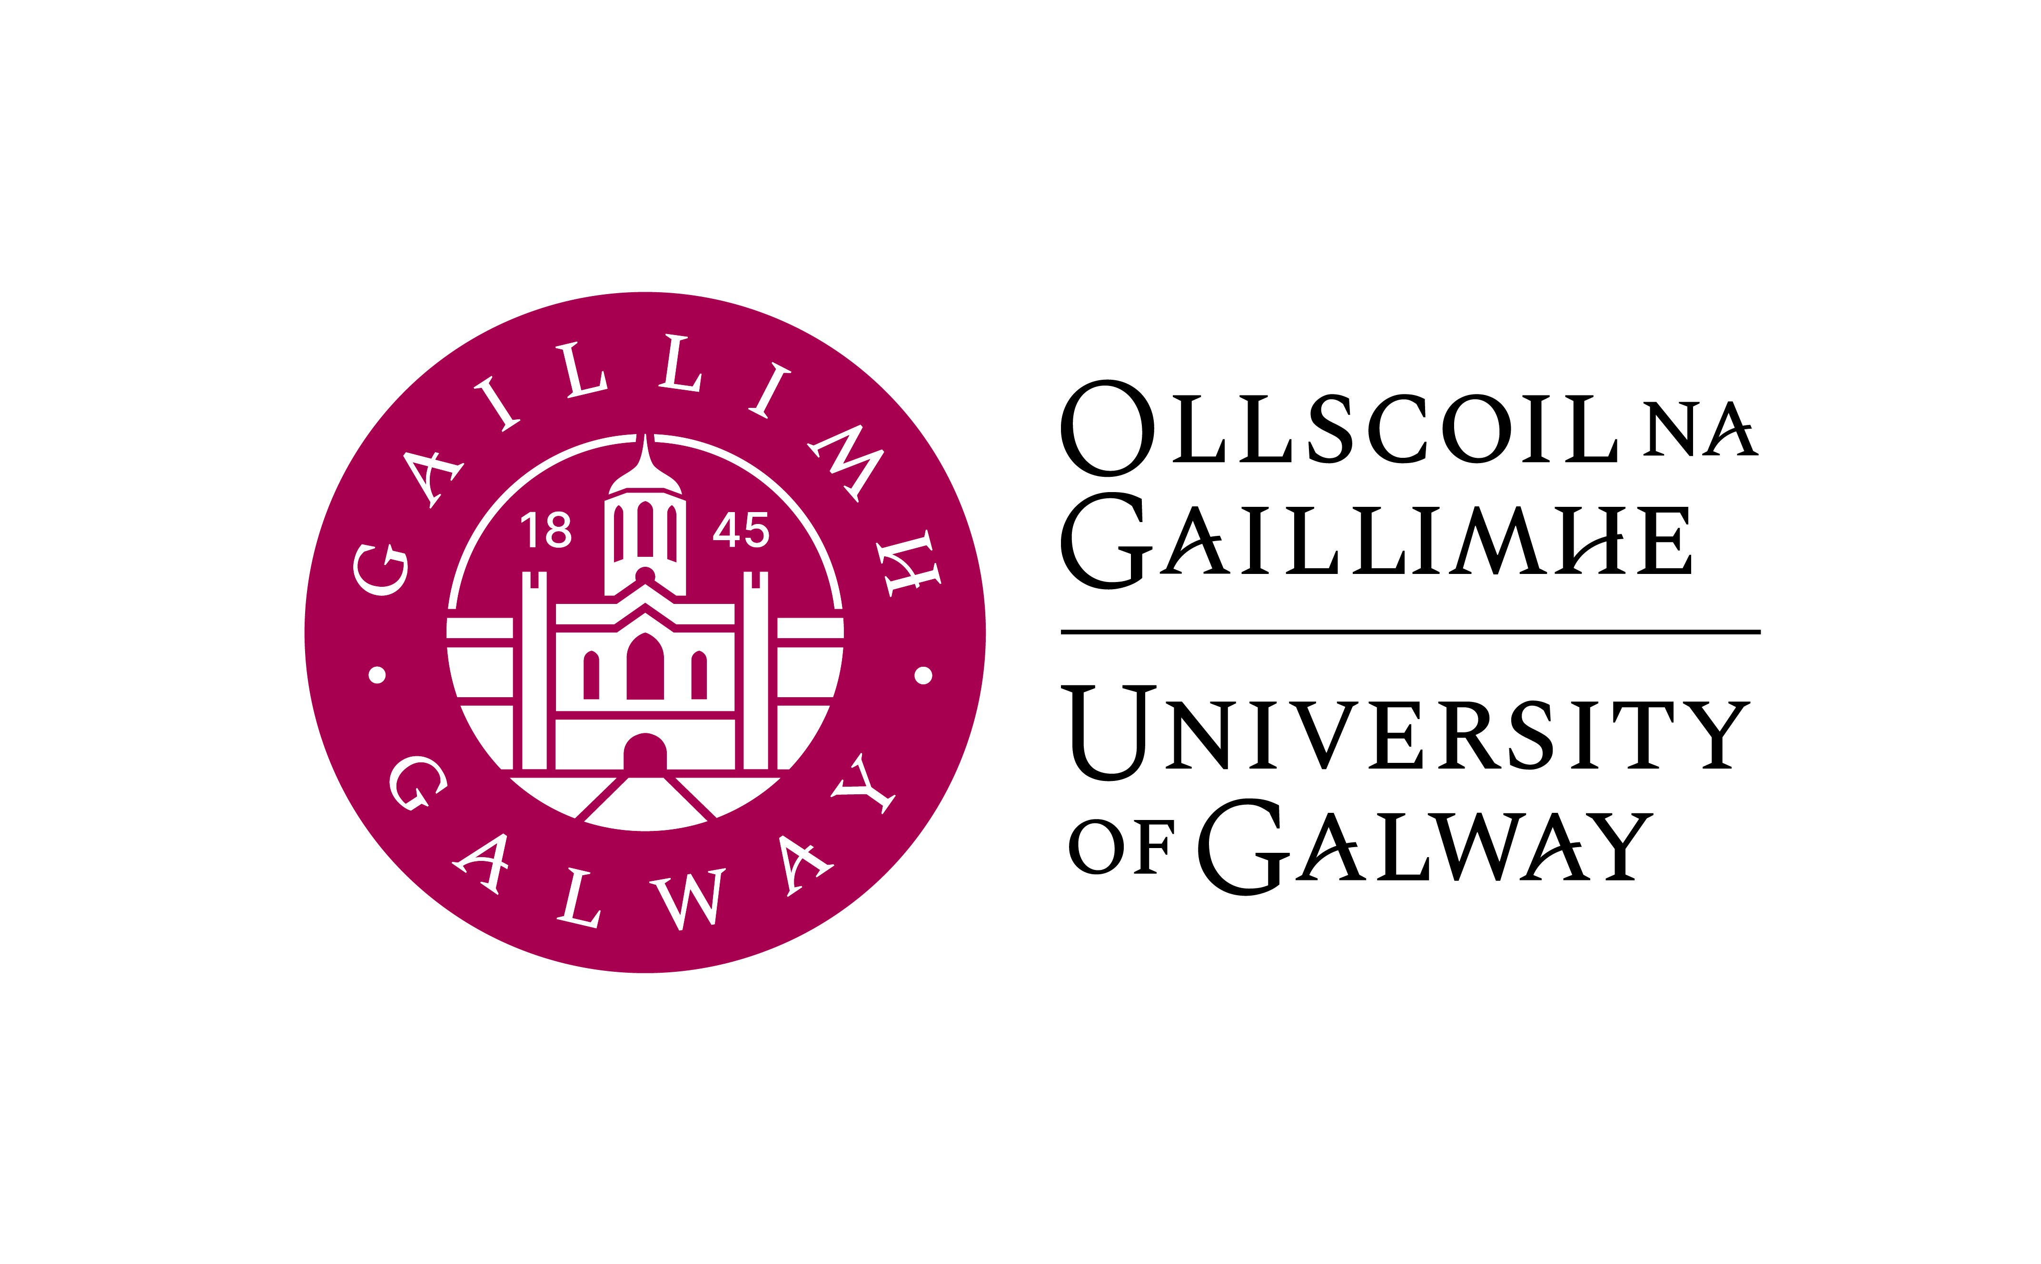

GR 141 1BC1 & 1BC3 & 1BC8
FIRST YEAR (ADVANCED) COMMERCE WITH GERMAN

First year (Advanced) Commerce with German is available to
- students who applied through the CAO for the B.Comm (International) with German programme: entry requirement H4 or better.
- students of the first year Commerce (General) and Commerce (Global Experience) programme 1BC1 & 1BC8.
(Entry Level: Leaving Certificate German)

Course Coordinator: Dr Thomas Wilks
E-mail: thomas.wilks@universityofgalway.ie
Tel: Ext. 2276
Room: Arts Millennium Building (AMB) 2002

Lecturers: Tom Wilks (German Language/Business German, Landeskunde)
Vincent O’Connell (Conversation/Multimedia Lab)
vincent.OConnell@nuigalway.ie

Course Outline:
5 hours per week (Semester 1 & 2) are made up of:

- German Language I (3 hrs. per week)
- Society, culture & economy in the German-speaking world (1hr. per week)
- Conversation & multimedia laboratory (1 hr. per week)

Course Aims and Objectives:
Students will follow a course which is designed to
- build and expand on the language skills they already possess
- develop the ability to express ideas and argue convincingly in oral and written German
- expand existing vocabulary and introduce new business terminology
- equip students with the linguistic skills necessary to successfully take and pass level A2+ (CEFR) university examinations
- facilitate through authentic course materials from German/Austrian magazines, video clips, audio files a feeling for and the insight into the cultural and social issues currently discussed in Germany/Austria.
- use continuous assessment and regular feedback in order to encourage and motivate students to actively participate and engaged with their chosen language
- convey a general understanding of social, political, economic and cultural affairs in the German-speaking world

Learning Outcomes:

After the end of the academic year, first year students should be able to
- understand and feel comfortable with the use of general structures of German grammar in oral and written expression
- make basic oral presentations in German on a variety of general and business- related topics
- form opinions and discuss basic general and business-related topics
- translate a variety of simple texts and grammatical structures into English and German
- analyze different types of texts in German and discuss text-related questions
- read and answer basic general and business correspondence as well as compose argumentative and descriptive essays on a variety of topics
- use self-study and multimedia laboratory facilities for autonomous learning and project work
- have a basic understanding of the culture and civilisation in German-speaking countries
- relate to social and economic affairs in Germany

Learning and Teaching Methods:

The programme actively engages students in the learning process, encouraging student participation from the outset. Small class size, role-plays, group discussions, presentations, project work and an open and student-centered learning approach facilitate a productive and communicative learning environment.
The extensive use of authentic materials, such as newspaper and magazine articles, blogs, video clips and podcasts ensure the contemporary focus of the curriculum. Self- study and multimedia laboratories provide access to Internet resources and multimedia language applications.
The language of instruction and communication is predominantly German ensuring that students are from the beginning exposed to the target language of their choice.
All students have access to the Virtual Learning Environment Canvas where they can find announcements, assignments, lecture notes, websites, videos and audio materials as well as a discussion group and virtual classroom.

Textbooks:

A-Grammatik | Übungsgrammatik A1-A2 | Publisher:  Schubert | Semester 1 & 2
Begegnungen A2+ | Kurs- und Arbeitsbuch A2+ | Publisher:  Schubert | Semester 1 & 2
Both books will be available in the campus bookshop. Additional materials will be provided on Canvas and in class.
Course elements:

  - Grammar:
In first year, students will receive a detailed revision of all basic elements and structures of German grammar, syntax, punctuation and orthography up to level A2+. (CEFR)

Introduction to Business German:
An introduction to Business German focusing on the topics, language, vocabulary and structures used in everyday business dealings in the German-speaking world (level A2+).

Reading skills:
Analysis of various types of texts and selective reading with prepared and authentic texts from newspapers, magazines and articles from the Internet.
Introduction to surface, selective and detailed reading skills as well as business texts.

Writing skills:
Introduction to various writing skills in the general and business context, e.g. informal and formal correspondence, essay and free composition writing on general and business-related topics, basic job applications etc.

Conversation:
General conversation and discussions on a variety of topics like family & friends, student life, youth problems, work and finance, plans for the future, media and multimedia, social networking, travel in Europe etc.

Presentations:
Students will receive a detailed introduction on how to make successful general and formal presentations. All students will have the opportunity to give class presentations on a cultural/business topic. These presentations will equip students with skills they might need in other academic subjects or for job interviews.

Multimedia laboratory:
Students work with audio and multimedia applications to perfect existing language skills and expand on newly acquired skills. The use of Web 1.0 (Internet) and Web 2.0 (blogs, podcasts, social networks) technologies also facilitate students to gain insight into cultural and social aspects of the German-speaking world as well as engage in autonomous learning.

Society, culture and economy in the German-speaking world:
This module will introduce students to important aspects of German, Austrian and Swiss culture and society as well as analyzing basic economic affairs and developments in the German-speaking world. It will also give a brief introduction to Liechtenstein.

Exams and Assessments:

First year students take their German written examination at the end of the academic year (May-June 2024). There is also an oral examination at the end of semester 2.
Continuous online assessment throughout the academic year is a vital part of the course as well as grades awarded for attendance and homework/project work.

Allocation of Marks:

Semester 1: 5.0 ECTS

Final In-Class Exam 30%
Mid-term Exam 20%
Language Lab/Conversation 15%
Landeskunde 15%
Graded coursework assignments 20%

Semester 2: 5.0 ECTS

Applied German Language Paper (2 hrs. written exam) 30 %
Oral Examination 20 %
Language lab 15 %
Oral presentation 15 %
Graded coursework assignments 20 %

Repeat Examinations:
In-house examinations and/or language tests cannot be repeated in the August examinations. Year’s work cannot be carried forward to the August repeat examinations as assessment is based on performance in the examinations (written & oral) only.

