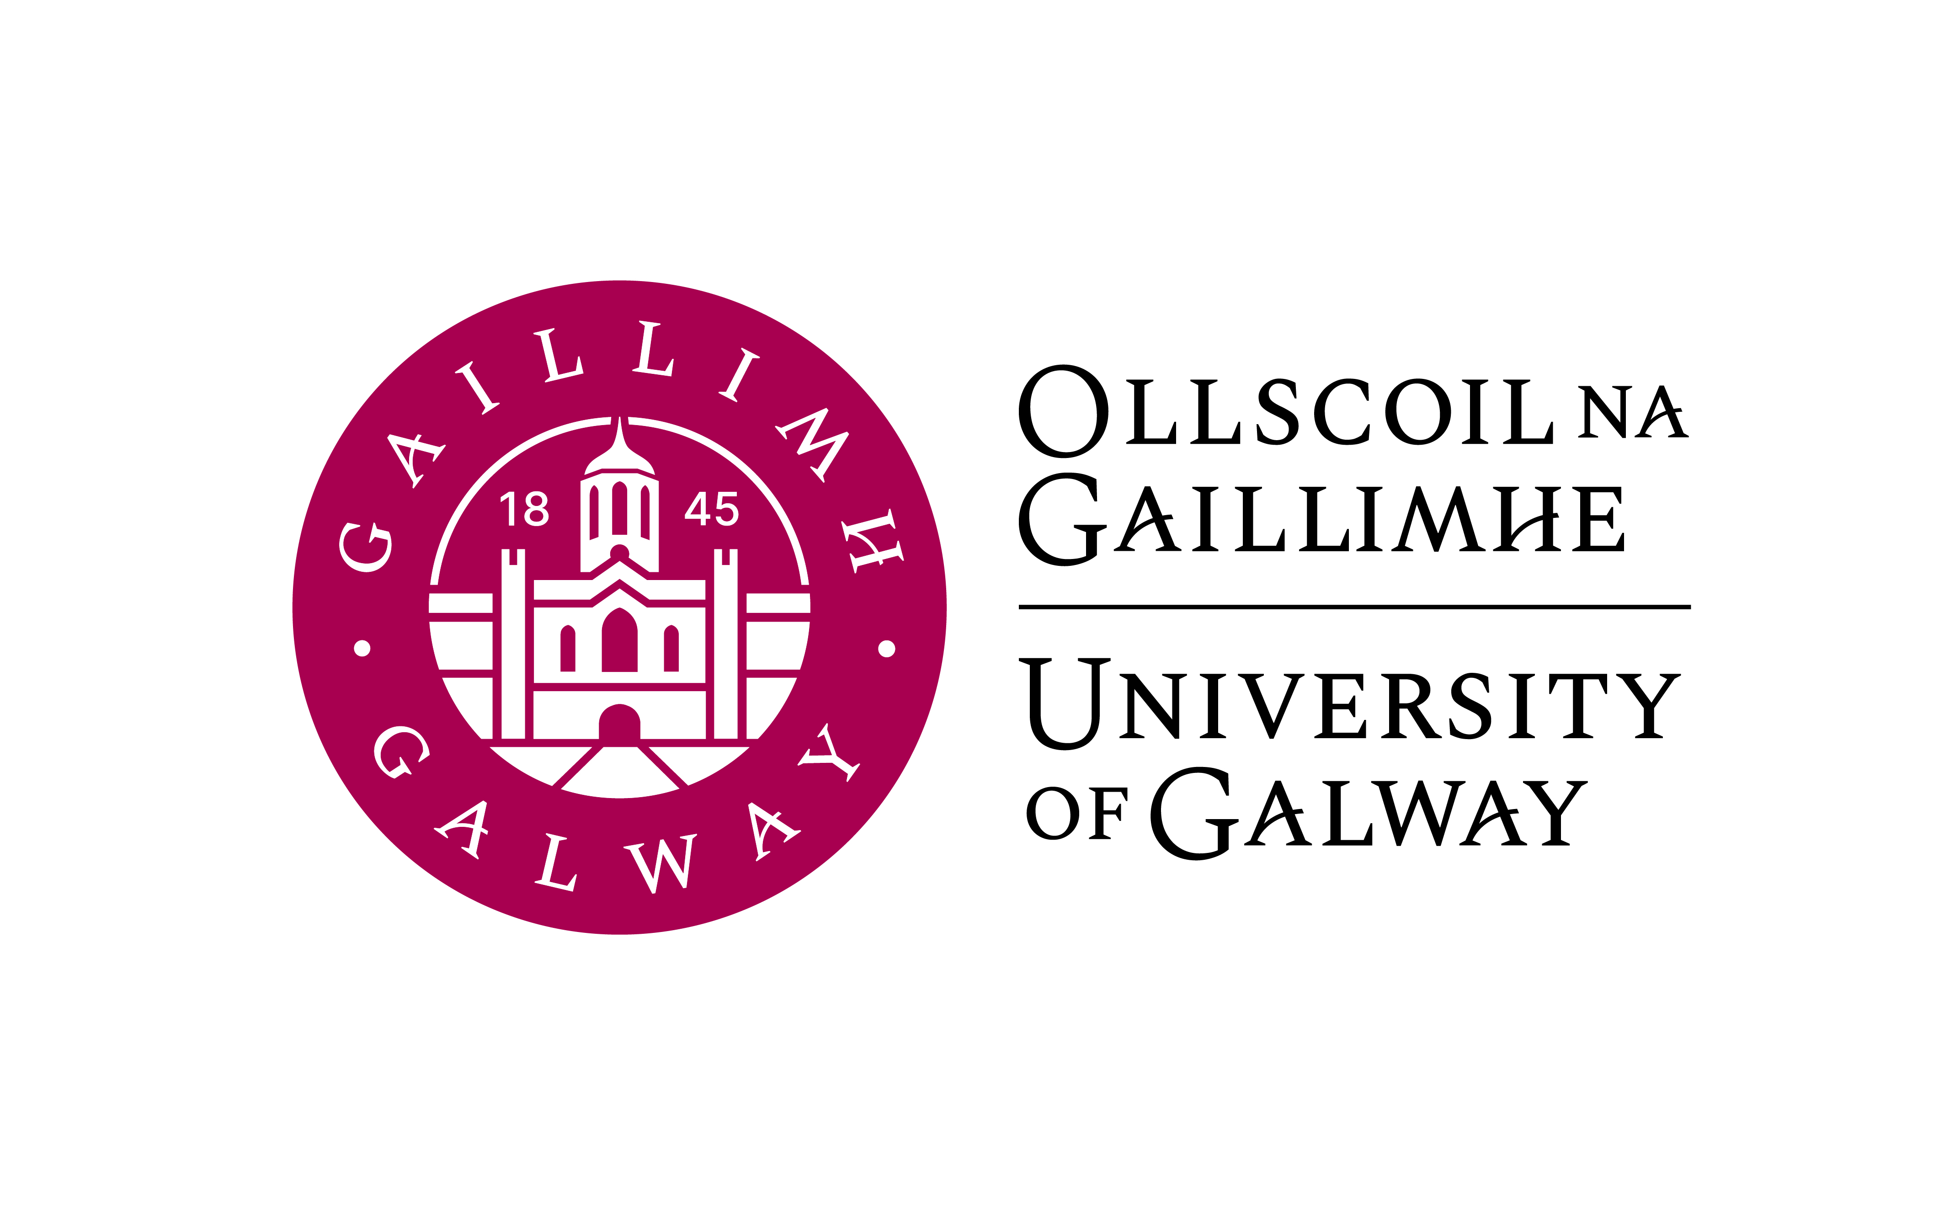

GR 222/223 2BC3

SECOND YEAR COMMERCE WITH GERMAN

Course Coordinator: Dr Jeannine Jud

ERASMUS Coordinator: Dr Jeannine Jud

Lecturers: Maybritt Bonifer (GR223: Language, Business German, Unternehmen Deutsch)
Email: maybritt.bonifer@universityofgalway.ie
Office: Arts Millennium Building (AMB) 2050

Dr Jeannine Jud (Social & Economic German Studies / ERASMUS)
Email: jeannine.jud@universityofgalway.ie
Office: Arts Millennium Building (AMB) 2001

Vincent O’Connell (Conversation /Multimedia Lab.)
Email: vincent.oconnell@universityofgalway.ie
Office: Arts Millennium Building (AMB) 2005

Course Outline:

5 contact hours per week (Semester 1: GR222 & Semester 2: GR223) consist of:

- German Language II: General & Business German / Project work (3 hours)
- Social & Economic German Studies / Erasmus (1 hour)
- Language & multimedia laboratory (1 hour)

Course Aims and Objectives:
Students will follow a course which is designed to:

- build on the linguistic skills gained in first year and advance in the areas of grammar, reading and writing skills as well as aural skills and communication
- extend knowledge of how to conduct business in a German-speaking work environment
- continue from GR141 (or commence after GR140) in researching current economic and business developments in the German-speaking world
- increase familiarity with specialised language for business transactions and communications
- enable sophisticated oral and written business and research presentations in German
- engage receptively and productively with digital technologies including blogs, videos, data and audio files and podcasts
- advance into the area of intercultural business communication through project work
- prepare students thoroughly for the year abroad and familiarise them with aspects of academic study at a German or Austrian university
- facilitate insights into current cultural and social issues in German-speaking countries through authentic German-language sources in a range of media.
- continue the use of continuous assessment and regular feedback to encourage active participation in the target language.

Learning Outcomes:

By the end of the Second Year, students should be able to:
- understand and apply more complex grammar structures (CEFR Level B1+)
- translate more advanced texts and language structures into and out of German
- reflect on and analyse complex texts and data, and discuss these in class
- use a variety of writing skills in general and business contexts
- give oral presentations in German on business-related topics and conduct a collective research project
- use multimedia applications for autonomous learning, research and project work
- compose and post online contributions for specific purposes
- utilise an advanced understanding of culture and civilisation in German-
- speaking countries to relate to social and economic affairs in the target culture(s)
- make use of additional vocabulary and business terminology in everyday business and conversational situations
- feel comfortable and well-informed about the ERASMUS Year in Germany/Austria.

Learning and Teaching Methods:

The programme actively engages students in the learning process, encouraging student participation from the outset. Small class size, role-plays, group discussions, presentations, project work and an open and student-centred learning approach all facilitate a productive and communicative learning environment.
The extensive use of authentic materials, such as newspaper and magazine articles, blogs, podcasts and video clips ensure the contemporary focus of the curriculum. The VLE and multimedia laboratory provide access to online and multimedia language applications. The emphasis here is on blended learning to facilitate and encourage foreign language acquisition.
All students have access to the Virtual Learning Environment Canvas for announcements, assignments, seminar notes and slides, websites, videos and audio materials as well as a discussion forum.

Textbooks (required; available in the campus bookshop):

A.Buscha & S. Szita, B-Grammatik, second edition/ zweite Auflage (2024) | Übungsgrammatik  ISBN: 978-3-96915-077-1 | Schubert | All year
I. Grigull & S. Raven, Geschäftliche Begegnungen B1+, zweite überarbeitete Auflage (2022) | Textbook  ISBN: 978-3-96915-026-9 | Schubert | All year
Students will also have access to specifically prepared handouts, reading materials, PowerPoint presentations, audio and visual materials on the Canvas VLE.

Course elements:
- Advanced German II:
In second year, students will continue to develop their comprehension and command of grammatical and lexical structures in German to CEFR level B1+.

- Reading skills:
Identification and analysis of various text forms, e.g. business reports and correspondence, company profiles, orders, application and registration forms as well as general reading comprehensions.

- Writing skills:
In second year, students continue with general and business correspondence as well as descriptive and argumentative compositions on general and business-related topics.

- Oral skills:
General conversation and discussions on various topics, e.g. preparing for the year abroad, studying, living and working in Germany, dealing with bureaucracy abroad, e.g. application and registration, contracts (accommodation, mobile phone etc.), communication via various media (telephone, email, social and professional networks), travelling within Europe, current economic and general issues in Germany and Ireland.
Students will also discuss various topics of intercultural communication.
Oral skills are developed through role-plays, discussions, quizzes and free discussion.

- Presentations:
In second year, students continue to deepen existing presentation skills. Students are required to present a variety of company profiles and participate in an online research project involving contact with German business. All presentations are held in German.

- Multimedia laboratory:
Students will work with audio and multimedia applications to perfect existing language skills and expand on newly acquired skills. The use of Web 1.0 (Internet) and Web 2.0 (blogs, wikis, podcasts, social networks) technologies also facilitates insight students gain into cultural and social aspects of the German-speaking world as well as engagement in autonomous learning.

- ERASMUS Year Abroad preparation:
Students will receive a thorough introduction into the administrative, academic and practical aspects of the immersive year abroad (ERASMUS) exchange in Germany.

- Social and Economic German Studies II/ Unternehmen Deutsch:
In semesters 1 (GR222) and 2 (GR223), students will continue with the study of comparative aspects of business in the German-speaking world. Topics will include Company Structures, Company Profiles, Economic Regions and Business Locations, Advertising and Marketing and Intercultural Business Communication, all informing students’ group project work and oral presentations.
Exams and Assessments:

Second-year students take their German oral examinations at the end of the teaching period in Semester 2. The two written papers are taken during the summer examination period (22 April—9 May 2025).
Continuous assessments in class and online throughout the academic year are a vital part of the course as well as grades awarded for participation and project work.

Allocation of marks:

GR223 is weighted more heavily than GR222 because the German oral examinations are taken in-house towards the end of the teaching period in Semester 2. The two written examination papers are taken during the summer examination period (21 April—8 May 2026), assessing language and content from all sections of both GR222 and GR223. GR223 also assesses preparedness for the Year Abroad as well as group project work developed beyond its foundations in GR222.
Continuous assessments in class and online throughout the academic year and the feedback received from these are vital in both GR222 and GR223 for ensuring comprehension and production of German language as well as for ensuring that course topics have been understood prior to further testing in the final examinations. Grades are also awarded for participation and project work

Semester 1 (GR222) 25% of year mark for German
In-House Assessment 100% of module mark 200 5.0 ECTS

Applied Language Exam (Week 12) 30% 60
Midterm Exam (Week 7) 20% 40
Project/Presentation 20% 40
Language Lab. & Conversation 15% 30
Assignments 15% 30

Semester 2 (GR223) 75% of year mark for German

15.0 ECTS
Examinations (70% of module mark)
Applied German Language Paper I (2h written exam) 33 %
Social & Economic German Paper II (2h written exam) 20%
Oral examination 17%

Continuous Assessment 30%
Project/ Presentation 10%
Assignments 8%
Language Lab & Conversation 6%
Midterm Test (Week 7) 6%

Autumn/Repeat Examinations:
In the case of repeat examinations held in August (‘Autumn’ sittings), assessment is based on performance in the written examinations and an extended oral examination only. Any marks already awarded during GR222 and/or GR223 for coursework and/or graded essays/projects (continuous assessment) during both semesters are not carried forward

