Polasaí agus Nósanna Imeachta/Policies and Procedures

Code | QA214
Title | Paid family leave: doctoral students
Policy Owner | Dean of Graduate Studies
Date | 17th September 2024
Approved By | University Management Team

1.0 Purpose

The University is committed to supporting eligible doctoral students to ensure that they are not disadvantaged in their studies due to pregnancy or adoption of a child.
Students are supported through
- QA603 Policy on Supports for Students Experiencing Pregnancy, Maternity and Paternity
- QA245 University Guidelines for Research Degree Programmes

This policy aims to inform eligible doctoral students of their paid family leave rights, and to ensure that those rights are understood. It details the benefits provided to eligible doctoral students which comply with the spirit of the law on family leave rights and are in excess of these statutory requirements.

2.0 Description

This policy applies, from 17th September 2024, to full-time registered doctoral students in receipt of a stipend from an eligible funding source, regardless of their length of service and entitlement to relevant social welfare benefits, and is supported by an Operating Procedure which forms part of the approved policy.

3.0 Paid Family Leave Entitlements

- Where a full-time registered doctoral student is in receipt of a stipend paid through the University from a funding source that contributes significantly to the costs of the paid family leave, in the form of at least an amount equivalent to the scholarship stipend per month of eligible leave, entitlement to paid family leave and an extension to their funded period is determined by the conditions of their visa status and their funding.

  - Doctoral students funded by Hardiman or College Scholarships are, if permitted by their visa status, entitled to the maximum statutory paid maternity leave or paid adoptive leave periods.

- Doctoral students on Student Visas (Stamp 2) who become pregnant or adopt during their studies must seek up-to-date advice from the Human Resources and International Office to determine whether they have an entitlement to paid family leave under this policy.
- Doctoral students do not have to take maternity leave and can opt for a shorter period of leave; however, in line with guidance for staff, students are expected take at least 4 weeks leave following the birth of the child.
- Paid maternity leave, for those entitled to such under points 1 and 2 above, must commence at least 2 weeks but not more than 16 weeks before the end of the expected week of childbirth. Doctoral students are entitled to the paid maternity leave if the expected week of childbirth will occur during their funded period.
- Paid adoptive leave is generally taken after the adoption takes place. Doctoral students do not have to take adoptive leave and can opt for a shorter period of leave. Doctoral students are entitled to paid adoptive leave under points 1 and 2 above if the expected week of adoption occurs during their funded period.
  - Paid adoptive leave gives time off to a parent who is adopting alone or to one parent of an adopting couple.
  - In the unfortunate event of the death of the adopting parent who has availed of the paid leave another adopting parent, where one exists and is eligible to avail of paid family leave under points 1, 2 and 5 of this policy, may be entitled to the remainder of the paid leave.
- The University is required to recover the value of paid maternity or adoptive leave, above social welfare benefit paid directly to the doctoral student, from doctoral students who decide not to return to study at the end of the approved paid leave, or following any extended unpaid leave, period.
- Doctoral students whose stipends are self-funded are not eligible to receive paid family leave from the University.
- Doctoral students who are funded by an external funding source that does not contribute to the costs of the paid family leave are not eligible to receive paid family leave from the University; doctoral students should contact their funder with any enquiries about the provision of paid leave.
- Doctoral students who are funded by an external scholarship (i.e. not paid through the University) are not eligible to receive paid family leave from the University; doctoral students should contact their external funder with any enquiries about the provision of paid leave.
- Doctoral students who are paid a salary, e.g. those with a Marie Curie Fellowship, may be eligible for paid leave through the terms and conditions of the relevant staff policy. They are not eligible for paid leave under this Policy.
- Doctoral students who remain registered but are beyond their funded periods of study, or the expected week of childbirth is outside the funded period, are not eligible to receive paid family leave from the University.
- Doctoral students who are on a leave of absence for reasons excluding family leave and whose stipends have been temporarily suspended during the period of leave, are not eligible to receive paid family leave during this period from the University.
- Visiting Research Students are not eligible to receive paid family leave from the University.

Payments

- A doctoral student taking paid family leave will receive pay, through payroll, starting from the first day of leave, minus the amount of any social welfare maternity or adoptive leave benefit payment received from the state.

- State Maternity or Adoptive Leave Benefit is paid directly to the doctoral student on a weekly basis so that they receive the tax benefit directly.

- University of Galway will pay an amount, less the state benefit amount, to provide a net monthly benefit equivalent to the scholarship stipend amount. Such net benefit will minus the pension contribution (currently 20%) as this will be paid to the doctoral student upon termination of the paid leave.

- Family leave pay is subject to the condition that no work is undertaken during the paid period of leave.

5.0 Early or Stillborn

- A doctoral student whose child is born early will commence family leave and pay immediately. If a pregnancy ends in stillbirth after the 24th week of pregnancy, the doctoral student remains entitled to family leave and pay commencing from the date of birth.

Breastfeeding

- A doctoral student is entitled to time off without reduction in scholarship stipend for up to one hour every day to either breastfeed or express breastmilk for up to two years following the birth of the child.
  - A map of on-campus family friendly facilities is available on the Buildings and Estates Office website.

Ante-natal Appointments
- A doctoral student is entitled to time off without reduction in scholarship stipend in order to attend ante-natal appointments, which may include a set of ante-natal classes (with the exception of the last three which are normally after childbirth) over all their pregnancies. The supervisor may require such doctoral student to produce an appointment card from their clinic. Doctoral students are also entitled to take time off without reduction in scholarship stipend for medical visits related to the pregnancy for 14 weeks after the birth.

Paid Leave Application Procedure

    - The workflow of the procedure for paid maternity or adoptive leave is provided overleaf.
    - Doctoral students on Student Visas (Stamp 2) who become pregnant or adopt during their studies must seek up-to-date advice from the Human Resources and International Office to determine whether they have an entitlement to paid family leave under this policy.
    - The doctoral student must submit a completed University of Galway GS-80 form to the supervisor at least six weeks in advance of proposed commencement date of paid leave, to initiate a Leave of Absence from the programme in accordance with the QA245 section 5.8.5. The doctoral student must provide a letter from a medical practitioner confirming when their baby is due, or their certificate of placement for the adoption.
    - The doctoral student, if eligible must also submit an application for benefit to the Department of Social Protection and inform their supervisor of any benefit they will receive.
    - If a doctoral student wishes to take unpaid leave for a period following the paid leave, they must submit GS-80 form to the supervisor to extend Leave of Absence from the programme in accordance with the QA245 section 5.8.5 at least four weeks before the paid leave period is due to expire.

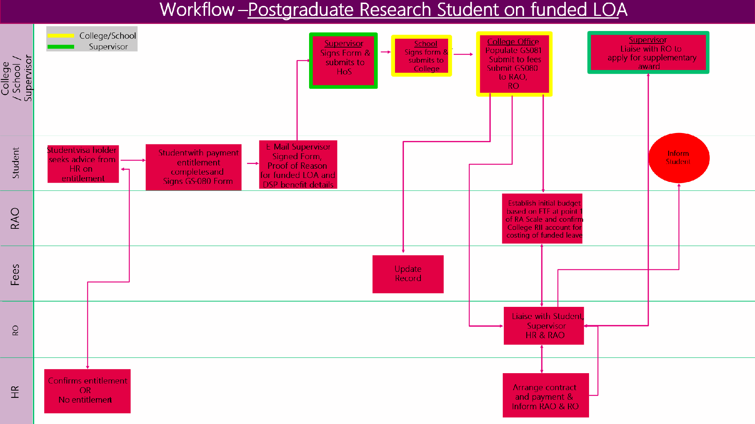

9.0 Responsibilities

Name | Responsibility
Dean of Graduate Studies | Policy Owner
Eligible student | Give six weeks’ notice of intention to avail of this leave, completing the appropriate application
Supervisor | Initial approval of leave application; Read and comply with this leave policy and ensure the leave application is reviewed and submitted to HoS and College promptly
Human Resources Office | Final approval of leave application; Review this policy on a regular basis in light of any changes in legislation

10.0 Related Documents
- Health and Safety Risk Assessment Form

Websites:

- http://www.equality.ie
- http://www.welfare.ie
Appendix 1: Maternity Leave Resources and Supports

Breastfeeding Group
The University Women’s Network with the help of La Leche League, Cuidiú and other colleagues facilitate a monthly on campus group to provide peer-to-peer support for breastfeeding mothers. The group meets on the third Wednesday of every month (during term time only) from 12–2pm in the River Room AS203. All mothers, babies, toddlers, expectant women, grandmothers, and female supporters are most welcome to attend. Please contact claire.withey@universityofgalway.ie, oonagh.meade@universityofgalway.ie or rachel.hilliard@universityofgalway.ie for further information or to join the mailing list.

Family-Friendly Facilities
The University is expanding its family-friendly facilities on campus. The Buildings and Estates Office have developed a map of nursing and changing rooms which may be useful.


Appendix 2 – Equality Impact Assessment Form

Section A: Initial Screening
Name of proposed policy/revised policy (name of policy or subject of review/decision) |  |  | Paid family leave: doctoral students
Purpose of proposed policy/revised policy (who is the intended target group?) |  |  | To inform eligible doctoral students of their paid family leave rights, and to ensure that those rights are understood.
College/School/Unit |  |  | HR & Graduate Studies
Date |  |  | 03/04/2024
Name(s) of assessor(s) |  |  | Dónal Leech/Aoife Cooke
STAGE 1 - Consider any potential impact (on staff, students and the public)

What is the potential impact on any of the following groups?
i.e. How might the proposal affect people from diverse backgrounds and circumstances, either adversely or beneficially? This includes both direct effects and other effects as an indirect consequence of the policy. Remember we need to:
- Eliminate discrimination
- Promote equality of opportunity and treatment of staff, students and other persons to whom we provide services
- Protect human rights of our members, staff, students and other persons to whom we provide services

Characteristics | Potentially Beneficial | Potentially Adverse |  | No Anticipated Impact | Evidence/explanation of this impact
Gender | x |  |  |  | Clarifies eligibility for paid family leave
Civil Status | x |  |  |  | Clarifies eligibility for paid family leave
Family Status | x |  |  |  | Clarifies eligibility for paid family leave
Age | x |  |  |  | Clarifies eligibility for paid family leave
Disability | x |  |  |  | Clarifies eligibility for paid family leave
Race | x |  |  |  | Clarifies eligibility for paid family leave
Sexual Orientation | x |  |  |  | Clarifies eligibility for paid family leave
Religious Belief | x |  |  |  | Clarifies eligibility for paid family leave
Membership of the Traveller Community | x |  |  |  | Clarifies eligibility for paid family leave
Other e.g. part-time, Stamp 2 visa holders, certain externally-funded or self-funded doctoral students |  |  |  | x | As part-time students are not entitled to be paid a stipend scholarship, they are not eligible for paid family leave under this policy.  Eligibility to be paid through payroll may not be available to Stamp 2 visa holders (e.g. some non-EU students enrolled on FT education programmes)  In addition students in receipt of scholarship stipends from a funder that does not contribute to the costs of paid family leave are ineligible for paid family leave through this policy

EIA screening outcome | Mark below as appropriate | Next step
No impact identified |  | Go to Stage 5 of the Guidelines (pg. 10)
Only beneficial impact identified |  | Go to Stage 5 of the Guidelines (pg. 10)
Potential negative impact identified | x | Go to Section B (below)

Section B: Detailed Assessment
STAGE 2 - Collecting the relevant data

What evidence have you gathered to help you to assess the impact of this policy on particular groups? Please give details. | Department of Justice controls conditions for award of Stamp 2 (and 2A) visas to students from certain (non-EU) jurisdictions.  Revenue controls conditions for award of scholarships (and stipends) to full-time students under instruction.  Certain external funders do not contribute to the cost of paid family leave, and students funded through them are ineligible for paid family leave under this policy.  Self-funded students that do not have a funder to contribute to the cost of paid family leave are not eligible for paid family leave under this policy.
What consultation has been undertaken as part of this Equality Impact Assessment? Please state who has been consulted, how and when. | Revenue, Minister DFHERIS, Director of HR, Vice-President Internationalisation, Vice President Equality Diversity and Inclusion, Vice-President Research & Innovation, IUA Deans of Graduate Studies, SU PGR representatives (3 nominees, over 3 separate years). UMT.
What were the results of the consultation? Please summarise. | Recognition that payment through payroll is the only legally available option to allocate a payment to students in receipt of a scholarship stipend should they seek to take paid family leave.

STAGE 3 - Analysing the evidence

 | No | Yes
- Does the proposed policy have the potential to advance equality of opportunity and protect human rights? | Go to Stage 3(b) | This policy aims to inform eligible doctoral students of their paid family leave rights, and to ensure that those rights are understood.
- Is there an adverse impact on any of the following protected characteristics or groups?  - Other e.g. part-time, Stamp 2 visa holders, certain externally-funded or self-funded doctoral students | Go to Stage 5 of the Guidelines | The policy and process do not permit payment to certain categories of doctoral students:  - Where the conditions of their visa do not permit them to be paid  - Where their funder does not contribute significantly to the costs of paid family leave.  - Self-funded students  Such students do NOT have to take family leave and can opt to take shorter periods of leave.

STAGE 4 – Identify and address any adverse impact

Characteristics | Analyse the evidence  Comment on evidence and potential impact | Eliminate or reduce any adverse impact  Recommended actions or specific requirements (e.g. reasonable accommodations for disability)
Gender & Nationality | 50.5% of registered female doctoral students are in receipt of stipends (281 of 556) therefore 49.5% (275) registered female students are not eligible to avail of paid family leave.  Female doctoral students are less likely to be in receipt of stipends (50.5% F;63.2%M), half of whom are ineligible for paid family leave therefore the potential disadvantage due to maternity or adoptive leave is considerable and creates an inequity within the cohort of female doctoral students.  There is also potential for international doctoral students to be disproportionately excluded from paid family leave on the basis of their visa conditions (Stamp 2 students visa). This may compound the disadvantage for international women where the conditions of their visa who not permit them to be paid. | Engage with  - Funders (including the HEA)  - Department of Justice  - Revenue  to have  - funders contribute to the cost of paid family leave for externally funded and self-funded doctoral students  - Department of Justice to permit paid family leave to be paid through payroll to Stamp 2 visa holders (or alternate solution, such as revenue permission for stipend payment to students while on family leave)  Alternate action is to interact with all 3 above to move to pay doctoral students through payroll, with hosting agreement for visa-required candidates that grants them leave-to-remain in the state, and funds them, and permits them to be paid through payroll, while on family leave.
Other e.g. part-time | No paid family leave available to part-time doctoral students. A higher proportion of PT doctoral students are F (56.2% F: 42.2% M) and are excluded from taking paid family leave. | Engage with  - Funders (including the HEA)  - Department of Justice  - Revenue  to permit scholarship stipend and paid family leave to be paid to part-time students under instruction.  Alternate action is to interact with all 3 above to move to pay doctoral students through payroll and thus permits them to be paid through payroll, while on family leave.

Stage 5 - Share results and keep evidence | Next steps
Equality information published by the University (a legal requirement) must include evidence that we have paid ‘due regard’ to equality issues. | - Send a digital copy of the completed EIA form and any attachments to the OVPEDI, so that the EIA can be kept (and published as appropriate): OVPEDI@universityofgalway.ie.  - A copy of the EIA should also be appended to the policy for the duration of the life of the policy.  - Share the EIA results with the Trade Unions and/or Students’ Union, as appropriate, as part of the normal consultation process  - Keep a copy of the completed EIA form and any associated documents, emails, data, or information

Stage 6 – Monitor Actual Impact and Review Policy | Next Steps
Equality Impact Assessment is an ongoing process that does not end once a policy has been agreed or implemented. This does not necessarily mean repeating the Equality Impact Assessment, but using the experience gained through implementation to check the findings and to make the necessary adjustments.  At the proposed date of review, consider the actual impact of the policy taking into account any changes that have occurred (e.g. structural, organisational, demographic, customer requirements). | - The policy should be reviewed at a future date which should be identified and clearly stated as part of the Equality Impact Assessment. The length of time between one analysis and the next will depend on the relevance of the policy to equality issues and any potential impact on groups with protected characteristics.  - At the proposed date of review, consider the actual impact of the policy taking into account any changes that have occurred (e.g. structural, organisational, demographic, customer requirements).

Signed by the Chair of the Policy Development/Review Group:
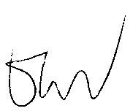

Tuesday 6 August 2024

