


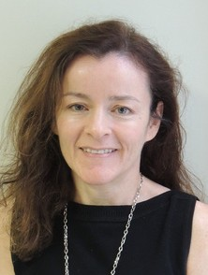
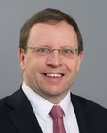
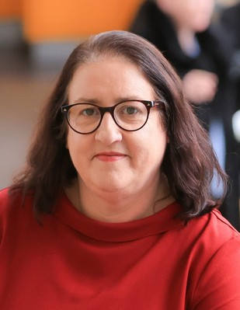
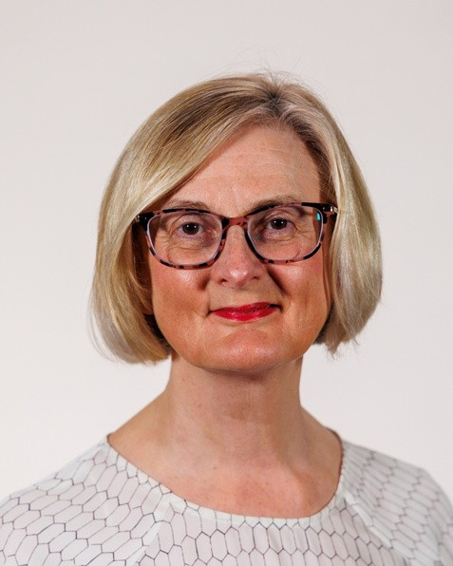

Presentation
Slides
Policy Implementation for Impact
26th May 2026

Case Study - Pension Reform
John McKeon, Secretary General, Dept. of Social Protection

Case Study - Energy
Philip Nugent, Assistant Secretary, EU, International and Marine Affairs, Dept of Climate, Energy and the Environment

Case Study - Online Youth Safety
Triona Quill, Assistant Secretary, Broadcasting & Media Division, Dept of Culture, Communications & Sport.

Beyond Business as Usual: Rethinking Research and Policy in Changed Times
Elizabeth Canavan,
Assistant Secretary General, Dept of the Taoiseach,
Prof. Caroline McGregor,
Director, Institute for Lifecourse & Society

