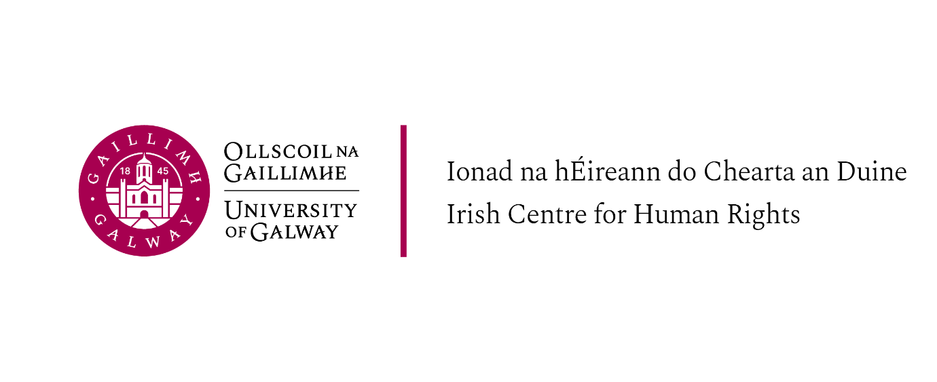
LW 5117 International Human Rights Law 2026-27 | Module coordinator: Professor Siobhán Mullally  Lecturers: Prof Siobhán Mullally
Credits: 10 ECTS | Venue and Timetable  Wednesday 10-1pm (ICHR Seminar Room) – LLM IHRL programme students only  All other LLM programmes: Wednesday 2-5pm (ICHR Seminar Room)
Aim:  The course aims to provide students with a comprehensive analysis of the sources, protection systems, and key concepts of of international human rights law. It also aims to include a critical lens that will give students the skills to apply international human rights law to selected issues, analysing the origins, impacts, and power of international human rights law.  Teaching Methods:  Classes will include discussion-based lectures, guest presenters, and small group exercises. The format will vary each week. Students are expected to have completed all reading prior to class and should be prepared to contribute to discussions. | Learning Objectives:  - Develop knowledge and skills to conduct research and analysis in the field of international human rights law.  - Be familiar with the major universal and regional systems of human rights law, their relationships to each other, and the legal value and authority of declarations, decisions, judgments, and other materials generated by them.  - Develop knowledge of and capacity to analyse the historical development of the international human rights system for the protection of human rights.  - Develop the skills necessary to analyse and apply core concept of international human rights law to selected issues and areas of concern.  - Understand the critiques of human rights law and be able to critically engage in human rights analysis and debate.  - Application of international human rights law to potential situations of international human rights law violations
Assessment:
100% Research essay (5000 words, excluding footnotes and bibliography), submission online via Canvas

***A list of essay topics will be provided. You must choose one of the listed topics. (Submission online via CANVAS). Submission deadlines noted in the LLM Programme Guidelines ***

Online Resources  UN OHCHR  https://www.ohchr.org/en/ohchr_homepage  UPR Info  https://upr-info.org/en | International Human Rights Reports (Available via Library sign in)  https://ihr-reports.org/  ISHR Academy  https://academy.ishr.ch/

Introductory Bibliography
Rhona K.M. Smith, Texts and Materials on International Human Rights, Routledge). [Full text available as an ebook through library website.]
Philip Alston International Human Rights (2026) https://humanrightstextbook.org/ (open access, available free to download)

Background readings:
- Makau w. Mutua, Savages, Victims, and Saviors: The Metaphor of Human Rights, 42 Harvard International Law Journal 201 (2001).
Also available at: https://digitalcommons.law.buffalo.edu/journal_articles/570
- Patricia J. Williams (1987), 'Alchemical Notes: Reconstructing Ideals from Deconstructed Rights', Harvard Civil Rights – Civil Liberties Law Review (1987) Vol. 22 (Issue 2), p.401 (Available on HEIN ONLINE – via the Library catalogue)
- Lorenzo Cotula ‘Between Hope and Critique’ in Alston P (ed) International Human Rights (2026 pp.437-441 https://humanrightstextbook.org/
- Hannah Arendt (1951) The Decline of the Nation-State and the End of the Rights of Man Chapter 9 of The Origins of Totalitarianism,” pp. 267 Available online at: https://german.rutgers.edu/images/documents/news/Arendt_Decline%20of%20the%20Nation-State.pdf
- March 4, 2026 TWAILR: Dialogues ‘Whose Rights, Whose World? TWAIL-ing International Law’s Ambivalences’ (available at: https://twailr.com/whose-rights-whose-world-twail-ing-international-laws-ambivalences/ )

