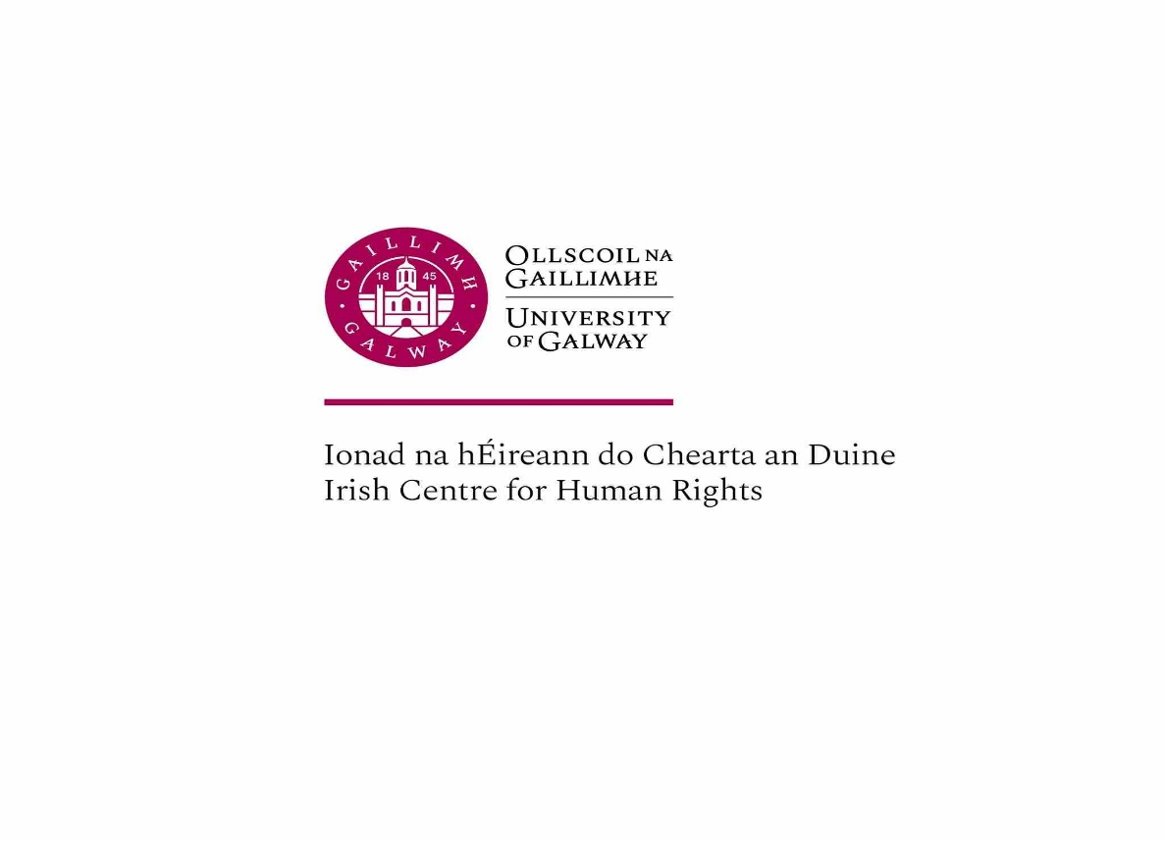
INTERNATIONAL CHILD RIGHTS LAW 2025-26
Semester 2
Module coordinator: Professor Siobhán Mullally (Irish Centre for Human Rights, Room 208)
Email: siobhan.mullally@universityofgalway.ie

- Introduction: Children’s Rights in International Law

The rights of the child in international law are often contested, raising questions as to the status of the child as a subject of international law. Historically children were perceived as extensions of their parents or guardians, and intervention by the state or international law into the realm of the family, was considered an unjustified interference into matters properly falling with the private or domestic sphere.
Significant developments in international and regional human rights law, and in the domestic laws of many states, have changed this perception. Most significantly the UN Convention on the Rights of the Child and its Optional Protocols, have extended the protection of children’s rights, including in areas of migration, armed conflict, climate change, cultural rights, and access to justice. The practice of regional human rights bodies, expanding case-law, and new jurisprudence from the UN Committee on the Rights of the Child have all contributed to this rapidly evolving area of international law.
In this module, we will examine the core principles underpinning the UN CRC and its Protocols, and explore current developments and debates at global, regional and national levels.
The module will examine selected topics and issues, to analyse and discuss the limitations of current international and regional human rights law responses to the rights of children.

- Rights of Migrant, Refugee and Stateless Children
- Children, Conflict and Peace building
- Minority Rights and Indigenous Peoples- child rights
- Climate Change and Child Rights
- Child friendly justice / Youth justice
- Selected topics and issues: gender, sexuality and rights; privacy, digital rights

2. Module Learning Objectives
• To understand the theory underlying children’s rights;
• To be able to critically analyse the legal arguments around children’s rights;
• To apply international law on the rights of the child to selected contemporary issues;

- Mode of Study

The module is taught by means of 3 hour seminars, and will include a lecture presentation and class discussion, drawing on analysis of the various international legal documents on child rights and relevant scholarship in the area.
Seminars are of a participatory nature to encourage free exchange of critical views and perspectives.
Please consider the ‘key questions’ posed for each seminar and prepare advance your responses to these questions (perhaps in the form of bullet points), drawing on the assigned readings and legal sources.

- Readings

There is no core text for this module. A range of legal texts and readings will be used. Weekly readings for this module are provided on CANVAS. Please see below recommended introductory readings for this module.

- Assessment
Students will be assessed via an essay of 3,000 words. A list of essay topics will be circulated to students.

Background reading
Faulkner, E. A., & Nyamutata, C. (2020). The Decolonisation of Children’s Rights and the Colonial Contours of the Convention on the Rights of the Child, The International Journal of Children's Rights, 28(1), 66-88. doi: https://doi.org/10.1163/15718182-02801009
Aoife Daly, ‘Climate Competence: Youth Climate Activism and Its Impact on International Human Rights Law’, Human Rights Law Review, Volume 22, Issue 2, June 2022, ngac011, https://doi.org/10.1093/hrlr/ngac011
Nolan A and Kirrily Pells, ‘Children’s Economic and Social Rights and Child Poverty: The State of Play’, International journal of children’s rights, 28 (2020) 111-132
Kravchuk, N. (2021). Privacy as a New Component of “The Best Interests of the Child” in the New Digital Environment, The International Journal of Children's Rights, 29(1), 99-121. doi: https://doi.org/10.1163/15718182-29010006
Yohannes Eneyew Ayalew, Valerie Verdoodt, Eva Lievens, General Comment No. 25 on Children’s Rights in Relation to the Digital Environment: Implications for Children’s Right to Privacy and Data Protection in Africa, Human Rights Law Review, Volume 24, Issue 3, September 2024, ngae018, https://doi.org/10.1093/hrlr/ngae018
Stoffel ‘Children: a Blind Sport of Peace and Security’ (18 November 2020) https://www.policycorner.org/en/2020/11/18/children-a-blind-spot-of-peace-and-security/
Fionnuala Ní Aoláin, The Limits of Equality and Gender Discourses in Counter-Terrorism: The Case of Women and Children in Syria and Iraq, 29 Minn. J. Int'l L. 7 (2020), available at https://scholarship.law.umn.edu/faculty_articles/694
Wagner, K., Bartels, S.A., Weber, S. et al. UNsupported: The Needs and Rights of Children Fathered by UN Peacekeepers in the Democratic Republic of Congo. Hum Rights Rev 23, 305–332 (2022). https://doi.org/10.1007/s12142-021-00652-y
Chapter 1: Jaap E. Doek, ‘The Human Rights of Children: An Introduction’ pp 3-30 in International Human Rights of Children (Kilkelly and Liefaard, eds.) (Springer 2019)
Karl Hanson and Laura Lundy, ‘Does Exactly What it Says on the Tin? A Critical Analysis and Alternative Conceptualisation of the So-called “General Principles” of the Convention on the Rights of the Child’ 25 (2017) International Journal of Children’s Rights, pp 285-306

