Speaker Biographies

Adrian Carroll - is Senior Policy Officer with AsIAm, where he leads policy development, government engagement, and cross-sector collaboration to advance the rights of Autistic people in Ireland. Since joining AsIAm in 2019, he has worked across training, policy, and advocacy initiatives, including submissions, consultations, and monitoring Ireland’s commitments under the UNCRPD, drawing from his personal and professional experience. Adrian holds degrees in Law and from the University of Limerick and an LLM in International and Comparative Disability Law and Policy from the University of Galway. His research focused on how the UNCRPD and Assistive Technology can bridge the gap between education and employment for Disabled people with cognitive disabilities. Originally from Killarney, he previously worked in stagiaire traineeship at Inclusion Europe in Brussels, has served on the Irish Human Rights and Equality Commission Disability Advisory Committee and currently serves on the National Disability Authority.



Senator Dr Tom Clonan is an Independent Senator elected to Seanad Eireann, Dublin University, Trinity College Dublin Panel. Senator Tom Clonan is an academic, writer and Journalist. He is an Independent Security Analyst and provides defence and intelligence analysis for international broadcasters. As an Army Officer, (Captain) Tom has direct experience of armed conflict in Ireland the Middle East and former Yugoslavia. One of Ireland’s foremost Whistleblowers, his PhD revealed shocking levels of sexual violence within Ireland’s armed forces. He provides consultancy on gender-based discrimination and gender-based violence. Tom is one of Ireland’s leading public advocates for citizens with Disabilities. He is a parent of four children and is carer for his son Eoghan who suffers from a rare neuro-muscular disease. Tom has been Chairman and Board Member of Dogs for the Disabled (Ireland). He is Chairman of the Board of Dance Theatre Company, Junk Ensemble and an author of two books, Blood, Sweat and Tears, 2012 (Liberties Press) and Whistleblower, Soldier, Spy (2013)
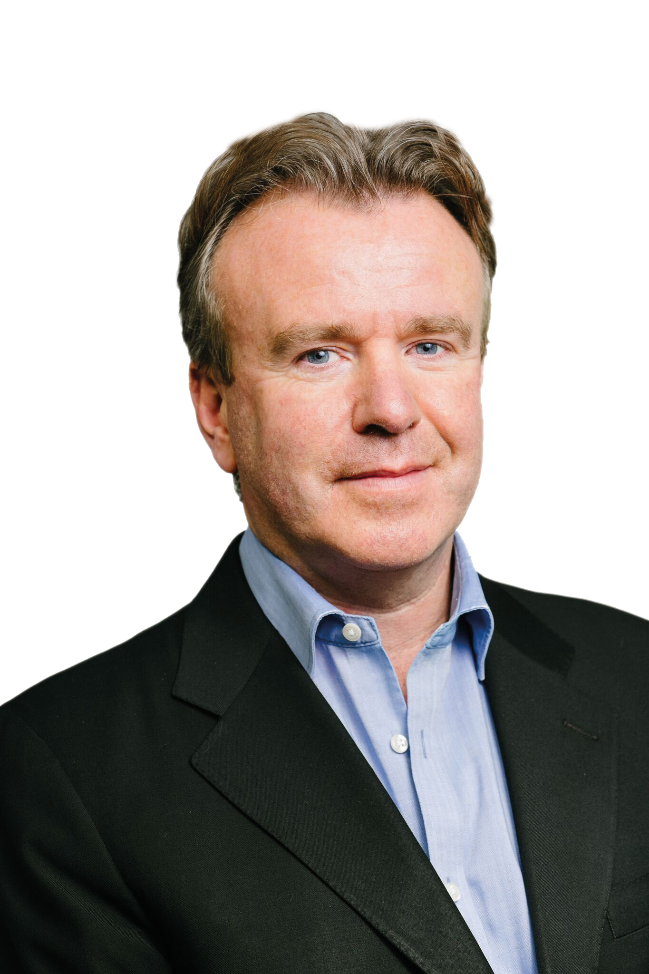

Ciarán Finlay is a Senior Policy & Public Affairs Advisor at the National Disability Authority. In this role, he leads the agency’s policy work on justice, equality and capacity matters, political participation, and international instruments. Ciarán has previously worked with the Permanent Missions of Ireland to the United Nations in both New York and Geneva during Ireland’s most recent terms of membership of the UN Security Council and UN Human Rights Council. A qualified barrister, he has also held legal and policy roles with the Irish Human Rights and Equality Commission, Free Legal Advice Centres (FLAC) and UNHCR Ireland. Dr Deirdre Mc Hugh (She/her), Universal Design Manager, Office of the Vice-President for EDI, University of Galway

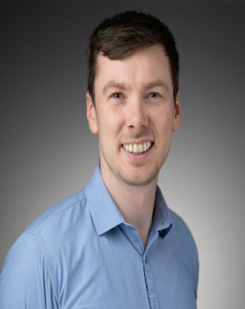

Prof Eilionóir Flynn is an Established Chair in Law and Director of the Centre for Disability Law and Policy at the University of Galway. Her research focuses on disability and social justice, with a particular emphasis on legal capacity, advocacy and access to justice. Her first book, “From Rhetoric to Action: Implementing the UN Convention on the Rights of Persons with Disabilities” was published by Cambridge University Press in 2011) and since then she has gone on to publish extensively in the domain of disability rights. Eilionóir was the Scientific Co-ordinator of the Disability Advocacy Research in Europe (DARE) Marie Curie Training Network, made up of 15 PhD researchers across seven European countries. Her work has attracted significant research funding, including a Starting Grant from the European Research Council, and an Investigator Award from Wellcome Trust. She has acted as a board member and advisor in a range of local, national and international bodies working on the rights of disabled people, and regularly advises policy-makers at national and international levels, including providing support to the Secretariat of the UN Committee on the Rights of Persons with Disabilities, and in particular the working group which developed General Comment 1.

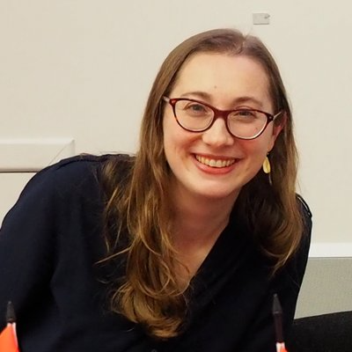

Prof Mary Keogh is an Adjunct Professor at the School of Law, University of Galway, as well as an international disability rights scholar and practitioner with more than two decades of experience. Dr. Mary Keogh is Advocacy Director at CBM Global Disability Inclusion and Chair of the International Disability and Development Consortium (IDDC), a global network of leading NGOs advancing inclusive development and humanitarian action. She has over 20 years’ experience in international policy, advocacy, and research on disability rights and disability-inclusive development, working with organisations including the United Nations, World Bank, European Commission, and CBM. A PhD graduate in Disability Law and Public Policy from University of Galway, Dr. Keogh has led major global advocacy initiatives on disability rights, gender equality, climate justice, and inclusive development. She has served on multiple national and international boards and is widely recognised for her leadership in shaping disability-inclusive policy and practice worldwide.

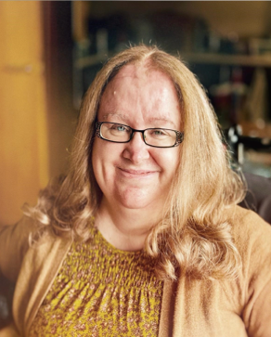

Professor Anna Lawson, who is blind, co-directs the Centre for Law and Social Justice at the University of Leeds and co-directed the Centre for Disability Studies from 2015-2023. Her work focuses on disability equality and human rights at international, European, national and local levels. She has led a range of multinational research projects on disability rights and justice, including a European Research Council Advanced Grant on Inclusive Public Space. Anna regularly works closely with inter-governmental organisations, national governments and local government. She is an active member of a range of disabled people’s organisations and the patron of the UK National Association of Disabled Staff Networks. Anna is one of the founding editors of the new Hart Series on Disability, Law and Justice, and Fellow of the British Academy and the Academy of Social Sciences. In recognition of her work on disability equality, she was awarded the international Bob Hepple Memorial Prize by the Equal Rights Trust and Industrial Law Society in 2016.

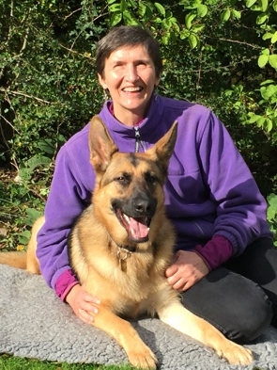

Dr Deirdre Mc Hugh is the Universal Design Manager and Access Officer at the University of Galway and is based in the Office of the Vice-President for Equality, Diversity and Inclusion. Her recent work on Universal Design (UD) of the built environment, her background in educational development, and over a decade of experience as a university teacher, give her key insights into how accessibility barriers can impact learning. Collaboration is central to Deirdre’s work, and she has worked with colleagues and students across units and functions in her home institution on a range of projects to improve accessibility and embed UD, and on national projects, including the development of the ALTITUDE Charter for UD in Tertiary Education. Her work is informed by the lived experience of students, colleagues and members of the public who experience barriers to accessibility and inclusion. She has presented her work at international conferences, including UD2024 and the European Access Network (EAN) Conference 2024. She was the conference lead on the EAN 2025 Conference, hosted by University of Galway in June 2025.
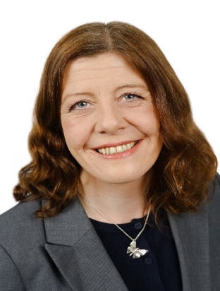

Derval McDonagh is the CEO of Inclusion Ireland and a life time ally of people with an intellectual disability and their families. Having qualified originally as a speech and language therapist, Derval has a particular interest in the role of accessible information in accessing human rights. She has campaigned extensively for more inclusive schools, communities and workplaces through the lens of human rights, equality and belonging. She simply believes that our society is better when everyone has their rights respected and is included and valued. Derval is also the chairperson of the Irish Penal Reform Trust, working towards a fairer justice system in Ireland and a Director at LINQ Ireland.

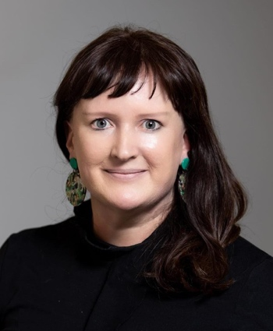

Dr Karen Murphy currently works with the Irish Human Rights and Equality Commission, with a specific focus on IHREC’s role as the Independent Monitoring Mechanism under the UN Convention on the Rights of Persons with Disabilities. Karen has worked in the field of human rights protection for two decades and previously worked on women’s empowerment, protection of human rights in emergency and insecure contexts and international development with international NGOs and multilateral agencies in Ireland and globally. Karen was awarded a PhD in Politics and Int’l Relations from University College Dublin and an LLM in International Human Rights from the University of Galway.



Dr Charles O’Mahony is an Associate Professor at the University of Galway’s School of Law, specialising in disability and mental health law and policy. His research is grounded in the UN Convention on the Rights of Persons with Disabilities (CRPD), focusing on identifying legal and policy gaps and proposing reforms aligned with international human rights standards. At the University of Galway, Charles teaches across law, nursing, and arts programmes. He has published widely in leading journals such as the International Journal of Law and Psychiatry, Industrial Law Journal, Northern Ireland Legal Quarterly, and the International Journal of Law, Crime and Justice. Charles served as Head of the School of Law (2017–2021). He holds a PhD from the Centre for Disability Law and Policy at the University of Galway, where his thesis examined legal responses to defendants and offenders with mental health issues and intellectual disabilities.

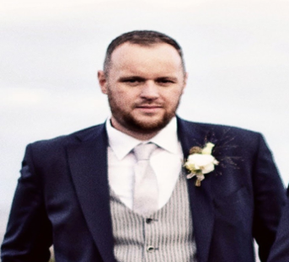

Dr. Shivaun Quinlivan is Associate Professor at the School of Law, University of Galway. Her research focuses on gender and disability discrimination with a particular focus on educational equality, see De Beco, G., Quinlivan, S., & Lord, J. (Eds.) (2019) The Right to Inclusive Education in International Human Rights Law: Cambridge University Press. She is an active member of the Berkeley Center on Comparative Equality and Anti-Discrimination Law. Dr Quinlivan's pedagogical research addresses equality, diversity and inclusion in higher education. She has co-led a number of funded research projects on inclusive learning, one of which received a SATLE Impact Award from the Higher Education Authority in 2024. From 2018-2020, Dr. Quinlivan acted as an expert advisor to the States of Guernsey in relation to the development of new multi-ground equality legislation, legislation that was adopted in 2022. In 2016 Dr Quinlivan, was awarded an O'Brien Residential Fellowship and has completed a period in residence in the Centre for Human Rights and Legal Pluralism, Faculty of Law, McGill University, Canada. Shivaun was the first Vice Dean for Equality, Diversity and Inclusion in the College of Business, Public Policy and Law (2018-2022). Dr Quinlivan coordinated the establishment of the LLM in International and Comparative Disability Law and Policy, for which she was the Programme Director from 2010-2016.

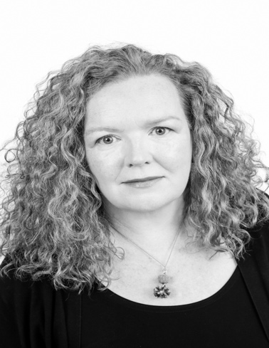
Conference Schedule

The Disability Act 2005 at 20: Reflecting and Reforming

3rd of December 2025, 9:30am to 4:00pm, ILAS Building,
University of Galway

09:30 – 10:00 | Registration

10:00-10:10 / Welcome

10:10– 10:40 | Presentation of Survey Findings
“The Disability Act at 20: Stakeholder Reflections and Future Directions”
Dr. Shivaun Quinlivan and Dr. Charles O’Mahony

10:40– 11:20 | Keynote Address / Prof. Anna Lawson
“Disability Law at a Crossroads: International and EU Perspectives”
Prof. Anna Lawson, School of Law, University of Leeds

11:20 – 11:35 | Coffee Break

11:40 – 13:10 | Roundtable 1: The Disability Act in Practice (Chair: Prof Mary Keogh)
Contributions from Derval McDonagh (Inclusion Ireland), Senator Tom Clonan, Dr. Dr Deirdre McHugh.

13:10 – 14:00 | Lunch

14:00 – 15:30 | Roundtable 2: Disability Rights and Policy Directions (Chair: Prof. Eilionóir Flynn)
Contributions from members of the Karen Murphy (IHREC), Ciaran Finlay (NDA), Adrian Carroll (AsIAm), Prof Mary Keogh.

15:30 -15:50| Key priorities for the review of the Disability act 2005
Derval McDonagh (Inclusion Ireland)

15:50 – 16:00 | Conference Rapporteur
Prof Mary Keogh.

