The Disability Act 2005 at 21: Reflecting, Reforming, Reimagining

Lived Experiences, Rights and Reform Priorities for the Disability Act 2005 at Twenty-One Years

Professor Shivaun Quinlivan & Dr Charles O’Mahony

May 2026

Table of Contents
Acknowledgements 5
Chapter 1 Introduction: The Disability Act 2005 at 20 – Context, Commitments and the Case for Reform 6
1. A Moment for Reflection and Reimagination 6
2. Purpose and Scope 6
3. Methodology and Participatory Design 6
4. Limits of Research 7
5. The Architecture of the Disability Act 2005 8
6. The European and International Context 8
7. Structure of the Report 9
Chapter 2 The Disability Act 2005 in Context: Origins, Purposes and Evolving Understandings 10
1. Introduction 10
2. Commission on the Status of People with Disabilities 10
3. Disability Bill 2001 11
4. Disability Legislative Consultation Group (DLCG) 12
5. Disability Bill 2004 13
6. General concerns relating to the Act 14
7. The assessment of needs (AON) process in action 15
7.1 Assessment 15
7.2 Assessment / Standard Operating Procedure 16
7.3 Statutory appeals process 17
7.4 Discussion of the cases 17
8. Programme for Government: Securing Ireland’s Future 18
9. External triggers 18
10. Disability (Amendment) Bill 2025 19
11. Conclusion 22
Chapter 3 Disability Rights and the Review of the Disability Act 2005: Findings from the National Survey 23
1. Overview of this Chapter 23
2. Survey Design and Scope 23
3. Section 1 of the Survey: General Information 24
4. Section 2 of the Survey: General Questions on the Disability Act 2005 25
Qualitative Analysis of Open-Ended Responses: Responses on the Disability Act 2005 28
5. Section 3 of the Survey: Assessment of Need (AON) 31
Qualitative Analysis of Open-Ended Responses: Responses on the Assessment of Need Process 34
6. Section 4 of the Survey: Accessibility under the Disability Act 2005 37
Qualitative Analysis of Open-Ended Responses: Responses on the Access Officer role under the Disability Act 2005 38
7. Section 5 of the Survey: Enforcement and Implementation of the Disability Act 2005 41
Qualitative Analysis of Open-Ended Responses: Responses on the Implementation and Enforcement of the Disability Act 2005 44
8. Section 6 of the Survey: Other Parts of the Disability Act 2005 47
Qualitative Analysis of Open-Ended Responses: Responses on Genetic Testing Provisions 48
Qualitative Analysis of Open-Ended Responses: Responses on Public Sector Employment Quotas 49
Qualitative Analysis of Open-Ended Responses: Responses on the Centre for Excellence in Universal Design 53
9. Section 7 of the Survey: International and European Perspectives 55
Qualitative Analysis of Open-Ended Responses: Responses on Aligning the Disability Act 2005 with the United Nations Convention on the Rights of Persons with Disabilities (CRPD). 56
Qualitative Analysis of Open-Ended Responses: Responses on the Role of the EU in Advancing Disability Rights 58
10. Section 8 of the Survey: Review and Reform of the Disability Act 2005 61
Qualitative Analysis of Open-Ended Responses: What Role Should Disabled People Play in the Review of the Disability Act 2005? 62
Qualitative Analysis of Open-Ended Responses: Final Comments on the Review of the Disability Act 2005 64
11. Conclusion 66
Chapter 4: The Disability Act 2005 at 20: Report of the National Conference and Key Reform Themes 68
1. Introduction 68
2. Opening Reflections: Legislative Memory, Legislative Compromise and Structural Gaps 69
3. National Survey Findings 71
4. Key Note Address Professor Anna Lawson 71
4.1 Discussion Following the Keynote 73
5. Roundtable 1: The Disability Act in Practice 73
Derval McDonagh: Re-imagining Disability Law from the Ground Up 74
Senator Tom Clonan: Personal Experience and Structural Resistance 74
Dr Deirdre McHugh: Universal Design and Institutional Practice 75
5.1 Audience Led Discussion 75
6. Roundtable 2: Disability Rights and Policy Directions (Chair: Professor Eilionóir Flynn) 77
Dr Karen Murphy: Aligning Domestic Reform with the Human Rights Model of Disability 77
Ciaran Finlay: Legislative Coherence and Structural Reform 77
Adrian Carroll: Enforceability and the Consequences of Legal Gaps 78
Professor Mary Keogh: Political Will, Co-Creation and Movement Building 78
6.1 Audience Led Discussion 79
7. Closing Address: Derval McDonagh, Chief Executive Officer, Inclusion Ireland: Re-imagining Ireland Through Enforceable Rights and Collective Action 80
8. Conclusion: From Reflection to Structural Transformation 82
Chapter 5: Conclusions & Priorities for the Review, Reform and Reimaging of the Disability Act 2005 84
1. Twenty Years On 84
2 Key Findings Across the Chapters 84
2.1 The Assessment of Need: A Right Without a Remedy 84
2.2 Accessibility: Progress Without Effective Enforcement 84
2.3 Employment Targets: Symbolic Commitment, Limited Transformation 85
2.4 Genetic Testing: A Forward-Looking but Underdeveloped Safeguard 85
2.5 Enforcement: The Structural Weakness 85
5.3 The European and International Dimension 85
5.4 From Welfare Architecture to Rights Architecture 86
5.5 Recommendations for Legislative Reform 86
5.6 Process of Reform 87
5.7 Final Comments: Reflecting, Reforming, Reimaging 88

Acknowledgements

This report arises from the national conference marking twenty years of the Disability Act 2005, held at the University of Galway on the 3rd of December 2025. The conference formed part of the project “Disability Rights and the Disability Act 2005 at 20: Ireland, the EU, and the Future of Disability Law & Policy”. We gratefully acknowledge the generous support of the Department of Foreign Affairs under the Communicating Europe Initiative. This funding made possible both the organisation of the conference and the preparation of this report. We extend our sincere thanks to our colleague Lorna Cormican for her invaluable assistance in organising the conference. Her professionalism, care, and attention to accessibility and logistics were central to the success of the event.

We are deeply grateful to all of the speakers, chairs and panellists who participated in the conference and whose insights form the substance of this report. We wish to record a particular note of appreciation to Professor Anna Lawson, who delivered the keynote address. Her thoughtful and incisive reflections situated the review of the Disability Act 2005 within a broader international and comparative context, setting an important tone for the conference and for the reform discussions that followed and which informed this report. We would also like to thank Adrian Carroll (AsIAm), Senator Tom Clonan, Ciaran Finlay (National Disability Authority), Professor Eilionóir Flynn (University of Galway), Professor Mary Keogh (CBM Global), Dr Deirdre McHugh (University of Galway), Dr Karen Murphy (Irish Human Rights and Equality Commission) and Derval McDonagh (Inclusion Ireland), who brought critical policy, advocacy and lived experience perspectives to the roundtable sessions. Their expertise, candour and engagement greatly enriched the day’s deliberations and are reflected throughout this report.

We are also grateful to all those who took the time to respond to the national survey conducted as part of this project. The 156 responses received provided invaluable insights into lived experience, policy implementation and priorities for reform. We are thankful also to those who provided formative feedback during the development of the survey questions, whose constructive input helped us refine its scope, clarity and focus prior to national dissemination. We are appreciative of the outstanding expertise and experience shared both at the conference and through the survey process, and we have sought throughout this report to do justice to the depth, nuance and critical insight reflected in those contributions, particularly in light of the Government’s commitment to review and reform the Disability Act 2005.

Professor Shivaun Quinlivan & Dr Charles O’Mahony
School of Law, University of Galway

This report reflects the law, policy, research, and publicly available information available to the authors up to the 28th of March2026. Developments after this date are not reflected in the analysis or recommendations contained in this report.

Chapter 1 Introduction: The Disability Act 2005 at 20 – Context, Commitments and the Case for Reform

A Moment for Reflection and Reimagination

The Disability Act 2005 was enacted as a landmark statute. It was presented as a decisive step in modernising Ireland’s disability framework and as a move towards greater legal structure, accountability and inclusion. For many, it symbolised a shift away from informal, discretionary provision towards a more rights-conscious model. Twenty years later, it is both legitimate and necessary to ask a direct question: has the Act delivered what it promised? This report is written at a moment of renewed political attention. The current Programme for Government commits to reform of the Disability Act 2005 in consultation with stakeholders. Since the Act’s enactment, Ireland has ratified the United Nations CRPD (hereafter the CRPD). The European Union has likewise acceded to the Convention. European disability policy has evolved. Domestic equality anti-discrimination law has matured and the expectations disabled people have changed. The legal environment in 2025 is not the environment of 2005.

This report proceeds on the basis that twenty years is not an anniversary. It is a moment for reflecting, reforming and reimagining.

Purpose and Scope

This report has three interrelated purposes. First, it documents stakeholder perspectives on the operation of the Disability Act 2005 after two decades of implementation. Those perspectives include the lived experience of disabled people and their families, the views of advocates and service providers, and reflections from legal and policy experts. Second, it analyses the architecture and operation of the Act in light of contemporary disability rights standards, particularly those articulated in the CRPD. The Convention reframes disability as a matter of equality, autonomy, participation and structural inclusion. Domestic law must now be assessed against that framework and Ireland’s ratification of the CRPD. Third, this report identifies priorities for legislative reform based on the evidence gathered across the three core components of the project: a structured literature review and legal analysis, the national conference proceedings including audience discussion, and the national survey. The reform proposals are therefore grounded in doctrinal analysis, deliberative engagement and empirical data.

This research forms part of a project supported under the Department of Foreign Affairs’ Communicating Europe Initiative 2025. In line with the 2025 theme, “The EU as a catalyst for change”, the report explicitly situates the Disability Act 2005 within its European context. The 2005 Act does not operate in isolation. It sits within a broader framework shaped by EU equality law, accessibility standards, and the joint ratification of the CRPD by Ireland and the European Union.

Methodology and Participatory Design

This report draws on three sources of evidence: a structured review of the relevant legal and policy literature (Chapter 2), a national survey on the operation of the Disability Act 2005 (Chapter 3), and discussions held at a national conference marking the Act’s twentieth anniversary (Chapter 4). As part of this research, the Disability Act 2005 was examined in detail, including its original purpose, how it has operated in practice, and how it fits alongside other Irish legislation and Ireland’s international obligations. This legal review helps explain the strengths and limitations identified in the survey and conference discussions.

A national survey was also developed to gather structured stakeholder perspectives on the operation of the Act. The survey was organised around eight sections reflecting both the structure of the Disability Act 2005 and the broader reform debate. These addressed general information and perspectives, general questions on the Act, Assessment of Need, accessibility, enforcement and implementation, other specific parts of the Act including genetic testing, public service employment and Universal Design, international and European perspectives, and finally review and reform priorities. The survey combined quantitative questions with open-ended qualitative questions. This allowed respondents not only to rate aspects of the Act but to explain their experiences in their own words. The survey was open to disabled people, family members, advocates, service providers, practitioners, academics and policymakers. Responses were anonymised. Qualitative responses were analysed using a structured thematic approach. This involved systematic coding of responses to identify recurring patterns, areas of consensus and points of tension. The purpose was to identify structural themes emerging across multiple responses to open ended questions.

In addition to the survey, a national conference entitled The Disability Act at 20: Reflecting and Reforming was organised at the University of Galway on the 3rd of December 2025. The conference brought together disabled people and their representative organisations, policymakers, legal practitioners, academics and international experts etc. Structured roundtable discussions were used to facilitate focused deliberation on key reform themes. The conference was live captioned and a full transcript was provided by the captioning service. This transcript was reviewed in detail and used to prepare a structured conference report. The report identifies the principal points raised by speakers and reflects the substance of the audience discussion. It does not present a formal thematic analysis, but rather an accurate account of the key issues and reform priorities articulated during the conference.

Accessibility was a central consideration in the design and delivery of this project. The survey was hosted on MS Forms, which is compatible with screen readers, and was made available in accessible digital formats. An easy-to-read version of the survey was developed to support wider participation. The researchers were available to assist participants who required support in completing the survey, and the deadline was extended to maximise opportunities for engagement. The national conference was held in an accessible venue and included live captioning. Irish Sign Language interpretation was arranged in advance; however, due to a late withdrawal by the provider, ISL interpretation was unfortunately not available on the day. While this was beyond the organisers’ control, it was regrettable. Efforts were made to facilitate inclusive participation through live captioning and maximise the time allocated for audience discussion.

Limits of Research

The methodology integrated legal analysis with lived experience. This project was conducted within a defined timeframe associated with the Communicating Europe Initiative funding cycle and in anticipation of the Government’s forthcoming review of the Disability Act 2005. The research was therefore carried out over a relatively concentrated period.

The national survey was open and voluntary in nature. While it generated rich and detailed responses, it does not constitute a statistically representative sample of all disabled people or stakeholders. The findings reflect the views of those who chose to participate. Similarly, the conference brought together a wide range of contributors, but it does not capture every perspective within the disability community or across the public policy spectrum. The conference report reflects the principal points raised during the event, rather than a comprehensive qualitative study. These limitations shape the scope and depth of engagement possible. However, they do not diminish the value of the evidence gathered. The consistency of themes across the literature review, survey responses and conference discussions provides a useful basis for identifying recurring structural issues with the 2005 Act. This report does not claim to be exhaustive. It seeks to provide a structured and evidence-informed contribution to an ongoing national conversation, informed by legal analysis, and capture the perspectives of people with lived experience of the Act and a broad range of stakeholder. This research project was designed to inform the current reform process.

The Architecture of the Disability Act 2005

The Disability Act 2005 contains a number of distinct components. Part 2 provides for Assessment of Need and Service Statements. It establishes a process through which a person may have their needs assessed and receive a statement outlining services to be provided. Part 3 addresses access to public buildings and services and requires the preparation of sectoral plans across specified government departments. Part 4 regulates genetic testing. Part 5 sets targets for the employment of persons with disabilities in the public service. Part 6 establishes the Centre for Excellence in Universal Design. The Act combines individual procedures, administrative duties and institutional provisions. It does not create a general enforceable right to disability-related services. It relies heavily on procedural mechanisms and administrative compliance. Understanding this architecture is essential. Many of the concerns expressed by respondents relate not to isolated implementation failures but to the structural design of the Act itself.

The European and International Context

Disability law reform in Ireland cannot be understood in isolation from its European and international context. EU equality law, particularly the Employment Equality Framework Directive 2000/78/EC, has shaped Ireland’s anti-discrimination framework. EU accessibility initiatives and disability strategies have further influenced policy development. The joint ratification of the CRPD by Ireland and the European Union reinforces the obligation to ensure domestic law aligns with Convention standards. The Communicating Europe Initiative project underpinning this report reflects the recognition that the European Union acts not only as a legislative actor but as a catalyst for rights-based reform. Therefore, reform of the Disability Act 2005 must therefore be understood as part of Ireland’s engagement with shared European and international commitments.

Structure of the Report

This report is structured to support engagement with the forthcoming review of the Disability Act 2005. It moves from context, to evidence, to synthesis and reform priorities in a way designed to be useful to disabled people, Disabled Persons’ Organisations, policymakers and others participating in the reform process. The aim is to provide some analysis of the Act, but we also seeks to provide a clear and accessible evidence base to inform the next phase of legislative development.

Chapter 2 situates the Disability Act 2005 in its historical and legislative context. It examines the origins and stated purposes of the Act and traces the evolution of disability law from a welfare and service-based model towards a human rights framework. This chapter provides the conceptual and legal foundation for the analysis that follows.

Chapter 3 presents the findings of the national survey. It follows the structure of the survey instrument itself, examining each of the eight sections in turn. Quantitative findings are presented alongside qualitative responses, with structured analysis of open-ended comments addressing Assessment of Need, accessibility, enforcement and implementation, genetic testing, public sector employment, Universal Design, international and European perspectives, and priorities for reform. This chapter provides the core empirical evidence informing the report.

Chapter 4 documents the national conference held to mark twenty years of the Act. It provides a structured account of keynote contributions, roundtable discussions and audience engagement. The chapter identifies recurring reform themes emerging from these deliberations and situates them alongside the survey findings.

Chapter 5 draws together the evidence from the literature review, the national survey and the conference proceedings. It identifies priority areas for reform and outlines key considerations for the forthcoming review of the Disability Act 2005. The focus is on structural issues, including enforceability, accountability, participation and alignment with contemporary human rights standards.

Chapter 2 The Disability Act 2005 in Context: Origins, Purposes and Evolving Understandings

1. Introduction

The Disability Act 2005 was enacted at a key moment in the development of Irish disability policy. The late 1990s and early 2000s marked a period of significant reflection on the State’s historical treatment of disabled people, driven largely by the Commission on the Status of People with Disabilities and by the growing influence of equality law, international human rights standards, and public policy developments in other jurisdictions. The 2005 Act emerged within this context as the key legislative measure intended to provide a statutory basis for key supports, accessibility requirements, and institutional structures that would give practical expression to a rights-based approach. This chapter will address the relevant recommendations of the Commission on the Status of People with Disabilities, the history of the introduction of the Disability Act 2005, including a brief review of its failed predecessor the Disability Bill 2001, further this analysis will address the concerns that were raised at the time of the introduction of the Disability Act. Finally the chapter will highlight the ongoing issues with the Disability Act, with a particular focus on the controversial assessment of need process (AON), the commitment to reform the Act and what ought to influence any such reform.

2. Commission on the Status of People with Disabilities

A Disability Act was first proposed in the 1996 report of the Commission on the Status of People with Disabilities: A Strategy for Equality. The Commission on the Status of People with Disabilities (hereafter the Commission) report was ambitious in its scope addressing the full life cycle of people with disabilities and making over 400 recommendations for change. The report received all party support and provided a blueprint for disability law reform in Ireland. Recommendation number 9 stated:

“A Disabilities Act should be introduced which sets out the rights of people with disabilities and means of redress for those whose rights are denied. The Act should outlaw all discrimination against people with disabilities and should require public and private bodies, employers and educators to make reasonable accommodation to meet their specific needs.”

The Act proposed by the Commission was rights based, provided for a system of redress. The Commission provided that “legislation is only as good as its enforcement mechanism.” The Commission envisaged a Disability Act along the lines of the Americans with Disability Act 1990 the Disability Discrimination Act 1992 (Australia), the Disability Discrimination Act 1995 (UK), or the Law for the Care, Social Integration and Rights of People with Disabilities 1992 (Italy) as well as international agreements and human rights principles. The common theme of these Acts is a comprehensive, enforceable, anti-discrimination statute.

While discussions of a Disability Bill were commencing, the Employment Equality Bill and the Equal Status Bills were progressing through the Oireachtas. These bills addressed some, but not all aspects of the Commission proposed Disability Act. Therefore, the proposed Disability Act was to address those areas not already addressed in the Employment Equality Act and the Equal Status Act. As noted by the Commission, a significant issue for people with disabilities, was the fact that:

“… supports and services for people with disabilities are poorly co-ordinated. People with disabilities and their families have great difficulty and experience serious frustration getting information about their entitlement and accessing these from the multiplicity of agencies which are involved in undertaking assessments and providing services.”

Therefore the Disability Act, was to address issues such as access to the built environment, and access to services both public and private.

3. Disability Bill 2001

The first attempt to legislate for a Disability Act was ultimately withdrawn. The Disability Bill 2001 was widely criticised on its publication. The criticism centred primarily on the segregationist stance of the Bill, as epitomised by s.3(1)(b)(ii) which provided that separate access may be provided where common access “is not necessary for the benefit of persons with disabilities.” The presumption contained in sections like this was not based on the concepts of inclusion or equal participation. A second and more fundamental issue was the failure to introduce rights-based legislation and more importantly the attempt to ensure that there was no recourse to the courts. Section 47 of the bill provided, that nothing in the Act shall:

“(a) confer a right of action in any civil proceedings by reason only of a failure by a public body to comply with any duty imposed on it under this Act …”

It was as though failure to comply with the Act was anticipated, reflecting the unsatisfactory status quo. The failure to address the fundamental frustration of parents and people with disabilities, namely access to services with redress resulted in significant opposition to the Bill. The express prohibition on litigation contained in section 47 also received international criticism. The United Nations Committee on Economic, Social and Cultural Rights, stated:

“The Committee regrets that the Disability Bill does not adopt a human rights-based approach, as recommended in its previous concluding observations. Moreover, the Committee regrets that section 47 of the Disability Bill contains a clause purporting to remove the rights of people with disabilities to seek judicial redress if any of the Bill’s provisions are not carried out.”

The then Government withdrew the Disability Bill 2001 and agreed to enter into a process of consultation with the disability sector.

4. Disability Legislative Consultation Group (DLCG)

This led to the creation of the Disability Legislative Consultation Group (DLCG) a government appointed group. The consultation took place over a two and a half year time frame. In 2003, the DLCG produced their report on the Disability Act entitled Equal Citizens-Core Elements of Disability Legislation. In this report, the DLCG proposed that the Disability Act contain: a broad definition of disability; independent needs assessment and service coordination; advocacy; mainstreaming; accessibility; disability awareness; public service employment; implementation and monitoring; review procedures; complaints mechanisms and enforcement and remedies. Minister Fahey suggested that the Disability Bill of 2004 was drafted to take account of proposals in Equal Citizens, stating that it reflected “several important elements” sought by the DLCG and later agreed by cabinet. At this time, the Disability Bill 2004 was introduced as part of a highly publicised disability strategy. The strategy had four distinct elements, the Disability Bill was one element, the other three elements consisted of the Comhairle (Amendment) Bill 2004, six outline sectoral plans and a multi-annual investment programme.

The Disability Bill of 2004 was subject to significant criticism upon publication. One concern raised related to the status of consultation, if those consulted with are ignored. The DLCG raised concerns that the Bill produced did not reflect their joint consultations, highlighting ‘ten fundamental flaws’ with the Disability Bill. Among concerns raised were the fact that the definition of “disability” was too narrow, that it did not provide a clear right to an independent assessment of need, that there was no right to progressive realisation of their unmet needs, the complaint system was too complex and lacked independence. While some progress was made on the issues raised by the DLCG, many issues remained outstanding. The DLCG subsequently publicised what became known as the “five key concerns” in relation to the Bill. They contended that for the Bill to impact positively on the lives of people with disabilities in Ireland, progress must be made on these five key concerns.

The five key concerns were: 1. That there is a clear and unequivocal right to an assessment of needs which is not resource dependent: 2. That the services identified in the assessment of an individual must be provided within a reasonable and agreed timeframe. In other words provision should be made for the progressive realisation of the needs identified in the assessment report. 3. That the Bill should provide for clear protection of disability-specific resources, in other words the ring-fencing of disability funding. 4. Each Government Department with relevant disability services should provide a sectoral plan. 5. That a clear statutory duty is introduced that required all departments and public bodies to include people with disabilities in their plans and services with appropriate monitoring and accountability.

The DLCG indicated a willingness to compromise moving from the ten fundamental flaws position, to the raising of five key concerns, some of which could be introduced progressively. However, it became evident that the Government would not concede these points, that in turn led to the three significant disability groups withdrawing from the DLCG. The groups concerned concluded that their only choice was to end their cooperation with the Bill. Commentators at that time raised the valid concern about the purpose of consultation “if the voices and recommendations of those consulted are ignored?”

5. Disability Bill 2004

Minister Fahey described the Bill as:

“… a positive action measure comprising a number of distinct initiatives, which, taken together, will lead over time to a sustained improvement in the lives of people with disabilities.”

While the Act was introduced with a fanfare, the reality was it faced significant criticism. The critiques primarily centred around the definition of disability, the scope of the Act, the lack of enforceable rights, enforcement more broadly. The Government parties were clearly unwilling to make concession on these issues, raising concerns that rights based legislation would result in significant legal costs and highlighting the delays associated with litigation. The Government’s position was that the Bill established “a fair, person-centred system for complaint and appeal that will give real results relatively quickly and informally.” The fact that the Bill contained no clause that prohibited litigation was stressed as important. Deputy Kelleher summed up the Government’s opposition to the introduction of rights based legislation, which was twofold, in the first instance the concerns about the costs of court actions coupled with a separation of powers argument, namely that the expenditure of state monies or resources is quintessentially a function of the legislature. Deputy Kelleher stated:

“The Government is elected and it is in this Parliament that decisions must be made regarding the disbursal of revenue. No group is more entitled than the disability sector. Equally, nobody should head for the Four Courts to access their rights. That would result in diminishing the available resources and the State would be continually in the courts denying people their rights because those rights are resource based. The State would end up paying huge legal bills to solicitors and individuals. At the same time the rights of people who do not go to court would be diminished. Rights based legislation would deny the rights of people who, for various reasons, do not want to access the courts.”

It is clear that for many, after the failed Disability Bill 2001, there was an assumption that the Disability Bill 2004 would be rights based. Deputy McHugh stated:

“… great expectation for the Disability Bill 2004 was that it would be rights based. It was more than expectation because the Government appeared to confirm that it would be rights based. However, it is now very disappointing to find that the promise has not been delivered on.”

The critics of the 2004 Bill, which later became the Disability Act addressed the concerns raised by Government. Senator Burke stated:

“While everyone agrees legislation must take resources into account, the Government has adopted as a scare tactic the argument that a rights-based Bill would lead to a rush to the courts. Can the Minister of State tell the House why, if the Government believes the legislation to be free of warts, it is necessary to block access to the courts? As there would be no rush to the courts if the legislation was adequate, why is the Government's fear such as to demand a caveat which prevents court access?”

This is a consistent point raised throughout the debates, people with disabilities would not be in the courts if the services were provided, the access to courts is a last resort, and it only happens in the context of a consistent failure to provide services. A further point that was raised related to the fact that people with disabilities were merely trying to get equal rights to the rest of the citizens of Ireland. The issues that Disability Bill sought to address, were not issues for the majority of citizens. For example, the majority of citizens already have access to buildings, goods and services, this is not the case for all people with disabilities. The Disability Bill 2004 made several references to the term “as far as is practicable” and as “resources permit” and these terms and phrases gave rise to another significant element of the debate. Deputy Ó'Caoláin stated:

“It is not a rights-based Bill, it is a resource-based Bill. For equal rights to be so heavily circumscribed by the dictates of a Minister for Finance, which is sometimes described as the fourth wealthiest state in the world, is beyond my comprehension.”

6. General concerns relating to the Act

There were a number of specific concerns with elements of the Bill that will be set out here. Under Part 1 of the Bill there were two issues that gave rise to debate. One being the narrow definition of disability, this raised concerns that it would exclude a significant number of individuals. A second concern related to section 5 which sought to limit the provision of resources and the extent of provision under the Bill. The most significant critique arose in relation to Part 2 of the Act. Here the concerns raised related to the assessment of needs, the complaints mechanism, the failure to link the assessment report to the service statement; the failure to progressively realise the identified needs; the appeals mechanism and the failure to have access to courts other than on a point of law. There were many prescient statements made in respect of the assessment of need during the debates. For example Deputy Murphy stated:

“The assessment will establish the need of every disabled person with a direct or binding link to the service statement. All the statement may do is raise expectations because people with disabilities may find resources are not available.”

This concern is reflected in the findings of the 2025 national survey, where a significant proportion of respondents indicated that the Disability Act 2005 has not been effective in protecting the rights of disabled people in practice. As will be seen in Chapter 3 respondents reported delays in service provision following an Assessment of Need and described situations in which recommended services were not delivered due to resource constraints. These findings reinforce the structural gap identified in this chapter between formal statutory recognition and effective realisation.

Part 3 of the Bill related to access to buildings and services and sectoral plans. Part 4 addressed the issue of genetic testing, sections that received support across all parties and groups. Part 5 deals with public service employment, and Pt 6 addressed the establishment of a Centre for Excellence in Universal Design.

7. The assessment of needs (AON) process in action

This part focuses on the case law under the Disability Act. Given that the Assessment of Need is the central and most clearly articulated statutory entitlement under the Disability Act 2005, an examination of the case law arising from Part 2 is essential to understanding how the Act operates in practice and how its sole enforceable right has been interpreted and constrained by the courts.

These cases focus primarily on the assessment of needs (AON) process. Part 2 of the Disability Act 2005 established a statutory right to AON, it was commenced on the 1st of June 2007 in respect of children under five years of age only. As noted by Collins J in a 2023 Court of Appeal decision, its application was not expanded beyond the under-five cohort until January 2022 some 16½ years after the enactment of the Act. The prolonged delay to full implementation is indicative of ongoing issues with the one enforceable right in the Disability Act. The delay in roll out has had significant practical consequences. Media reports highlight that there are over 20,000 children waiting on AON appointments, reflecting systemic backlogs. Academic literature over the past two decades has highlighted a number of persistent issues within the Disability Act 2005. The case law on the 2005 Act speaks to the limitation of the AON process to children. This does not purport to be an exhaustive assessment of the relevant case law, but a brief overview. A fully comprehensive doctrinal analysis lies beyond the scope of this project. However, it is essential to give a sense of the case law, as they provide the clearest account of how the AON process has been interpreted, implemented and limited in practice, and they are key to understanding both the survey findings and the current reform agenda.

The case law highlight issues with the assessment process, delay, the standard operating procedure, statutory appeals process,

7.1 Assessment

The case of CD v HSE and LE v HSE the challenge relates to the child’s entitlement to have his educational needs assessed as part of the AON. There were issues surrounding the implementation of the assessment of educational needs (AOEN). During the action a deputy principal, one of the teachers involved in the AOEN, set out his concerns in respect of the process which he described as a “box-ticking exercise” with no real engagement with the child’s education needs or the educational services needed to meet those needs. Ms. Justice Bolger criticised the process in her judgment and found it did not meet the requirements laid out in the Disability Act. It is noteworthy that at the outset of the hearing that the HSE and the NCSE decided not to pursue their arguments in relation to delay and the availability of a statutory remedy, which the judge considered wise.

The issue of delay was picked up by the Supreme Court in RY and ZR v HSE where O’Malley J noted that delays were a noticeable and recurring theme in cases that have come to court in respect of the Disability Act. Again noting that the Act itself provides the timelines that are not being complied with. This case focused on the Individual Family Support Plan (IFSP) within children’s disability services as part of the family-centred model. The approach was solidified by the Disability Act. In this case the Supreme Court affirmed that the IFSP must comply with the obligations set out in the Disability Act 2005. O’Malley J noted that this involved setting out and implementing “measurable” actions. The IFSP must ensure it complies with the legislature’s intention to give “enforceable rights” to individuals. To that end O’Malley J stated that the HSE are obliged to specify what services will be provided to children with disabilities and when they will be provided.

7.2 Assessment / Standard Operating Procedure

In CTM v HSE and JA v HSE, the High Court addressed the process of assessment introduced under the standard operating procedure (SOP). The HSE introduced the SOP in January 2020. During the case the HSE clarified that the SOP arose out of concerns that AONs were diverting resources from intervention services. This new process involved a two stage process for the application for AON. This involved a desktop assessment, then a “preliminary team assessment” which would be a 30 minute conversation with the parent and an hour observation of the child at play. The reports did not contain a diagnosis of the child’s disability, it merely stated whether they had one or not.

Phelan J noted that section 8(5) required a blind assessment of the child’s needs without reference to resources. Additionally, that section 8(7) of the Disability Act requires a statement on the nature and extent of a person’s disability. Moreover, in 2007 HIQA had introduced standards for AONs, and required them to be “comprehensive accurate and up to date.” Phelan J applying a literal interpretation of the legislation noted that stating a child had a “substantial restriction” was not a diagnosis as required under the Act. Additionally, Phelan J held that by allowing concerns in respect of the provision of services to affect the assessment process, the HSE was ignoring the “exhortation” in the legislation. The court held that a child with a disability is entitled to have their needs fully assessed under the Act, a point previously supported by the courts. Phelan J also noted that the preliminary assessment did not sit comfortably with the HIQA requirement for a “comprehensive, accurate and up to date” report to be made. An assessment which did not address a child’s specific needs and services was not in compliance with the HIQA requirements, the court said. The court stated:
“It is not permissible for the respondent to hollow out these rights by adopting a SOP which seeks to convert an AON into a preliminary assessment contrary to the requirements of the Act, without the Act being amended.”

This case was appealed to the Court of Appeal. The Court of Appeal upheld the High Court decision and Whelan J stated that the language of the Act was clear and concise. She noted that the “the 2020 SOP, to a very significant extent, undermines the rights of persons with a disability.” While noting that the introduction of the SOP may have been well intentioned, it had in fact placed “very substantial and ultimately impermissible obstacles on the path of the individual attempting to exercise their right to obtain a valid independent assessment of need”.

7.3 Statutory appeals process

The Disability Act provides that a child is entitled to have an assessment of needs within 6 months, followed by a service statement. In the case of J.N. v. Harraghy the child at the centre of this case completed an assessment of needs in June 2018, and was given a date of March 2023 for the provision of the proposed supports. The applicant used the statutory appeals process to challenge the delay and the substance of the service statement. The High Court established that complaints can be made regarding the content of service statements, including the delay in providing services. Additionally, the court held that the Appeals Officer should make their determination in writing and to give reasons for that decision. Finally, in this case the respondent’s argued that the applicant should have challenged the decision by way of judicial review rather than by use of the statutory appeals process. However, the High Court held that the issues were clearly within the jurisdiction vested in the Appeals Officer through section 11(7) of the Act.

7.4 Discussion of the cases

This is not intended to be a comprehensive assessment of all the cases but an overview of the issues that the courts are addressing. There are cases that are not the subject of this report. What is evident in the cases discussed, is that there are issues in relation to access to the AON, delay in respect of the AON, that service statements may be too general, contain further delays. The complaint and appeals process are not always effective. It is of note that the Supreme Court in two different cases have highlighted the necessity for the HSE to comply with the legislation. In RY and ZR v HSE, O’Malley J in noted that the models employed by professionals working with children with disabilities “has gone on developing while the Act has remained essentially unaltered.” See also the decision of Baker J in the Supreme Court case of ELG v HSE, where Baker J provided that the fundamental task of the court is the to interpret the provisions of the act, by reference to the language employed in that act.

What is evident in reviewing some of the relevant cases is that the HSE did not have the resources human or financial to carry out its functions under the Act. Any attempt to address this deficit amounted to no more than moving the chess pieces around the board, rather than the Oireachtas resourcing the commitments they made in the Disability Act.

Finally, on the Act it would be wrong to suggest that the only problematic aspect of the Disability Act is the AON process. The accessibility provisions in the 2005 Act while important have been inhibited by weak enforcement. It has also been noted that public bodies vary significantly in their compliance. The public sector employment target (even as raised in the Assisted Decision Making Capacity Act 2022) has been criticised as not ambitious enough and under-enforced. It is clear from the findings from the survey below that the Disability Act 2005 has not kept pace with the existing needs of people with disabilities, let alone with the Convention on the Rights of People with Disabilities obligations on independent living, deinstitutionalisation, community inclusion, and the importance of accessibility.

8. Programme for Government: Securing Ireland’s Future

In 2025, the new Government published their Programme for Government: Securing Ireland’s Future. The Government recognised in that programme for Government that waiting lists for AON are too long and impact on the needs of children with disabilities and their families. The Government committed to addressing this and provide in that this Government will:

Reform the Disability Act 2005 in consultation with stakeholders

This commitment is significant. It represents an explicit recognition at the highest political level that the current statutory framework is not functioning as intended. The systemic delays in the AON process, now widely documented in media reporting and reflected in the survey findings discussed in this report, have become a catalyst for legislative reconsideration. The backlog in AON appointments exposes structural weaknesses in the design, implementation, and enforceability of the Act’s central entitlement. Therefore, the commitment to reform needs to address persistent operational difficulties. This chapter has examined the legal architecture of the Disability Act 2005 and the jurisprudence that has shaped the Assessment of Need process. It has indicated that delays, limitations in scope, and weaknesses in enforcement are not incidental but embedded features of the current framework.

9. External triggers

It is of note that in 2006, after the enactment of the Disability Act 2005, the CRPD was adopted. Ireland ratified the CRPD in 2018 and the Optional Protocol to the CRPD in 2024. Additionally, the European Union acceded to the CRPD in its own name in 2010. The impact of the European Union’s ratification is significant. This is evidenced by the decision of the Courts of Justice of the European Union (CJEU) in Ring and Skouboe Werge. In this case the CJEU had to assess the status of the CRPD in EU law and held that the CRPD was “an integral part of the EU legal order.” Moreover they held that international agreements concluded by the European Union had primacy over instruments of secondary law. What this means in practice is that EU secondary law, like Regulations and Directives must “as far as possible be interpreted in a manner that is consistent with those agreements.” Briefly, this means that Ireland has obligations to comply with the CRPD both in its own name, and also through its membership of the European Union.

Additionally, as part of the reporting mechanism under the CRPD Ireland has submitted its first report to the CRPD Committee. The Committee have responded and provided a list of issues that they wish to have action, or further information on. Amongst those issues the CRPD committee request information about the measures Ireland will take in respect of “reform the Assessment of Need (AON) process and to ensure holistic, rights-based assessments for children with disabilities”. The programme for Government commits to change in consultation with stakeholders, it is hoped that this would be a more meaningful consultation than that which took place with the DLCG. And the disability sector would do well to learn from that experience. Moreover, the concept of stakeholders should arguably be read broadly to include the institutions that will administer the provisions or any relevant laws.

10. Disability (Amendment) Bill 2025

A significant development at the time of writing this Report is the pre-legislative scrutiny of the Disability (Amendment) Bill 2025, which is currently being undertaken by the Joint Committee on Disability Matters. This proposed amending legislation seeks to reform Part 2 of the 2005 Act, particularly the AON process, which as discussed above has come under significant criticism due to delays, backlogs, and its limited connection to the provision of services that have been identified. The reforms are framed by Government and the Health Service Executive (HSE) as a necessary response to escalating demand, with over 20,000 assessments reported overdue by the end of 2025 and applications increasing sharply in recent years. The objective of the proposed amendments is a shift towards a more “streamlined” and “proportionate” model of assessment. This includes the introduction of a two-stage process, whereby an initial determination of disability may be made at an earlier stage, potentially without full multidisciplinary clinical assessment. The intention is to reduce unnecessary diagnostic burdens and to redirect people more quickly towards appropriate service pathways, including primary care, mental health services, or children’s disability network teams. The Bill also proposes enhanced statutory guidelines to support assessment officers in decision-making and a greater reliance on existing clinical information rather than requiring comprehensive new assessments in all cases.

However, the pre-legislative scrutiny process has revealed concerns regarding the direction of these proposed reforms. In particular, questions have been raised about the appropriateness of expanding the decision-making role of non-clinical assessment officers, especially in making early determinations of disability. Deputy Carrigy noted:

“I am just going to read from Mr. Considine’s opening statement: "The aim is to enable assessment officers to make an earlier determination of disability, where appropriate, and reduce the need for unnecessary clinical assessments." They are making decisions ahead of clinical assessment so how can they make a decision using clinical knowledge if no clinical assessment has taken place?”

Stakeholders and committee members have highlighted the risk that such changes could dilute procedural safeguards and potentially lead to erroneous or inconsistent determinations. Deputy Quaide noted:

“An Oireachtas briefing paper that we received on this proposed legislation cites a national clinical programme for people with disability review that shows that while most assessment officers felt confident deciding where a referral for clinical assessment was warranted, fewer than half felt confident making a no-disability determination at stage 1 and fewer than a third felt that the supports were adequate. Given that, how can Mr. Considine reassure the committee and the public that expanding the importance of stage 1 determinations is safe and robust?”

A further issue arising during the pre-legislative scrutiny process relates to the operation and effectiveness of statutory time limits under the Act. Martina Queally who was an expert witness from the Health Service Executive, Regional Executive Officer (Dublin and South East region) noted:

“Regulations 9 and 10 clarify timelines and ensure the six-month statutory period is maintained and understood.”

While the proposed amendments formally retain the six-month timeframe for completion of an Assessment of Need, the evidence presented to the Committee indicates that these timelines are routinely exceeded in practice, with over 20,000 assessments reported as overdue by the end of 2025. It is of note that representatives of the HSE acknowledged ongoing difficulties in complying with these statutory obligations and suggested that delays may be tolerated where communication with families is maintained. John Fitzmaurice, Integrated Health Area Manager, HSE West and North West noted:

“We still struggle to comply with the timelines… families are generally accepting if we communicate effectively with them around that, once they know that we may go slightly outside of the time limits.”

This reflects a significant shift from enforceable legal entitlement towards a more discretionary, administratively managed system of delay. In this context, the proposed reforms do not address the systemic failure to meet statutory timelines, but instead risk normalising non-compliance, thereby further weakening the procedural safeguards that underpin the right to assessment. Notably, the characterisation of delays as only “slight” sits uneasily with the case law discussed above, which demonstrates that delays in practice can be excessive rather than marginal departures from statutory time limits.

Concerns have also been expressed about the absence of a clear legal entitlement to services following an assessment, reinforcing long-standing critiques that the Act provides a right to assessment without a corresponding right to delivery. As Senator Clonan observed during pre-legislative scrutiny, “[c]urrently, the only right disabled citizens have in law is the right to an assessment of need”.

More fundamentally, this debate on the amending legislation speaks to the structural tension at the heart of Irish disability law and policy. While the proposed amendments aim to improve efficiency within the AON system, many contributors to the pre-legislative scrutiny debate emphasised that the crisis is based in procedural inefficiencies, the chronic under-resourcing of services, and fragmentation across disability, primary care, and mental health services. Deputy Quaide queried:

“Do the witnesses accept that there is a crisis in primary care waiting lists throughout the country and that the main reason for this is under-resourcing of those services for many years, aggravated by the HSE recruitment embargo and by the subsequent pay and numbers strategy, and severely affected by the roll-out of Progressing Disabilities, where large numbers of children were redirected from disability services to primary care without follow-on recruitment, and that this under-resourcing and poor service planning are the main reasons we have so many families trying to avail of an assessment of need for their child even if it is not necessarily the right thing for their child?”

Deputy Ó Murchú also noted that:

“Even if we get this AON part right, we all accept that there are a significant number of
people who will need autism assessments.”

In this context, there is a risk that legislative reform may function to manage demand rather than to vindicate rights of children requiring access to services. This has led to concerns that the amendments, rather than strengthening the rights-based framework of the Act, may further entrench a system in which access to services remains contingent on an inefficient administrative system (see discussion above).

The pre-legislative scrutiny process situates the proposed reforms within a broader trajectory of legislative and policy change, including commitments under the National Human Rights Strategy for Disabled People and Ireland’s obligations under the CRPD. Martina Queally who was an expert witness from the Health Service Executive, Regional Executive Officer (Dublin and South East region) noted:

“The proposed Bill represents an important step in aligning the Disability Act with a rights-based, needs-led model of disability support, as set out under the National Human Rights Strategy for Disabled People 2025-2030. It also advances progress towards a full UNCRPD aligned legislative framework with further, more comprehensive reforms being scoped, including links to the ongoing review of education legislation.”

While the HSE characterise the proposed amending legislation as advancing alignment with a rights-based, needs-led model and Ireland’s obligations under the CRPD, the evidence emerging from the pre-legislative scrutiny process raises significant questions about the extent to which this alignment is being realised in practice and to address the long-standing issues discussed in this chapter. In particular, multiple contributors highlighted that the central difficulties within the AON system does not arise from the legislation alone, but also from chronic under-resourcing, staffing shortages, and fragmentation across primary care, mental health services, and Children’s Disability Network Teams etc. These structural problems undermine the capacity of the system to deliver timely assessments or meaningful follow-on supports and services. In addition, the concerns were raised regarding the expansion of non-clinical decision-making at an earlier stage of the assessment process, which risks diluting procedural safeguards rather than strengthening a rights-based approach. The shift towards proportionate assessment and early determination of disability may, in practice, prioritise administrative efficiency over accuracy and individualised evaluation of children needing services. Crucially, the reforms will not address the long-standing absence of a clear legal entitlement to services following an assessment. As discussed during the pre-legislative scrutiny process, the existing framework continues to provide a right to assessment without a corresponding right to delivery of services identified. This disconnect sits uneasily with the substantive equality and effective access to supports envisaged under the Convention. Therefore, while the Bill is framed as part of a broader effort to comply with obligations under the CRPD, the evidence suggests that without parallel investment in services and the introduction of enforceable entitlements, the reforms risk reinforcing rather than resolving the gap between identified needs and the services actually delivered to children.

This falls short even of incremental reform, leaving the underlying structural deficiencies untouched and failing to engage meaningfully with emerging external drivers, including Ireland’s obligations under EU Law and the CRPD, European Union law and the CRPD.

11. Conclusion

This chapter has traced the origins of the Disability Act 2005 from an ambitious rights-based vision to the more constrained legislative architecture that ultimately emerged. It has shown that many of the concerns raised during its passage through the Oireachtas were prescient warnings about enforceability, delay, and the gap between assessment and delivery. The case law on the Assessment of Need process confirms that these tensions are structural issues. The Act’s sole enforceable entitlement has been narrowed by delay, resource constraints, and contested administrative practice. The Programme for Government commitment to reform therefore does not arise in a vacuum. It reflects the cumulative weight of two decades of experience, judicial scrutiny, and the lived reality of disabled people and their families. The question now is not whether reform is necessary, but what kind of reform will move the Act from procedural recognition to rights realisation in line with Ireland’s obligations under the CRPD.

Chapter 3 Disability Rights and the Review of the Disability Act 2005: Findings from the National Survey

Overview of this Chapter

This chapter presents a mixed-methods analysis of stakeholder experiences with the Disability Act 2005, based on 156 responses to the national survey Disability Rights and the Review of the Disability Act 2005: Your Views, Your Voice. The study integrates statistical analysis of closed-question responses with an in-depth reflexive thematic analysis of data from open-ended questions, following Braun and Clarke’s six-phase model of thematic analysis.

Survey Design and Scope

The survey was developed through consultation with key stakeholders, including disabled people, family members, advocates, and practitioners, with lived experience informing both the design and refinement of the questions. An initial focus was placed on specific core elements of the Disability Act 2005, most notably the Assessment of Need, reflecting long standing concerns regarding its operation in practice. However, feedback from stakeholders emphasised the importance of taking a broader view of the Act as a whole. In response, to this feedback the survey was expanded to examine the full scope of the Act, including accessibility, enforcement, employment, and lesser known provisions, as well as future directions for reform. In light of the Government’s commitment in the Programme for Government to review the Disability Act 2005 in consultation with stakeholders, the survey also includes questions on what changes are needed, what should be retained or reformed, and critically, how the review process itself should proceed. This approach ensured that the survey captured both retrospective assessments of the Act’s impact and forward looking perspectives on reform, grounded in the experiences and priorities of those most affected by the legislation.

The survey consisted of 34 questions organised across eight substantive parts, each reflecting a key dimension of the Disability Act 2005 and its operation in practice. The first part, General Information, gathered contextual information about respondents and their perspectives, enabling an understanding of the range of voices contributing to the survey. The second part, General Questions on the Disability Act 2005, explored respondents’ familiarity with the Act and their overall assessment of its effectiveness in protecting rights and improving services.

The third part focused specifically on the Assessment of Need (AON) and examined experiences of the process and its outcomes for those to whom it was applicable. The fourth part addressed Accessibility under the Disability Act 2005, including access to buildings, services and information, as well as awareness of the Access Officer role. The fifth part, Enforcement and Implementation of the Disability Act 2005, considered experiences of complaints and appeals mechanisms and perceptions of how effectively the Act is implemented in practice.

The sixth part examined Other Parts of the Disability Act 2005, focusing on provisions relating to genetic testing, public service employment of disabled people, and the work of the Centre for Excellence in Universal Design. The seventh part, International and European Perspectives, explored awareness of and engagement with the CRPD and the role of European Union law and policy in shaping disability rights. The final part, Review and Reform of the Disability Act 2005, invited views on priorities for reform and, in light of the Government’s commitment to review the Act, how that review process should be structured and conducted.

The following section sets out the findings of the survey across these eight parts, presenting respondents’ views, experiences and priorities in relation to each area before drawing together cross cutting themes and implications in the subsequent analysis.

Section 1 of the Survey: General Information

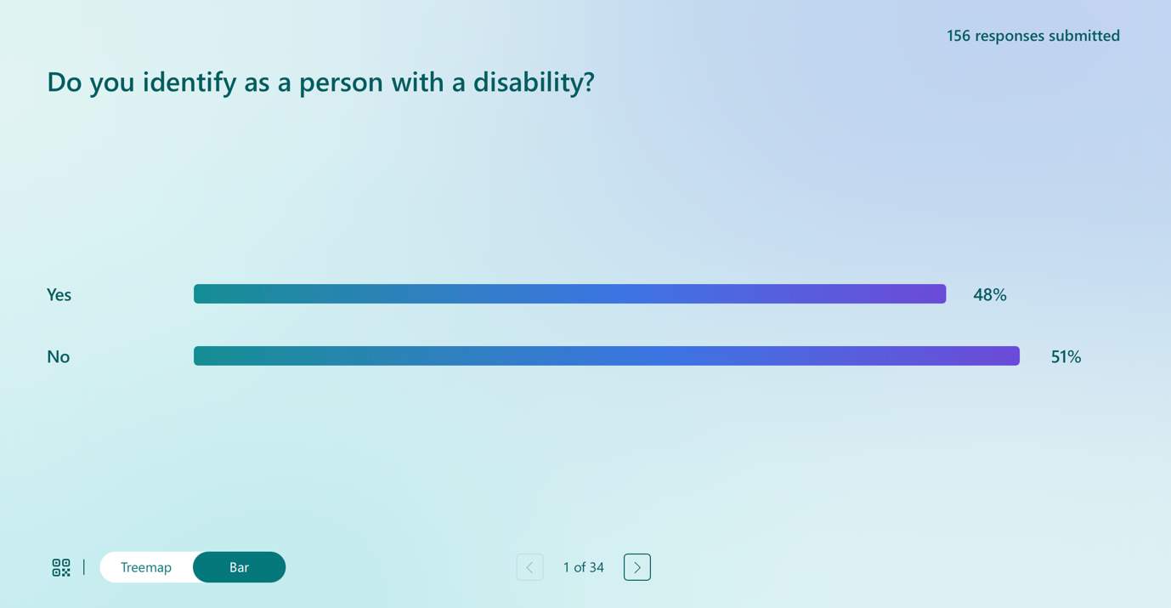

In response to the question “Do you identify as a person with a disability?”, 75 respondents indicated that they do identify as a person with a disability, while 81 respondents indicated that they do not. This response indicates that the survey captured a broad range of perspectives, including those of disabled people as well as family members, professionals, advocates and other stakeholders with an interest in disability law and policy. The balance between respondents with lived experience of disability and those engaging from other roles reflects the survey’s aim to inform the review of the Disability Act 2005 by capturing the insights of both people with direct lived experience and wider stakeholder perspectives.

In response to the question asking respondents to describe their role or perspective, participants could select more than one option. The largest group of respondents identified as persons with a disability. This was followed by 54 respondents who identified as a family member or caregiver to a person with a disability, highlighting the significant contribution of family perspectives to the survey. Health or social care professionals also formed a substantial group, with 40 respondents, reflecting strong engagement from those working directly within disability services. Thirty respondents identified as NGO staff or disability rights advocates, indicating active participation from civil society and advocacy organisations. Sixteen respondents identified as educators, such as teachers or lecturers. A small numbers of respondents identified as policymakers or public servants in disability or social policy, with 12 respondents selecting this option, and as legal professionals, with 2 respondents. Eleven respondents selected the ‘other’ category, indicating additional perspectives not fully captured by the predefined options. The ability to select multiple roles indicates the overlapping identities and experiences of respondents, many of whom engage with disability from more than one perspective. This reinforces the richness of the data and ensures that the survey findings reflect both lived experience and the perspectives of a wide range of people interested in the Disability Act 2005.

Section 2 of the Survey: General Questions on the Disability Act 2005

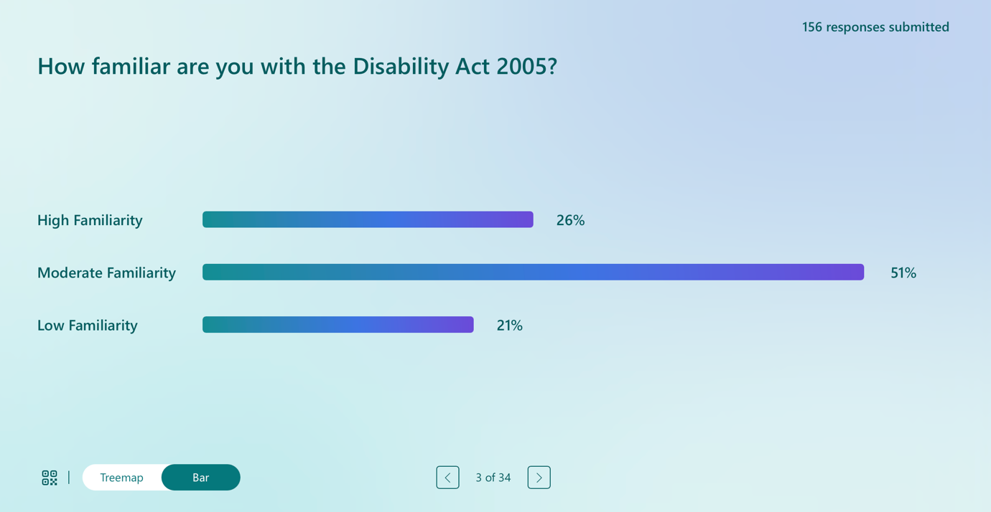

In response to the question on familiarity with the Disability Act 2005, respondents reported varying levels of knowledge of the legislation. A total of 41 respondents indicated a high level of familiarity with the Act. The largest group, comprising 81 respondents, reported a moderate level of familiarity, suggesting a general awareness of the Act without detailed or specialist knowledge. A further 34 respondents indicated low familiarity with the Disability Act 2005. The responses to this question suggests that while a majority of respondents have at least some awareness of the Disability Act 2005, relatively few consider themselves highly familiar with its provisions. This points to an information and accessibility gap in relation to the Act, particularly given its significance as a central piece of disability legislation. It also provides important context for interpreting responses to later questions, as many views on the effectiveness and impact of the Act are shaped by partial rather than comprehensive knowledge of its content and operation.

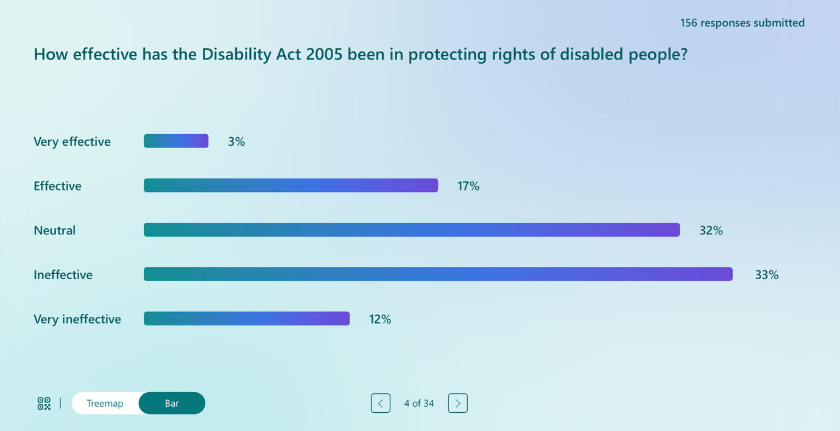

In response to the question on how effective the Disability Act 2005 has been in protecting the rights of disabled people, responses indicate a generally critical assessment of the Act’s impact. Only a small number of respondents viewed the Act positively, with 6 respondents describing it as very effective and a further 27 respondents considering it effective. In contrast, 51 respondents selected a neutral position, suggesting uncertainty or mixed views as to the Act’s effectiveness. It is of note that a substantial proportion of respondents expressed negative views. Fifty three respondents described the Act as ineffective, while 19 respondents rated it as very ineffective. These responses indicate that significantly more respondents view the Act as ineffective rather than effective in protecting rights. In fact the responses suggest widespread dissatisfaction or ambivalence about the Disability Act 2005 as a source of rights for disabled people. The high number of neutral and negative responses points to a perception that the Act has not delivered meaningful or enforceable rights in practice.

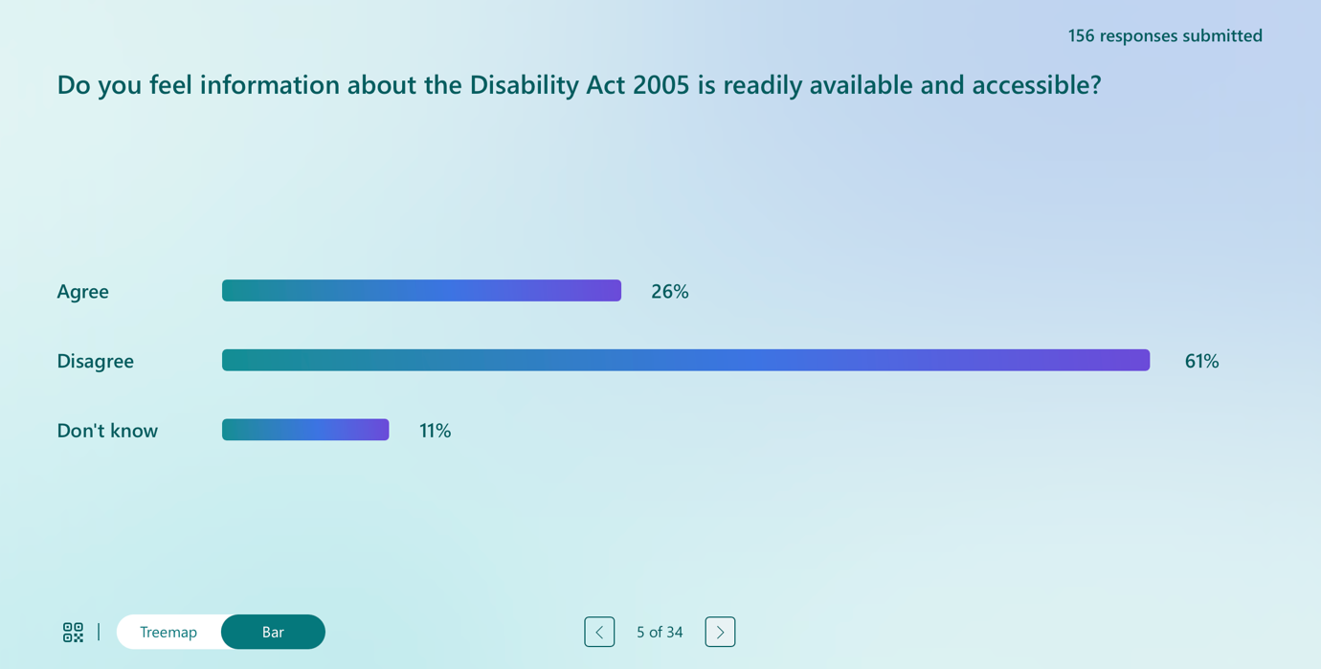

In response to the question on whether information about the Disability Act 2005 is readily available and accessible, the majority of respondents expressed a negative view. Ninety six respondents indicated that they disagreed with the statement, suggesting that they do not consider information about the Act to be easy to find or understand. In contrast, 42 respondents agreed that information about the Disability Act 2005 is readily available and accessible. A further 18 respondents selected ‘don’t know’, indicating uncertainty or limited exposure to information about the Act. These responses indicate a significant accessibility and information gap in relation to the Disability Act 2005. The predominance of disagreement responses suggests that many people affected by the Act, including disabled people and those supporting them, experience difficulty accessing clear and usable information. This lack of accessible information may also help explain the moderate to low levels of familiarity with the Act reported earlier and raises important concerns about transparency, awareness, and the effective realisation of rights under the legislation.

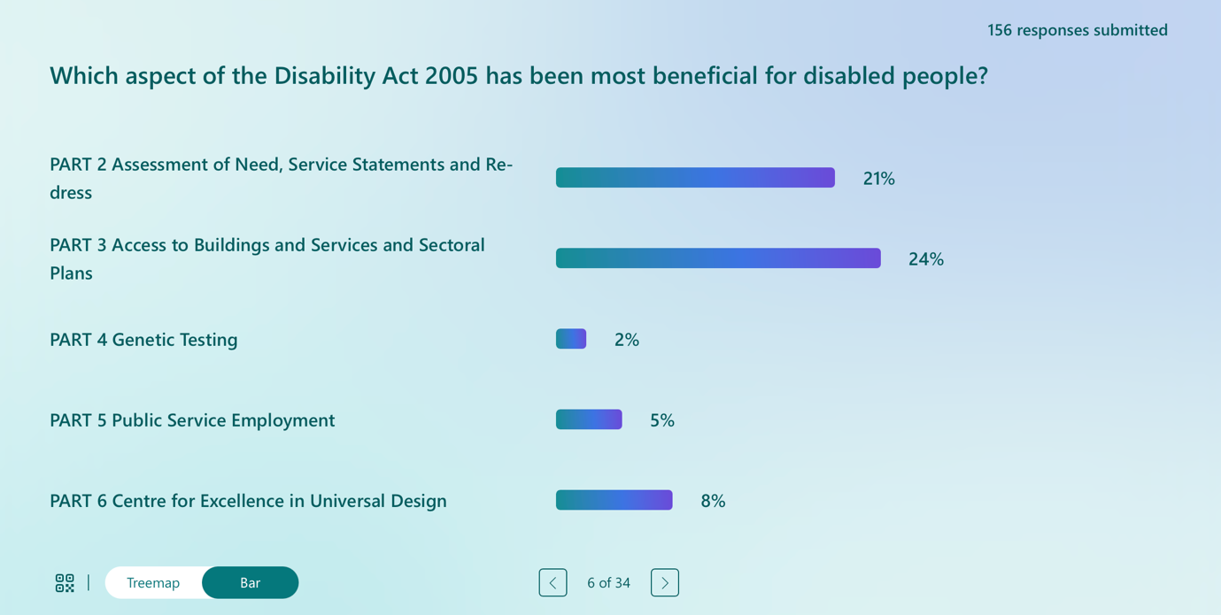

In response to the question on which aspect of the Disability Act 2005 has been most beneficial for disabled people, a significant proportion of respondents indicated that none of the listed elements of the Act had been beneficial. Fifty nine respondents selected ‘none of the above’, making this the single most common response. Among those who identified a beneficial aspect, the most frequently selected was Part 3 of the Act, relating to access to buildings and services and sectoral plans, which was selected by 38 respondents. Part 2, covering Assessment of Need, service statements and redress, was identified by 33 respondents. Smaller numbers of respondents identified Part 6, the Centre for Excellence in Universal Design, with 14 respondents, and Part 5, relating to public service employment, with 8 respondents. Very few respondents, only 4, identified Part 4 on genetic testing as the most beneficial aspect of the Act. The responses suggest that while certain elements of the Disability Act 2005 are perceived as having some positive impact, particularly in relation to accessibility and assessment processes, a substantial number of respondents do not consider any part of the Act to have delivered meaningful benefits. This reinforces concerns about the Act’s limited practical effect and supports the view that its provisions have not translated into enforceable or consistently realised rights for many disabled people.

Qualitative Analysis of Open-Ended Responses: Responses on the Disability Act 2005

The last question in this section of the survey was an optional open-ended question inviting comments on the Disability Act 2005. A total of 81 respondents, out of 156 survey participants, chose to provide written responses. These responses provide rich qualitative insight into respondents’ experiences, perceptions, and evaluations of the Act. The data were analysed using reflexive thematic analysis following Braun and Clarke’s approach. The analysis focused on identifying shared patterns of meaning across respondents’ evaluations of the Act’s design, implementation, and impact.

Theme 1: An Act Without Enforceable Rights

The most consistent theme across responses was the perception that the Disability Act 2005 does not create enforceable individual rights. Respondents repeatedly distinguished between duties placed on public bodies and the absence of corresponding legal entitlements for disabled people. The right to an Assessment of Need was widely described as procedural. Respondents emphasised that the Act provides a right to an assessment but not to any support services deemed appropriate by that assessment rendering it ineffectual. A number of respondents characterised the Act as establishing no enforceable rights, other than the right to an assessment and therefore failing to support disabled people. Across responses, the absence of enforceable rights was framed as a structural weakness that undermines the Act.

“The Act was established with no enforceable rights, other than the right to an assessment. People wanted services to enable them to be full citizens, this Act does not address that. It was predicted that the act would fail and it has.” Respondent 20

Theme 2: Weak Enforcement, Accountability and Resource Dependency

Concerns about enforcement and accountability were deeply intertwined with critiques of resource dependency. Respondents described enforcement mechanisms as slow, inaccessible, and largely ineffective. Public bodies were perceived as facing no meaningful consequences for breaching statutory timelines or failing to deliver services. The Ombudsman was described as an ineffective enforcer, lacking the power to compel change. Respondents repeatedly criticised the qualifying language in the Act, particularly references to what is “practicable and appropriate” or “subject to available resources,” as functioning loopholes. Such phrasing was described as “a get out clause for public bodies,” allowing systemic under-delivery to persist without legal consequence. Twenty years after enactment, respondents noted, access difficulties and waiting lists remain widespread.

“The use of the terms where it is practicable and appropriate is a get out clause for public bodies. 20 years later people with disabilities still experience access difficulties. There are huge waiting lists for AON's yet no one is held accountable even though it is in breach of legislation…. The Act is aspirational and is not reflective of the current experience of people with disabilities.” Respondent 12

Theme 3: Assessment of Need as Procedural, Harmful, and Disconnected from Services

The Assessment of Need process emerged as a focal point of frustration. Respondents described long delays, repeated reassessments, uncertainty with the system, and the absence of service follow-through once assessments were completed. Parents in particular highlighted the emotional toll of navigating the system. A respondent described the system starkly as “a disaster” (Respondent 31). Rather than functioning as a gateway to timely intervention, the AON process was frequently described as a bureaucratic endpoint.

“I initially filled out an Assessment of Need form before my son was accepted into the Intervention Disability Services, now known as the Child Disability Network Team (CDNT). At the time, I was not informed why I needed to complete the form, nor was I made aware of my rights or my son’s rights in relation to it. Later, due to the restructuring from the … Intervention Team to the CDNT, I was asked to complete the form again, three years later, without any explanation as to why this was necessary or how it would benefit us. In my experience, the process has not benefited us. I had to personally advocate to have psychological assessments carried out on my son so that he could access the appropriate services and supports at school. Once the Assessment of Need was completed, it was never referred to again.” Respondent 33

Theme 4: An Outdated Medical Model and Narrow Definition of Disability

Many respondents argued that the Act reflects an outdated medical or deficit-based model of disability. The statutory definition, with its emphasis on substantial restriction, was criticised as exclusionary and misaligned with contemporary social and human rights models of disability. Respondents highlighted the exclusion of people with invisible, fluctuating, or neurodivergent disabilities. One described the definition as problematic arguing that it focuses on impairment rather than social and environmental barriers. Deaf respondents noted the absence of any reference to Irish Sign Language, reinforcing the perception that the Act fails to reflect linguistic and cultural dimensions of disability.

“The definition of disability is outdated, very problematic and frankly offensive. Focuses on impairment and limitations. Medical model rather than looking at the social and environmental barriers. Excludes temporary conditions. This limits access to assessments and supports, hence it's not in keeping with UNCRPD. Weak enforceability. Huge failings in terms of the legal timelines for AON. Very vague terminology for the provision of services”. Respondent 96

Theme 5: Limited Areas of Progress Within a Structurally Weak Framework

While most responses were critical, some acknowledged limited areas of progress. Accessibility provisions and the work of the Centre for Excellence in Universal Design were frequently cited as positive developments, particularly in raising awareness and influencing policy discourse. However, these gains were described as constrained by the absence of enforcement powers. Public service employment provisions were viewed ambivalently: some respondents recognised progress, but many noted that targets are treated as aspirational and lack transparent monitoring, particularly regarding career progression. Respondents perceived isolated improvements operating within a structurally weak legislative framework.

“Ireland and Norway are unique internationally in having a commitment to Universal Design enshrined in primary legislation, in Ireland's case, through the Disability Act 2005... Enforcement measures under the Disability Act have been weak, however, National Disability Authority (NDA) monitoring of web accessibility under the EU WAD has led to significant progress in this area. This progress needs to be replicated across all UD pillars, and strengthening monitoring and enforcement of the Disability Act 2005 provides a vehicle for doing so.” Respondent 152.

Theme 6: Exclusion of Disabled People from Legislative Design and Governance

Finally, respondents strongly criticised the limited involvement of disabled people in the original design and implementation of the Act. Many distinguished between Disabled Persons’ Organisations and service providers, arguing that the latter exerted disproportionate influence. Several respondents noted that the Act was not shaped or informed by disabled people, describing this as both morally and democratically problematic. There was widespread agreement that future reform must be grounded in meaningful consultation, co-production, and compliance with the participatory obligations contained in the CRPD.

“The Disability Act 2005 was an important early step, but it has not met the needs of Deaf Irish Sign Language (ISL) users. The Act was built on a medical model of disability, which treats Deafness as a loss or impairment. This approach ignores the fact that Deaf people are a linguistic and cultural community, not just a group with a medical condition.” Respondent 103

Section 3 of the Survey: Assessment of Need (AON)

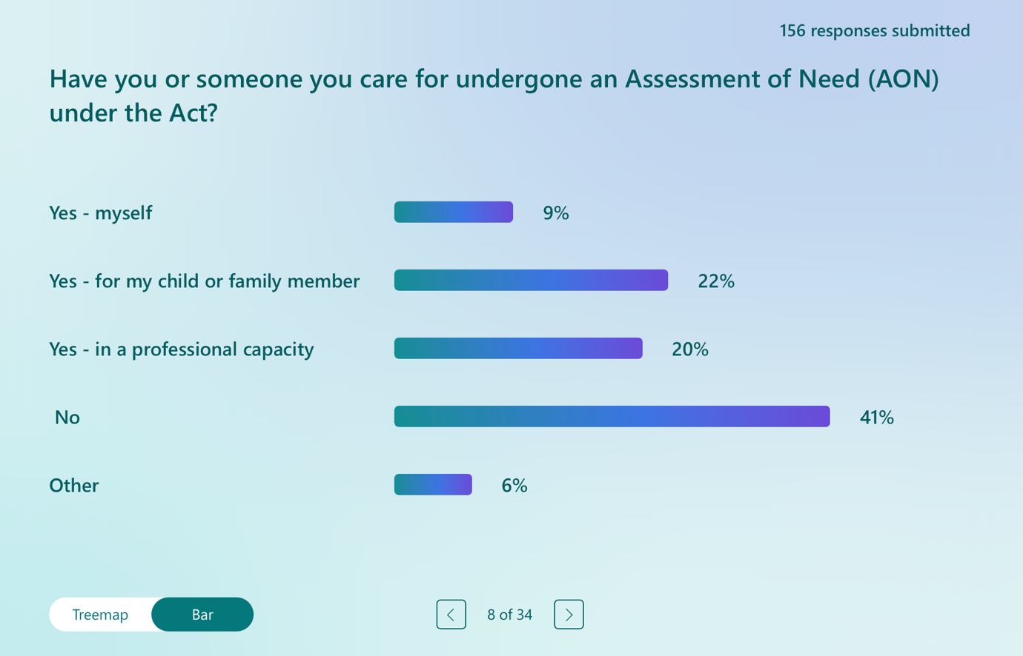

This question marked the beginning of the survey section focusing specifically on experiences of Assessment of Need under the Disability Act 2005. Respondents were asked whether they, or someone they care for, had undergone an Assessment of Need, with the option to select the response that best reflected their experience. Responses indicate that a substantial proportion of participants had direct or indirect experience of the Assessment of Need process. Fifteen respondents reported having undergone an Assessment of Need themselves. A further 34 respondents indicated that an Assessment of Need had been carried out for their child or another family member. Thirty one respondents reported experience of the Assessment of Need process in a professional capacity, reflecting the inclusion of health, social care, and disability service professionals among survey participants. At the same time, 64 respondents indicated that they had not undergone, nor been directly involved in, an Assessment of Need, while 10 respondents selected the ‘other’ category, suggesting experiences that did not fit neatly within the predefined options. The responses to this positioning question indicate that a majority of respondents had some level of exposure to the Assessment of Need system, either personally, through family members, or professionally. This breadth of experience provides an important foundation for interpreting responses to subsequent questions in this section, which explore perceptions of the effectiveness, timeliness, and outcomes of the Assessment of Need process under the Disability Act 2005.

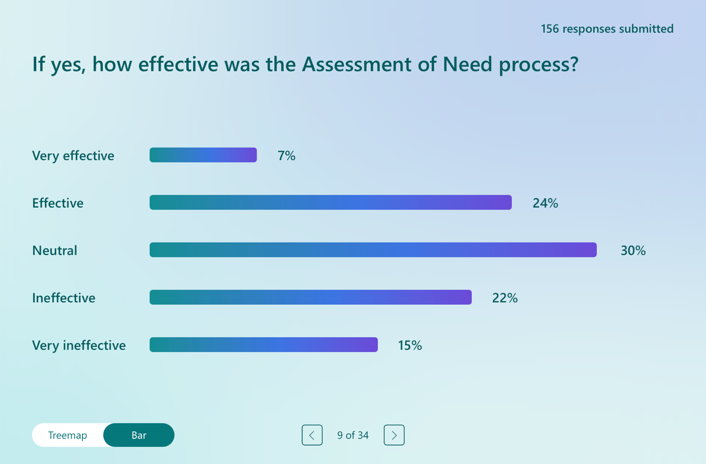

In response to the question on the effectiveness of the Assessment of Need process, views were mixed but tended towards a critical or ambivalent assessment. Only a small number of respondents rated the process very positively, with 8 respondents describing it as very effective and a further 27 considering it effective. Thirty three respondents selected a neutral response, suggesting uncertainty or mixed experiences of the process. By contrast, a significant number of respondents expressed dissatisfaction with the Assessment of Need process. Twenty four respondents described it as ineffective, while 17 rated it as very ineffective. These responses indicate that more respondents viewed the process as ineffective rather than effective. The responses suggest that the Assessment of Need process is not widely perceived as delivering clear or consistent benefits. The high proportion of neutral and negative responses points to variability in experiences and reinforces concerns raised elsewhere in the survey about delays, lack of follow-through, and the limited practical impact of assessments in securing services or supports.

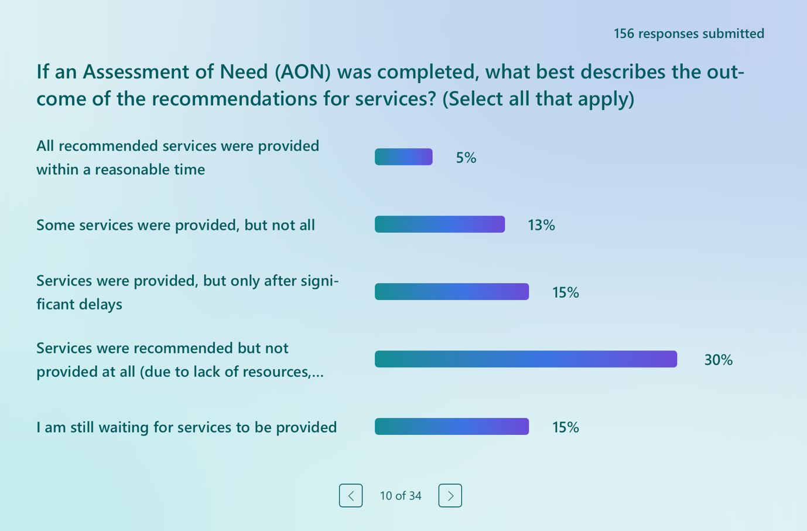

In response to the question on the outcomes of recommendations arising from an Assessment of Need, respondents were permitted to select more than one option, reflecting the fact that outcomes may vary across different services and over time. The findings indicate significant difficulties in translating assessment recommendations into timely and effective service provision. Only a small number of respondents, 8 in total, reported that all recommended services were provided within a reasonable time. By contrast, many respondents described partial, delayed, or absent service delivery. Eighteen respondents indicated that some services were provided but not all, while 21 reported that services were provided only after significant delays. A further 41 respondents stated that services were recommended but not provided at all, citing lack of resources, waiting lists, or other systemic barriers. An additional 21 respondents reported that they are still waiting for services to be provided following completion of an Assessment of Need. Twenty seven respondents selected the ‘other’ category, suggesting a range of additional or more complex outcomes not fully captured by the predefined response options for this question. These responses point to a substantial gap between the completion of an Assessment of Need and the delivery of recommended services. The low number of respondents reporting timely provision of all services, combined with high levels of delay, non-provision, and ongoing waiting, reinforces concerns that the Assessment of Need process frequently fails to result in meaningful or enforceable outcomes. This pattern supports broader critiques that the right to assessment under the Disability Act 2005 is not matched by a corresponding right to receive the services identified as necessary, limiting the practical effectiveness of the Assessment of Need framework.

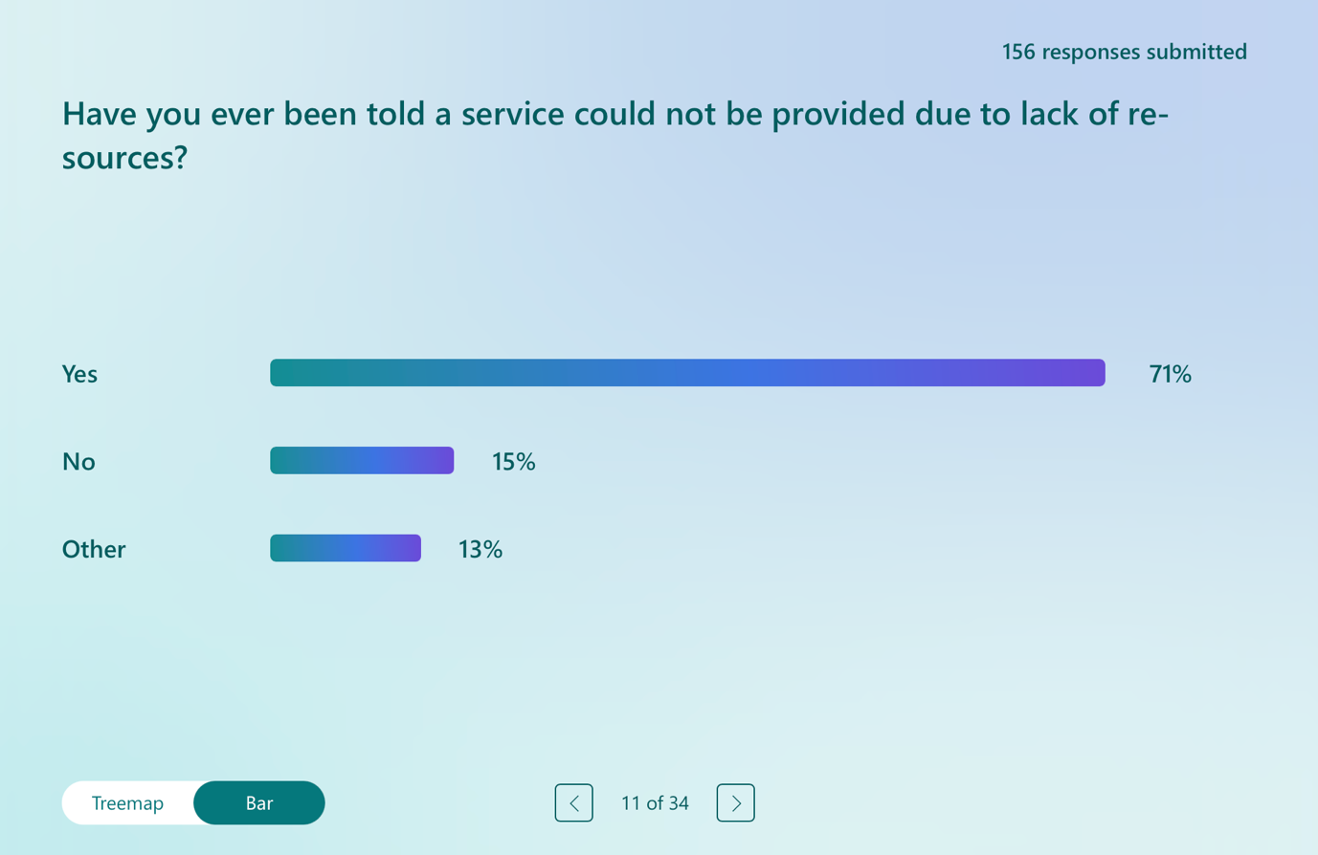

In response to the question on whether respondents had ever been told that a service could not be provided due to lack of resources, the vast majority reported that this had been their experience. Ninety eight respondents indicated that they had been informed that services could not be delivered because of resource constraints. By contrast, only 22 respondents reported that they had not been given this explanation. A further 18 respondents selected the ‘other’ category, suggesting experiences that did not fit neatly within a simple yes or no response. Again, these findings underline the central role that resource constraints play in shaping experiences of people accessing disability services. Being told that services cannot be provided due to lack of resources appears to be a common and normalised experience for respondents. This reinforces concerns identified elsewhere in the survey about the resource-dependent nature of the Disability Act 2005.

Qualitative Analysis of Open-Ended Responses: Responses on the Assessment of Need Process

The written responses to the optional question inviting comments on the Assessment of Need process captured from respondents’ accounts of lived experience, professional practice, and advocacy. The responses were detailed, at times emotive, and predominantly critical, offering significant insight into how the Assessment of Need framework operates in practice.

Theme 1: Assessment Without Entitlement: A Procedural Right Detached from Services

A dominant theme across responses was the perception that the Assessment of Need identifies needs without securing the provision of services. Respondents repeatedly described the process as generating reports and recommendations that are not acted upon. Assessments were characterised as administrative exercises rather than effective route to supports. The statutory right to assessment was widely viewed as disconnected from enforceable service provision. The absence of a corresponding legal entitlement to services was seen as rendering the process largely meaningless. In many accounts, assessments raised expectations among families only for those expectations to remain unmet, resulting in frustration and disillusionment.

“The AON has created undue anxiety among families. Parents are told that taking the AON will provide legal underpinning to services and yet those services, as described by the HSE, are not "promised" but only described as a "statement of need"... not delivery. Undergoing the AON means that valuable therapeutic time is given to a glossy thick report and then this report gathers dust. What is the point?” Respondent 50

“The Aon holds the State accountable for access to an assessment but not to services.” Respondent 95

Theme 2: Chronic Delays, Waiting, and Resource Shortages as Systemic Harm

Long waiting times and staff shortages emerged as central and deeply felt concerns. Respondents described delays extending over years, with waiting described as a form of harm with lasting developmental, psychological, and social consequences. Waiting often continued even after assessments were completed, with no clear timelines for service implementation. Respondents attributed this to chronic under-resourcing, unrealistic statutory timelines, and workforce shortages. Clinical expertise was described as being diverted toward meeting procedural assessment targets rather than delivering therapeutic support. Concerns were also raised about assessment quality, including assessments conducted without appropriate expertise or where professional recommendations were overridden by administrative decision-makers. These issues were described as systemic rather than isolated operational failures within the system.

“I think it is flawed from the outset for mild/moderate disabilities. I was made feel like I was imagining things and was told I had nothing to be concerned about, I ended up paying for private assessments pre starting the junior and senior cycle of school so that support needs could be identified and accessed. For early intervention I believe I only got the supports / programmes for my son through strong advocacy and persistent reaching out to early intervention” Respondent 131

“From research and advocacy work, waiting times are debilitating and causing long term impacts on the person reaching their full potential” Respondent 10

Theme 3: Inequality, Privatisation, and the Two-Tier System

A strong theme concerned inequality of access and the growing reliance on private resources. Many respondents reported paying privately for assessments, therapies, or diagnoses in order to bypass delays in the public system. Those who could afford private provision described it as the only viable option. This was described as producing a two-tier system in which outcomes are tied to the financial means of the parents. Families without resources were described as waiting indefinitely, while others secured earlier intervention privately. Respondents characterised this disparity as fundamentally inconsistent with principles of equality, fairness, and rights-based provision of services. Geographic inequality further compounded these concerns. Respondents noted significant regional variation in waiting times, which they described as a postcode lottery, undermining the notion of a national statutory entitlement.

“We opted to take the private route as the stories about AON and services were too much and my child was too fragile. We were lucky to have the means.” Respondent 21

“There are drastically different experiences of the Assessment of Need (AoN) process depending on where you live in the country, and this should not be the case. The variation is so significant that some parents resort to using relatives’ addresses, or even consider moving to different areas, in the hope of accessing faster assessments and services.” Respondent 54

Theme 4: Fragmentation, Lack of Coordination, and Poor Communication

The Assessment of Need process was widely described as fragmented and poorly coordinated. Respondents highlighted weak integration between assessment, service provision, education, housing, and adult disability services. Transitions, particularly from childhood to adulthood, were identified as points of breakdown, with supports abruptly ending at age eighteen and no clear pathway to adult services. The process was also described as opaque. Many families reported receiving little information about their rights, the purpose of the assessment, or the next steps following completion. This lack of transparency was described as compounding stress and forcing families into repeated advocacy or legal action.

“The Aon isn't worth the paper it's written on. If there is no law to force the HSE to provide services children are left on never ending waiting list for years until they age out at 18.” Respondent 107

Theme 5: Emotional Toll and Calls for Rights-Based Structural Reform

Beyond procedural and structural critiques, respondents consistently described the emotional and psychological impact of the Assessment of Need process. Families reported anxiety, exhaustion, frustration, and a sense of being retraumatised by repeated assessments and prolonged uncertainty. Some described therapeutic time being diverted into bureaucratic processes that ultimately failed to improve outcomes. Across the dataset, there was a strong and consistent call for reform. Respondents argued that the Assessment of Need framework must be reframed within an enforceable, rights-based system that guarantees timely service provision once needs are identified. Suggested reforms included enforceable timelines, transparent workforce planning, meaningful implementation of provisions such as section 16A, cradle-to-grave review mechanisms, and alignment with the CRPD.

“I was told that my younger child could only access supports if I agreed for my older child to be discharged from the disability service. My older child requires more supports so we kept them in. My younger child still hasn't received AON (2½ years on). It is a completely broken system.” Respondent 90

“It is a national disgrace. Especially for families with children who are at the highest level of need. Long wait for assessment, no therapies, only parental education.” Respondent 31

Section 4 of the Survey: Accessibility under the Disability Act 2005

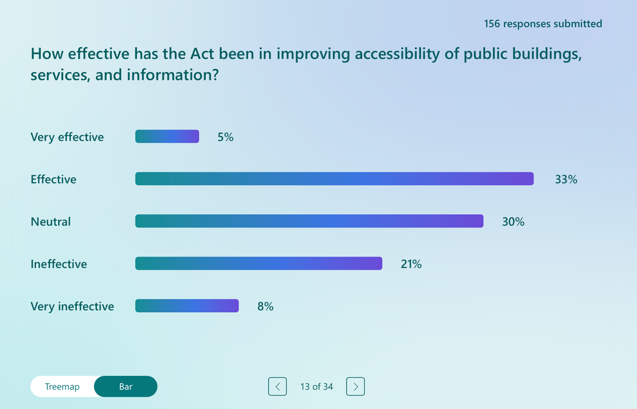

The first question in this section of the survey section explored the impact of the Disability Act 2005 on accessibility of public buildings, services, and information. Respondents were asked to assess how effective they considered the Act to have been in improving accessibility across these areas. Responses indicate a mixed but more moderately positive assessment compared to earlier sections of the survey. Nine respondents described the Act as very effective in improving accessibility, while a further 53 respondents considered it effective. Forty seven respondents selected a neutral response, suggesting either mixed experiences or uncertainty regarding the Act’s impact. It is of note that a substantial minority expressed negative views. Thirty three respondents rated the Act as ineffective, and 14 described it as very ineffective. These responses suggest that while accessibility is one area where the Disability Act 2005 is perceived to have had some positive influence, significant concerns remain about consistency, scope, and implementation. The relatively high number of neutral and negative responses points to uneven progress and provides important context for the questions that follow, which explore specific aspects of accessibility and lived experience in greater detail.

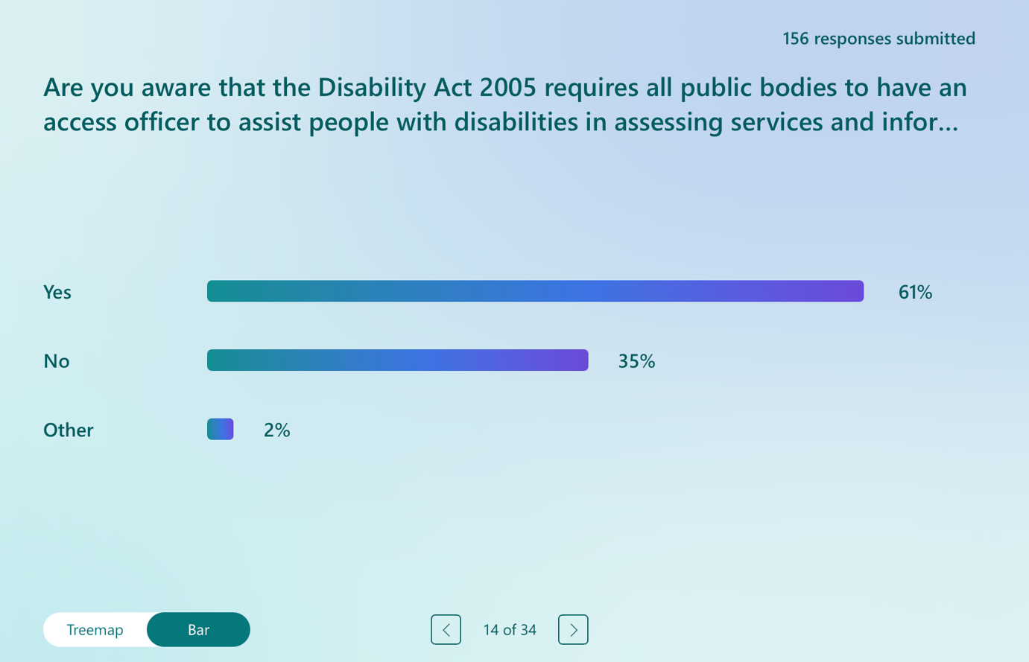

In response to the question on awareness of the requirement under the Disability Act 2005 for all public bodies to have an Access Officer, a majority of respondents indicated that they were aware of this obligation. Ninety six respondents reported that they were aware that public bodies are required to have an Access Officer to assist people with disabilities in accessing services and information. However, a substantial proportion of respondents, 56 in total, indicated that they were not aware of this requirement. A further 4 respondents selected the ‘other’ category, suggesting a lack of knowledge or experiences that did not fit neatly within a yes or no response. These responses indicate a significant awareness gap in relation to Access Officers, despite their central role in supporting accessibility under the Act. While awareness is relatively high among some respondents, the number of respondents who were unaware of this requirement points to shortcomings in how Access Officer roles are communicated and embedded across public bodies. This lack of awareness may limit the practical effectiveness of the Access Officer system and helps contextualise subsequent responses regarding experiences of accessing information and services.

Qualitative Analysis of Open-Ended Responses: Responses on the Access Officer role under the Disability Act 2005

The responses to this optional question indicate that while the Access Officer role is widely recognised as important in principle, it is perceived as poorly implemented, under-resourced, and insufficiently empowered to effect meaningful change.

Theme 1: Low Awareness and Institutional Invisibility

A consistent theme in the responses was the low awareness of the Access Officer role. Many respondents reported that they were unaware such a role existed, including individuals working within disability services or public bodies. Others described difficulty locating any information about Access Officers on organisational websites or internal systems. This invisibility was interpreted as symptomatic of a symbolic rather than a well-functioning role across public bodies. Respondents suggested that accessibility obligations are not actively communicated, and that individuals are required to seek out information rather than being proactively informed of their rights or supported to access services. The role was therefore seen as lacking visibility, clarity, and public profile, undermining its accessibility and effectiveness.

“When I saw this question, I decided to check out the public body that I work for, and nowhere could I find reference to an access officer. So going to have to guess this is ineffective.” Respondent 20

Theme 2: Tokenism, Marginalisation, and Structural Weakness

Respondents frequently described the Access Officer role as tokenistic and structurally marginalised. The position was often characterised as an add-on responsibility assigned to staff who already hold full-time roles, limiting time, commitment, and effectiveness. This theme also encompasses concerns regarding lack of seniority, insufficient training, and limited institutional authority. Access Officers were described as having little influence over infrastructure, procurement, or service design decisions. Some respondents who identified themselves as Access Officers reported having no budget and minimal organisational support. The cumulative effect was a perception that accessibility is deprioritised and treated as discretionary rather than legally mandated.

“Normally it is an add on role meaning that it doesn't get the time or the commitment that it requires.” Respondent 23

Theme 3: Inconsistency, Variability, and Lack of Accountability

A further theme concerned inconsistency in implementation across sectors and regions. Experiences were described as highly variable and dependent on the individual Access Officer rather than a standardised framework. While a minority of respondents reported positive experiences, these were presented as exceptions. This variability was viewed as incompatible with a statutory obligation. Respondents highlighted the absence of reporting mechanisms, performance standards, or enforcement powers. The lack of accountability structures was seen as contributing to inequitable access depending on geography or institutional culture within the public body.

“How do users find and contact [access officers]? What is their training? … My experience working as an access office was shocking. Manager taught me to be constantly lying about the organisation and the law, and dismissing unlawful acts of discrimination like a flea in the ear. Always trying to get disabled users to shut up and go away, instead of just implementing reasonable adjustments that users have a legal right to.” Respondent 111

Theme 4: Narrow Conceptions of Accessibility

Respondents strongly criticised the limited way in which accessibility is conceptualised and operationalised. Accessibility was frequently reduced to physical infrastructure, such as ramps or door widths, with insufficient attention to communication, digital access, sensory environments, and navigational supports. Deaf respondents and advocates emphasised deficiencies in communication access, including limited awareness of Irish Sign Language and Deaf culture. Broader concerns were raised about digital accessibility and information provision. Respondents argued that accessibility must be understood holistically and aligned with universal design principles rather than confined to physical adjustments.

“Access is not just about entry to buildings but navigating a building its communication information digital systems this is lacking in many not designed for all while there are improvements there’s a long way go.” Respondent 155

Theme 5: Organisational Culture and the Need for Strategic Reform

Beyond structural limitations, respondents highlighted organisational culture and attitudinal barriers as significant constraints to the effective function of the access officer role. Disability obligations were described as being regarded as burdensome or secondary within public bodies. People seeking accommodations reported adversarial interactions and experiences of being dismissed or condescended to. Across the dataset, respondents called for strategic reform and professionalisation of the access officer role. Suggested reforms included clarifying statutory functions, ensuring appropriate seniority and resourcing, mandating training in disability rights and universal design, embedding accessibility within governance structures, and aligning the role with the CRPD and the Public Sector Equality and Human Rights Duty. There was a strong view that access officers should operate proactively and strategically, including responsibility for audits, compliance monitoring, staff training, and systemic change, rather than functioning reactively in response to individual complaints.

“They are usually inaccessible (ironic given their title), usually untrained, and many public bodies appear not to have one or no-one knows who they are. We often find that someone is apparently nominated Access Officer just [as a result] of our enquiry. Training and knowledge are scant where they do exist.” Respondent 128

Section 5 of the Survey: Enforcement and Implementation of the Disability Act 2005

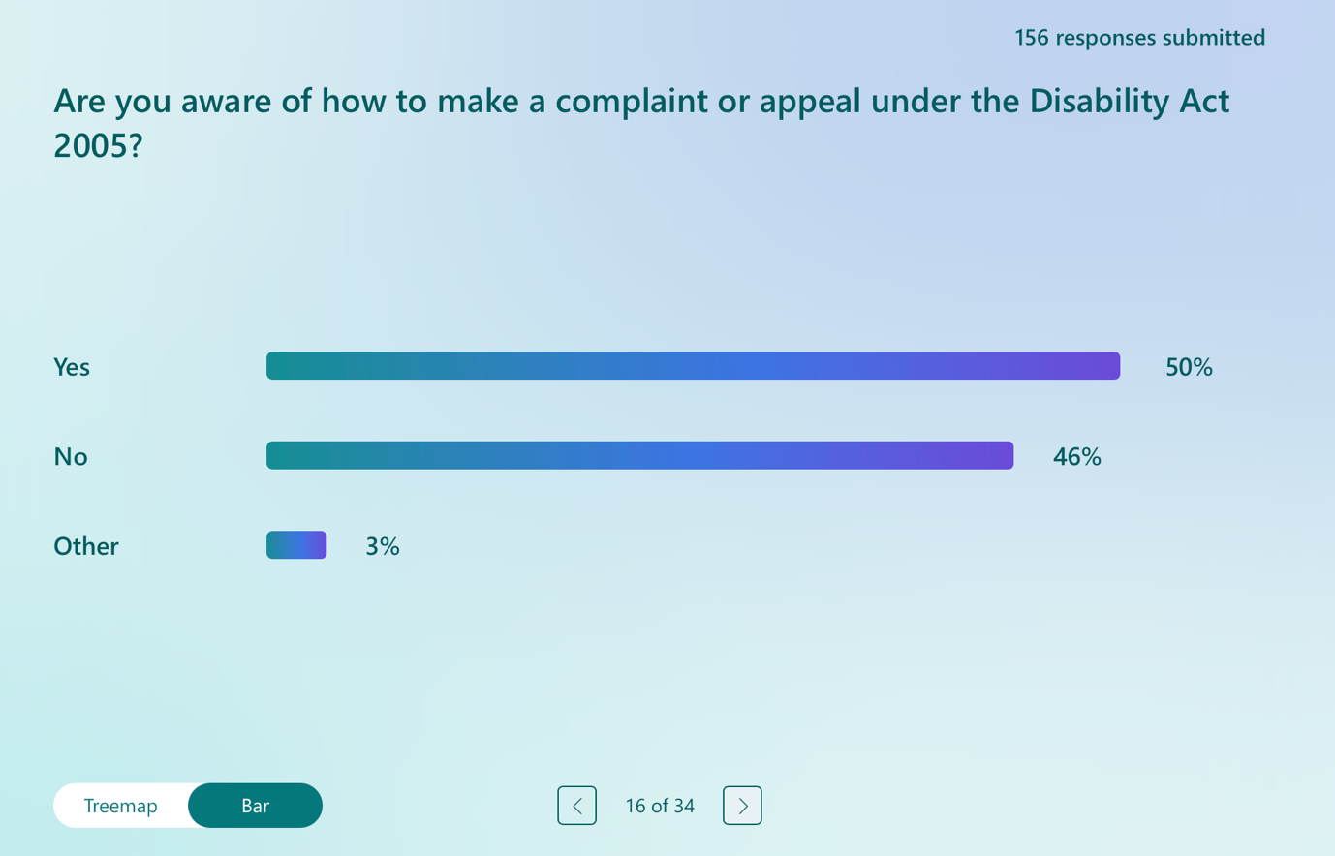

This question opened this section of the survey examining awareness of complaints and redress mechanisms under the Disability Act 2005. Respondents were asked whether they were aware of how to make a complaint or appeal under the Act. Responses indicate a near-even split in levels of awareness. Seventy eight respondents reported that they were aware of how to make a complaint or appeal under the Disability Act 2005, while 72 respondents indicated that they were not aware of how to do so. A further 6 respondents selected the ‘other’ category, suggesting uncertainty or partial awareness. These responses again point to a significant gap in awareness of complaints and appeal mechanisms, particularly given their importance for accountability and enforcement. The fact that almost half of respondents were unaware of how to pursue a complaint or appeal provides important context for subsequent questions in this section and reinforces broader concerns about accessibility of information, and transparency under the Disability Act 2005.

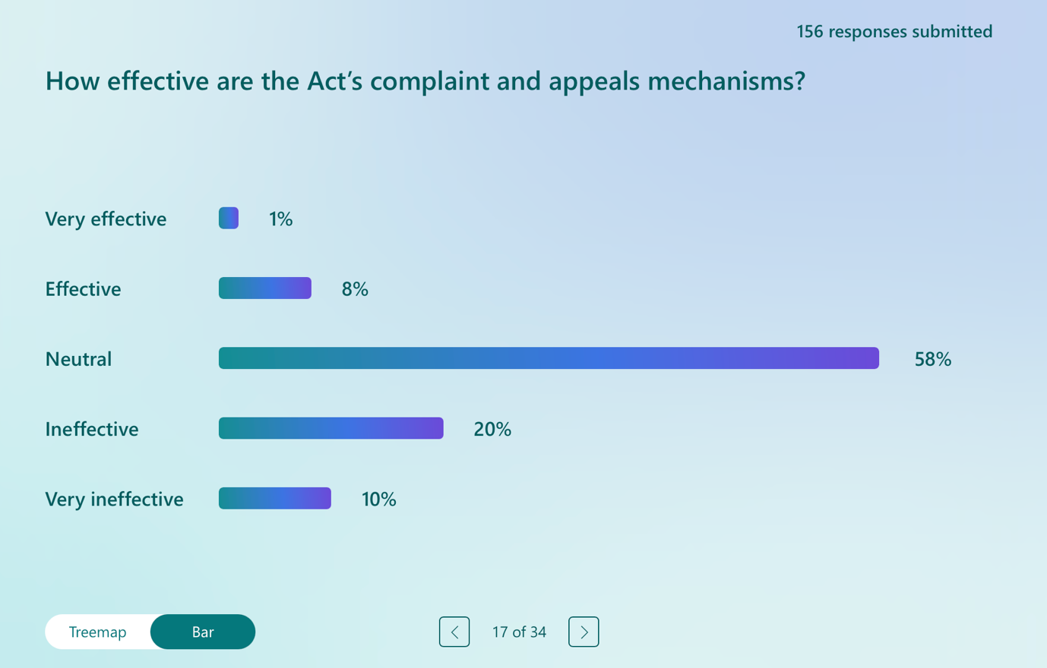

In response to the question on the effectiveness of the Disability Act 2005’s complaint and appeals mechanisms, respondents expressed a largely sceptical or uncertain view. Very few respondents rated these mechanisms positively, with only 3 respondents describing them as very effective and a further 13 considering them effective. The most common response was neutral, selected by 92 respondents, suggesting limited experience of the mechanisms, uncertainty about their operation, or a perception that they have little practical impact. It is of note that a substantial proportion of respondents expressed negative views. Thirty two respondents rated the complaints and appeals mechanisms as ineffective, while 16 described them as very ineffective. These responses indicate that negative perceptions significantly outweigh positive ones. The predominance of neutral and negative responses suggests that the complaints and appeals mechanisms under the Disability Act 2005 are not widely perceived as accessible, effective, or capable of delivering meaningful redress. This reinforces broader concerns identified throughout the survey regarding weak enforcement, limited accountability.

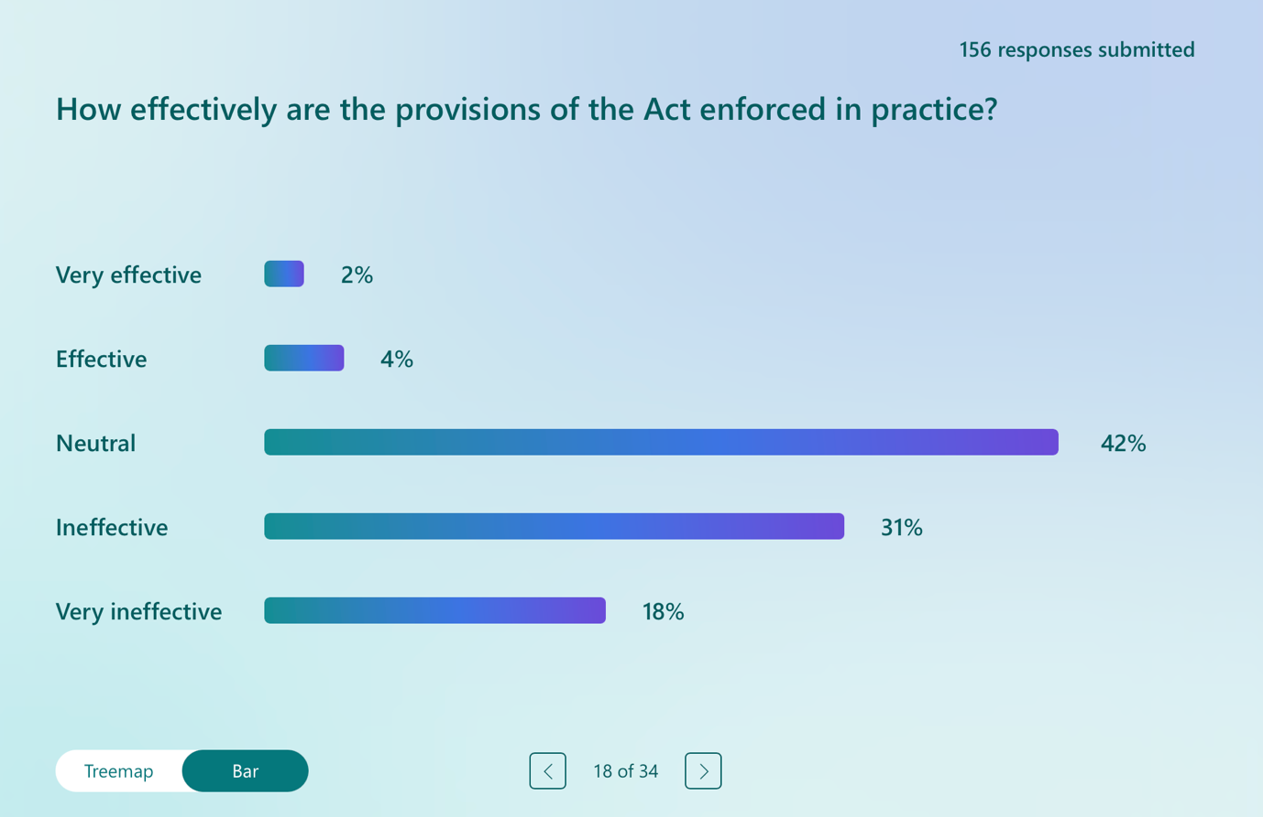

In response to the question on how effectively the provisions of the Disability Act 2005 are enforced in practice, respondents expressed predominantly negative or uncertain views. Only a small number of respondents perceived enforcement as effective, with 4 respondents rating enforcement as very effective and a further 7 describing it as effective. The most common response was neutral, selected by 67 respondents, indicating uncertainty, limited visibility of enforcement activity, or a perception that enforcement mechanisms lack practical impact. By contrast, a substantial proportion of respondents expressed negative views. Forty nine respondents rated enforcement as ineffective, while 29 described it as very ineffective. These responses indicate that significantly more respondents view enforcement under the Act as ineffective rather than effective. Again, this suggests widespread concern about the weak enforcement of the Disability Act 2005 in practice. The dominance of neutral and negative responses reinforces earlier findings relating to complaints and appeals mechanisms and supports the view that, in the absence of robust enforcement and accountability structures, the Act has limited capacity to secure compliance or deliver meaningfully for disabled people.

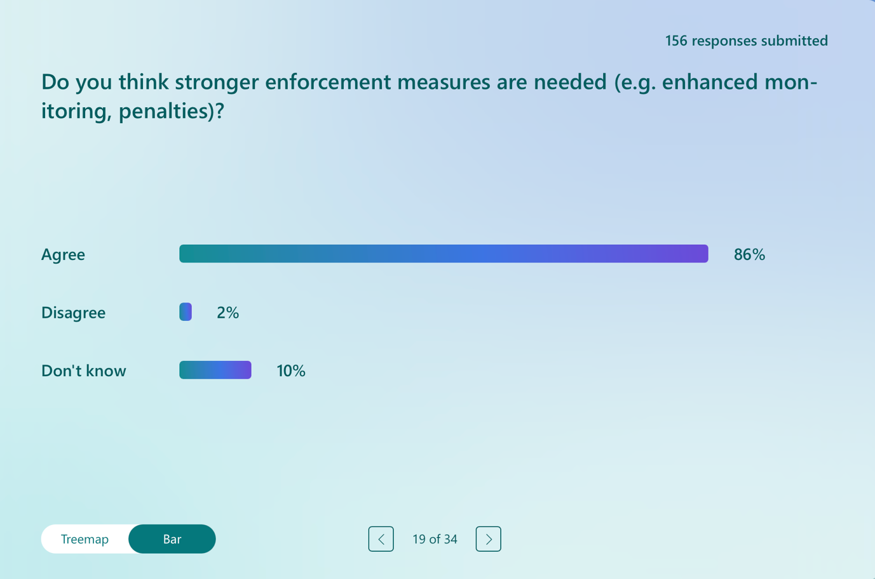

In response to the question on whether stronger enforcement measures are needed under the Disability Act 2005, there was an overwhelming level of agreement among respondents. One hundred and thirty five respondents indicated that they agreed that stronger enforcement measures are required, such as enhanced monitoring or the introduction of penalties for non-compliance. Only 4 respondents disagreed with this statement, while 17 respondents selected ‘don’t know’. The responses to this question demonstrate a clear and near-consensus view that the current enforcement framework under the Disability Act 2005 is inadequate. The strength of agreement provides strong empirical support for calls to introduce more robust monitoring, accountability, and enforcement mechanisms, and reinforces earlier findings regarding the perceived ineffectiveness of complaints, appeals, and enforcement processes under the Act.

Qualitative Analysis of Open-Ended Responses: Responses on the Implementation and Enforcement of the Disability Act 2005

The final question in this section of the survey invited respondents to share open-ended reflections on the implementation and enforcement of the Disability Act 2005. The responses were extensive, highly detailed, and strongly evaluative, drawing on lived experience, professional expertise, advocacy work, and engagement with complaints and legal processes. Respondents expressed significant dissatisfaction with the implementation and enforcement of the Disability Act 2005. They consistently described the Act as weakly enforced, overly reliant on individual advocacy, and incapable of delivering effective remedies.

Theme 1: Weak Enforcement and the Absence of Meaningful Consequences

A dominant theme across responses was the perception that the Act lacks effective enforcement mechanisms. Public bodies were described as facing no meaningful consequences for non-compliance. Obligations were characterised as discretionary, with enforcement dependent on goodwill rather than legal obligations flowing from the 2005 Act. Terms such as “toothless” and “guidance rather than law” were frequently used. Delays, excuses, and non-delivery were seen as normalised because effective sanctions for non-compliance were absent. The absence of credible consequences was viewed as fundamentally undermining the authority and legitimacy of the Act.

“Nobody is held to account. There are always delays and excuses. Disabled people are tired of fighting and advocating for their human rights.” Respondent 12

“There is no penalty or negative consequence to not adhering to the Act. When voicing or advocating for disabled people and citing the Act, it feels it is still viewed as a tick a box exercise and often not followed through on.” Respondent 60

Theme 2: Fragmented Oversight and Inadequate Accountability Structures

Respondents consistently highlighted the absence of a central, independent body responsible for monitoring and enforcing compliance. Oversight was described as dispersed, opaque, and inconsistent across different public bodies. Complaints procedures were criticised for requiring individuals to complain first to the very bodies alleged to be in breach, with investigations often conducted internally. The Ombudsman was viewed as an insufficient safeguard given the non-binding nature of recommendations. Many respondents called for an independent enforcement authority with investigatory powers and sanctions.

“It’s haphazard… The HSE often use the excuse as unable to recruit staff etc in the provision of services. If you bring a complaint to the ombudsman for children for example they cannot investigate staffing issue… When you do complain to the HSE there is no external body which investigates the complaint. The HSE are left to investigate themselves literally.” Respondent 91

Theme 3: Burdensome Complaints Processes and Inequality of Access to Justice

A strong theme that emerged concerned the design and accessibility of complaints and appeals mechanisms. Respondents described these processes as complex, multi-layered, and inaccessible, particularly for disabled people already facing systemic barriers. The burden of initiating and sustaining complaints was seen as unreasonable and inequitable. Even where complaints were upheld, they were often described as resulting in limited practical change. Litigation was viewed by some as the only effective route to securing statutory entitlements, yet access to litigation was recognised as uneven and shaped by education, financial means, and the emotional capacity of the disabled person to see complaints through. This created a system in which those with resources could pursue enforcement, while others disengaged or endured ongoing violations.

“While I know many people who experience various forms of disability discrimination, most choose not to make official complaints. The process appears burdensome, time-consuming, and complex… many people simply “get on with things” rather than engage with a system that feels inaccessible or out of reach. This limits the effectiveness of the Act in practice, as issues often go unreported and unresolved.” Respondent 54

Theme 4: Resource Dependency

Respondents repeatedly identified resource qualifications within the Act as a central barrier to enforcement. Phrases such as “in so far as is practicable” were viewed as opt-out clauses enabling routine justification of inaction. Resource constraints were described as standard explanations for non-compliance with the 2005 Act. This theme was closely linked to frustration that even the right to an Assessment of Need, one of the few clearly enforceable provisions, has required repeated court intervention to secure compliance. Respondents described the inadequacy of resources as weakening the Act’s enforceability.

“No point having legislation that does not reduce families, anxieties or concerns at the very basic human rights level of care.” Respondent 29

Theme 5: Loss of Trust and the Demand for Rights-Based Reform

Beyond structural critiques, respondents described the consequences of weak enforcement. Accounts of exhaustion, despair, adversarial interactions, and withdrawal from complaints processes reflected a significant loss of trust in public bodies. Enforcement failures were described as symptomatic of the deeper structural issue, which is that the Disability Act 2005 is outdated and misaligned with contemporary rights standards, particularly the CRPD. Across the dataset, respondents called for strong, rights-based reform. Suggested changes included enforceable timelines, binding remedies, financial penalties for non-compliance, enhanced monitoring obligations, independent oversight mechanisms, and proactive rather than the current model of complaint-driven enforcement. There was strong support for reimagining the Act as a rights-based statute capable of delivering practical and enforceable outcomes.

“Have given up, my child is at home every day, at lease she's safe with us. Trust [is] an issue from experience and don't believe personnel are adequately trained in disability.” Respondent 112

“Statutory, enforceable timeframes are needed along with realistic resourcing plans. There needs to be meaningful remedies where timelines are breached such as court/tribunal route. Independent mechanism to enforce rights under the Act would be welcome for independent accountability to be enhanced.” Respondent 156

Section 6 of the Survey: Other Parts of the Disability Act 2005

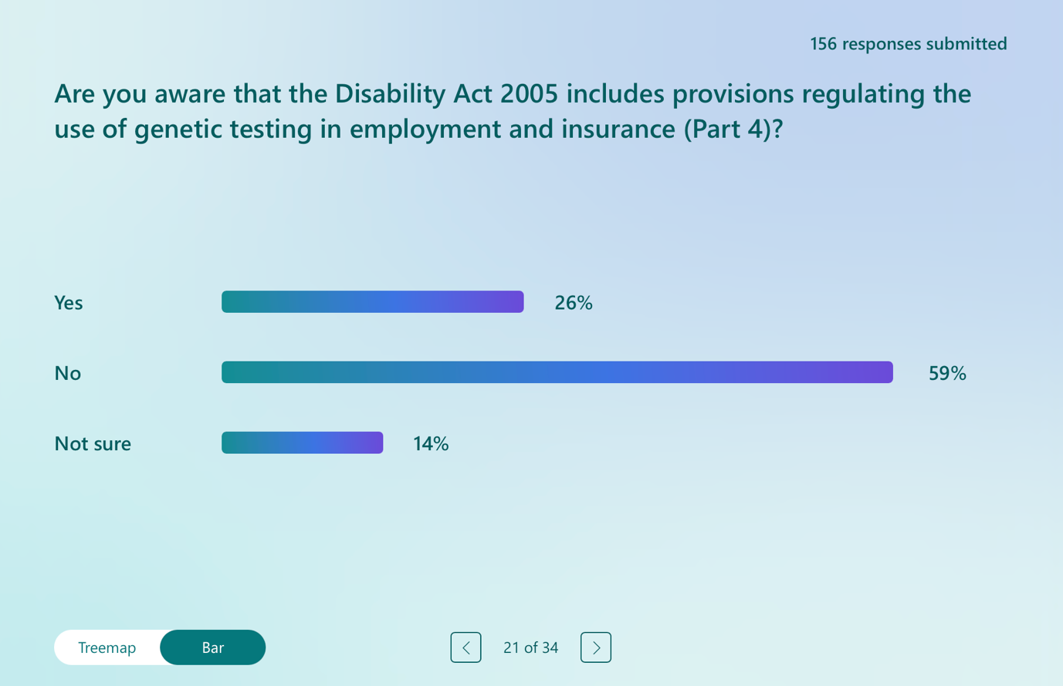

This question opened the section of the survey examining awareness of lesser-known provisions of the Disability Act 2005, specifically Part 4, which regulates the use of genetic testing in employment and insurance. Respondents were asked whether they were aware that such provisions exist within the Act. Responses indicate low levels of awareness of Part 4. Only 41 respondents reported that they were aware that the Disability Act 2005 includes provisions regulating genetic testing in employment and insurance. By contrast, a large majority, 91 respondents, indicated that they were not aware of these provisions. A further 22 respondents selected ‘not sure’, suggesting uncertainty or partial awareness. These responses highlight a significant lack of awareness of Part 4 of the Disability Act 2005 among respondents. This is notable given the potential implications of genetic testing for discrimination in employment and insurance contexts. The results suggest that these provisions are not well understood or visible in practice.

Qualitative Analysis of Open-Ended Responses: Responses on Genetic Testing Provisions

Although only 20 respondents addressed this question, the responses reveal important concerns about awareness, privacy, ethics, and disability identity. While there is broad support for protections against discrimination based on genetic information, significant tensions emerged between medical, rights-based, and identity-focused understandings of disability.

Theme 1: Low Awareness and Limited Practical Visibility

A key theme was limited awareness of the genetic testing provisions and a perception that they are largely invisible in practice. Many respondents explicitly stated that they were unaware this part of the Act existed. This lack of visibility was described as troubling given the potential implications of genetic testing for privacy, employment, and insurance. Respondents characterised the provisions as existing “on paper” but not meaningfully communicated, monitored, or embedded in public consciousness.

“Honestly, I don’t know anything about this aspect of the Act, which in itself is quite worrying. If such provisions exist, they don’t appear to be widely communicated or understood by the general public. This lack of awareness raises concerns about transparency and accessibility of information on an issue that could have significant ethical and personal implications.” Respondent 54

“Utter absence in practice.” Respondent 86

Theme 2: Strong Support for Privacy and Anti-Discrimination Protections

Among respondents who were aware of Part 4, there was clear support for regulating genetic testing to prevent discrimination in employment and insurance. Respondents emphasised the importance of protecting genetic data from intrusive collection and misuse. Several responses referenced experiences of excessive medical data collection in occupational health contexts, reinforcing the perceived need for robust safeguards. The principle that disability should not justify additional intrusion into personal medical information was strongly articulated.

“Just because you have a disability does not give your employer… the right to intrude on your medical genetic data… If other citizens had this much intrusion it would be all over the press as a civil rights issue.” Respondent 154

Theme 3: Ethical and Identity-Based Concerns about Genetic Framing

A more complex theme concerned ethical tensions surrounding genetic testing itself. While some respondents viewed genetic testing as beneficial for preventative healthcare and diagnosis, others expressed concern that genetic framing reinforces a deficit-based medical model of disability. Particularly strong concerns were raised by Deaf respondents and advocates, who warned that genetic narratives risk portraying. This theme reflects broader concerns about genetic determinism and the compatibility of Part 4 with the CRPD and the human rights model of disability.

“There is a risk that Deafness is treated as something to be ‘prevented’ rather than as part of human diversity… The Act must include clear safeguards to protect Deaf people’s rights to privacy, equality and identity.” Respondent 103

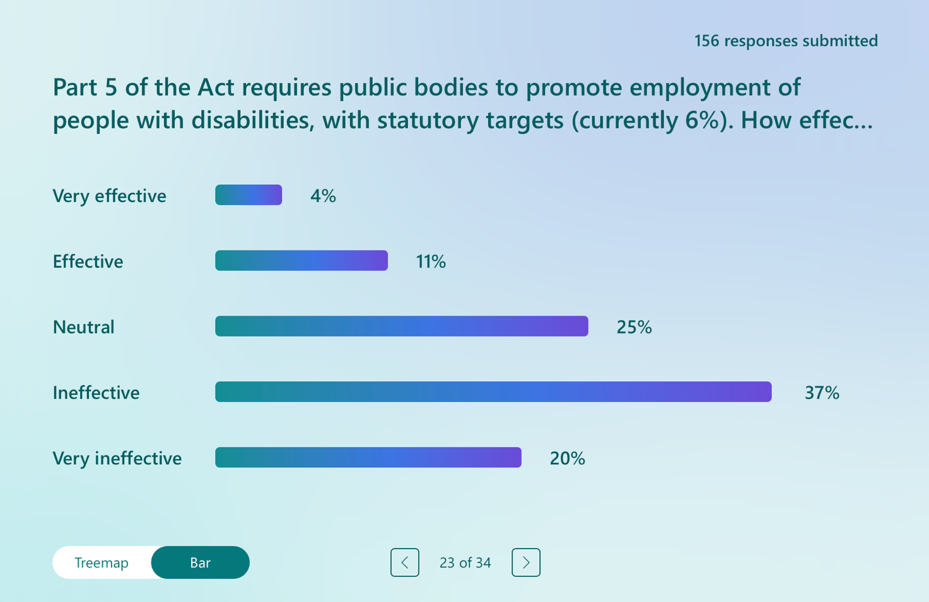

In response to the question on the effectiveness of the statutory employment targets under Part 5 of the Disability Act 2005, respondents expressed predominantly negative or ambivalent views. Only a small number of respondents viewed the targets as effective, with 7 respondents describing them as very effective and a further 18 considering them effective. Thirty nine respondents selected a neutral response, indicating uncertainty or mixed experiences regarding the impact of the targets. By contrast, a substantial proportion of respondents rated the targets as ineffective. Fifty eight respondents described the employment targets as ineffective, while 32 respondents rated them as very ineffective. These responses indicate that significantly more respondents view the statutory targets as ineffective rather than effective. Therefore, the responses suggest that the employment targets under Part 5 are not widely perceived as delivering meaningful or transformative change in employment outcomes for disabled people. The high number of negative responses points to concerns about how the targets are implemented, monitored, and enforced in practice, and provides important context for subsequent questions examining experiences of employment, reasonable accommodation, and workplace inclusion under the Act.

Qualitative Analysis of Open-Ended Responses: Responses on Public Sector Employment Quotas

The follow-up question invited respondents to elaborate on their views regarding the impact of the Disability Act 2005 on the employment of disabled people in the public sector. While a minority of respondents acknowledged positive developments, the overwhelming pattern across responses was that Part 5 has had limited transformative effect.

Theme 1: Symbolic Progress but Limited Transformative Impact

Respondents widely recognised that the introduction of statutory employment targets, initially set at 3% and later increased to 6%, placed disability employment on the public sector agenda and improved visibility through annual reporting to the National Disability Authority. For some, they described the Act as an important symbolic commitment and a baseline expectation of representation and meaningful participation in the labour market. However, many respondents characterised the impact as modest and incremental rather than systemic. Progress was described as slow and uneven, with some public bodies continuing to fall short of targets decades after enactment.

“6% as of 2005 has not been reached by 2025, according to the State itself. Shows how wishy-washy the Disability Act was.” Respondent 128

“[P]erhaps it has raised awareness but it hasn’t put people on equal footing.” Respondent 9

Theme 2: Targets as Ceilings and Compliance

A significant concern was that the 6% quota functions as a ceiling rather than a floor. Respondents repeatedly suggested that public bodies aim to meet, but not exceed, the minimum threshold. This was viewed as limiting ambition and reinforcing tokenistic approaches to inclusion. This perspective reflects the view that numerical targets, when treated as maximum limits, distort equal opportunity. Some respondents suggested rather than embedding disability inclusion as a core organisational value, the quota may instead incentivise minimal compliance. Other respondents went further, questioning the quota model itself and arguing that meaningful change requires structural reform rather than statistical thresholds.

“Six percentage… is very good and effective. However once that company reaches that 6% that’s it – they do not have any more people with disabilities even though they are just as qualified.” Respondent 58

“Token inclusion/ token employment is not enough.” Respondent 593

Theme 3: Weak Enforcement and Limited Accountability

Consistent with findings across other parts of the survey, weak enforcement emerged as a central theme. Respondents noted that compliance with Part 5 is largely self-reported and that there are no meaningful consequences for public bodies that repeatedly fail to meet targets.

This perceived absence of sanctions or corrective mechanisms undermined confidence in the seriousness of the statutory obligation. Some respondents pointed to failures in broader strategies, including the Comprehensive Employment Strategy and National Disability Inclusion Strategy, describing missed opportunities for measurable outcomes and accountability. The quota was therefore frequently described as aspirational rather than enforceable, contributing to uneven progress across departments and agencies.

“The HSE has missed the target for the past 5 years.” Respondent 27

Theme 4: Structural Barriers, Inaccessibility, and the Limits of Numerical Targets

Many respondents described the disconnect between numerical representation and meaningful inclusion within workplaces. Respondents emphasised that meeting a percentage target does not guarantee accessible workplaces, effective reasonable accommodations, retention, or career progression. Accounts provided by respondents highlighted inaccessible buildings, delayed assistive technology, inaccessible IT systems, undertrained staff, and lack of managerial awareness about disability and the quota.

“The numerical goal is unhelpful if the working environment remains inaccessible.” Respondent 45

Others described deeper structural barriers. People with intellectual disabilities were said to be offered “poorly paid menial jobs that nobody else wants to do” (Respondent 12). Deaf respondents identified barriers at every stage of recruitment and employment, from inaccessible interviews to lack of interpreting services in meetings and training. Fear of losing social protection supports, including medical cards and disability allowance, was also described as a significant disincentive to employment. Therefore, the limitations of Part 5 were described as evidence that numerical quotas alone cannot dismantle structural and attitudinal barriers that restrict disabled people from the labour market.

“[B]inding obligations, strong reasonable accommodation policies, proactive recruitment and retention measures, and meaningful consequences for non-compliance. This would align Ireland’s public sector more closely with the UNCRPD and set a leadership example.” Respondent 2

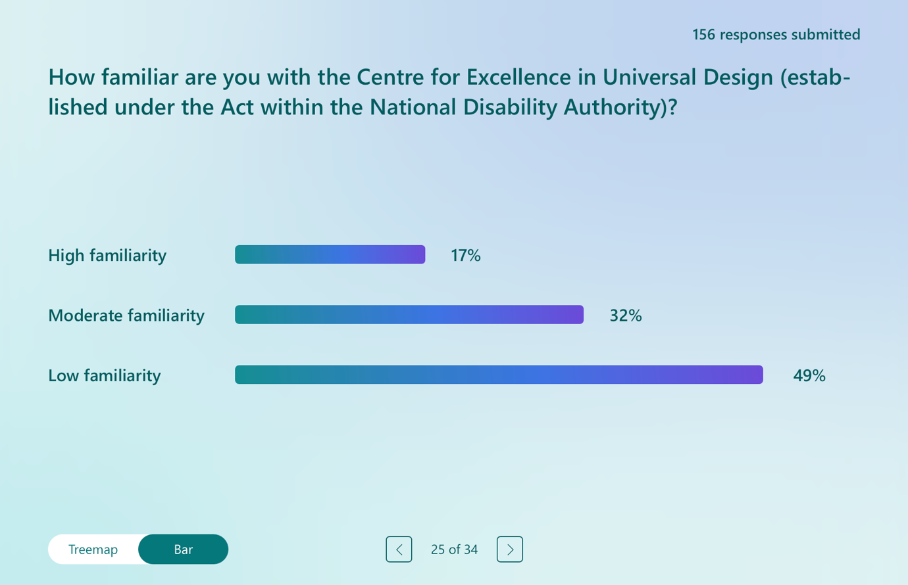

In response to the question on familiarity with the Centre for Excellence in Universal Design, established under the Disability Act 2005 within the National Disability Authority, respondents reported generally low to moderate levels of awareness. Only 28 respondents indicated a high level of familiarity with the Centre. A further 51 respondents reported moderate familiarity, suggesting some awareness of the Centre’s role and work without detailed knowledge. The largest group, comprising 77 respondents, indicated low familiarity with the Centre for Excellence in Universal Design. These responses suggest that while the Centre for Excellence in Universal Design is recognised by some respondents, particularly those working in disability, policy, or design-related fields, awareness remains limited among a significant proportion of survey participants. This lack of familiarity may constrain the broader impact of the Centre’s work.

Qualitative Analysis of Open-Ended Responses: Responses on the Centre for Excellence in Universal Design

The follow-on question invited respondents to share their views on the Centre for Excellence in Universal Design, established under Part 6 of the Disability Act 2005 within the National Disability Authority. While respondents widely recognised CEUD’s expertise and symbolic importance, the dominant narrative across the dataset was one of frustration at limited systemic impact.

Theme 1: CEUD as a Respected and Internationally Recognised Leader

Respondents acknowledged CEUD’s high-quality guidance, thought leadership, and international standing. Many described it as a world leader in universal design, noting that Ireland’s statutory establishment of a dedicated universal design centre is unusual in comparative perspective. Its toolkits, standards, digital accessibility work, and engagement with professional education were widely praised. Universal design itself was framed as transformative in principle, capable of shifting Ireland from a deficit-based model of disability to a social and inclusive model.

“Regarded as an international leader in the field – very impressive.” Respondent 13

“The Centre for Excellence in Universal Design… is a world leader in advocating for and progressing the development of accessible and inclusive societies.” Respondent 152

Theme 2: Strong Guidance but Weak Translation into Practice

Despite recognising CEUD’s leadership, a number of respondents described a significant implementation gap. Universal design principles were seen as well-articulated in policy documents but poorly reflected in lived environments. New schools, housing developments, and public buildings were frequently cited as examples of poor design, including unnecessary steps, hostile sensory environments, inaccessible apartments, and inadequate adaptability for ageing or disability. Universal design was often described as “aspirational” rather than embedded in practice.

“It's a wonderful wonderful thing that produces no difference to anyone's real life. Working in the disability sector I heard it wheeled out to sound impressive, but never saw the principles applied ever.” Respondent 111

Theme 3: Advisory Status and Lack of Regulatory Power

A central explanatory theme concerned CEUD’s advisory mandate. Respondents emphasised that CEUD lacks statutory authority to compel compliance, embed universal design within building regulations, or influence planning decisions in a binding way. Its impact was seen as dependent on the goodwill of departments, local authorities, planners, and developers. The absence of enforcement mechanisms was described as a structural limitation that fundamentally constrains systemic change.

“Statutory powers are lacking to enforce universal design. It relies completely on voluntary cooperation.” Respondent 75

“It is an excellent unit… at the moment it just promotes best practice.” Respondent 132

Theme 4: Narrow Conceptions of Universal Design and Insufficient Co-Production

A number of respondents also criticised how universal design is interpreted and implemented in practice. Accessibility was described as frequently being reduced to physical access, with insufficient attention to communication accessibility, sensory environments, neurodiversity, Irish Sign Language, and lived expertise. Deaf respondents and others emphasised the need for meaningful co-production with Disabled Persons’ Organisations and criticised insufficient alignment with Article 4(3) of the CRPD. Some respondents argued that expert-led models continue to marginalise disabled people’s lived experience in design processes.

“True universal design must include sign language and visual accessibility in digital services, websites, public information and customer communication.” Respondent 103

“It recognises experts other than the person with a disability. We are experts in the field and co-design opportunities are not always envisaged or practiced.” Respondent 156

Section 7 of the Survey: International and European Perspectives

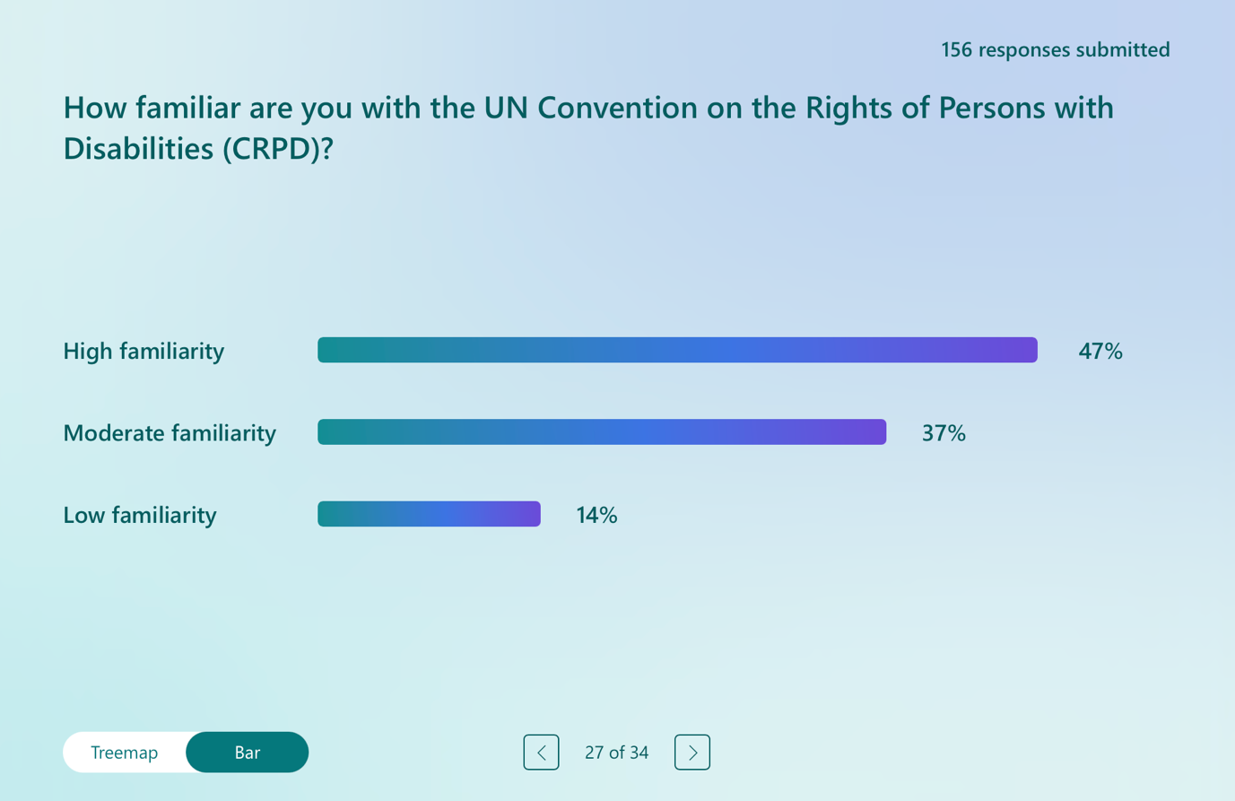

The first question in this section of the survey asked respondents about their familiarity with the CRPD. A substantial proportion of respondents reported moderate to high levels of familiarity. Seventy four respondents indicated a high level of familiarity with the Convention, while a further 59 respondents reported moderate familiarity. In contrast, 23 respondents indicated low familiarity with the CRPD. The responses suggest that awareness of the CRPD among survey respondents is relatively strong, particularly when compared with familiarity levels reported for other institutional mechanisms under the Disability Act 2005. This reflects the profile of the survey sample, which included disabled people, advocates, professionals, and public servants with an interest in disability rights. However, the presence of a smaller but notable group reporting low familiarity also highlights the continued need for broader dissemination and education on the CRPD and its relevance to disability law and policy.

Qualitative Analysis of Open-Ended Responses: Responses on Aligning the Disability Act 2005 with the United Nations Convention on the Rights of Persons with Disabilities (CRPD).

This follow-on question invited respondents to suggest changes to the Disability Act 2005 to better align it with the CRPD. Across responses, there was a strong and consistent consensus that meaningful alignment with the CRPD requires structural reform of the Disability Act 2005. Respondents repeatedly emphasised that the Act must move from an administrative and service-based framework to an enforceable human rights statute grounded in the social and human rights model of disability.

Theme 1: Transforming the Act into an Enforceable Human Rights Statute

A dominant theme was the need to transform the Disability Act from a framework centred on public body obligations into one that explicitly recognises disabled people as rights-holders. Respondents criticised the prevalence of conditional clauses in the 2005 Act such as limiting obligations to the notion of being “practicable,” arguing that these undermine the enforceability of rights and deny equality to disabled people. There were repeated calls for binding entitlements, statutory timelines, progressive realisation duties with accountability mechanisms, and access to effective remedies. Respondents emphasised that without enforceable consequences for non-compliance, accessibility, inclusion, and participation would continue to remain aspirational. The Act was frequently described as operating more as guidance than law.

“The Disability Act 2005 ought to move away from the medicalised and service-based approach from when it was introduced. Instead, it ought to reflect the social model set out in the UNCRPD. To be fit-for-purpose in today’s Ireland, the Act should recognise disabled people as rights-holders with equal entitlement to participation, autonomy, and non-discrimination, rather than as service users with “needs” to be managed.” Respondent 62

Theme 2: Re-Founding the Act on the Social and Human Rights Model of Disability

Respondents strongly advocated for replacing the medicalised and deficit-focused framework underpinning much of the current Act with the social and human rights model articulated in the CRPD. Many respondents identified the need to redefine disability as the interaction between individuals and societal barriers, rather than as a condition located solely within the person. Many criticised the continued emphasis on diagnosis and expert-driven gatekeeping to services, arguing that this reinforces stigma and restricts access to supports. Reform was also described as requiring doctrinal change, including updating the definition of disability, aligning capacity provisions with Article 12 of the CRPD and the Assisted Decision-Making framework, and integrating language and cultural rights protections, including for Deaf Irish Sign Language users.

“Move (in practice, not just theoretically) to a social model of disability and follow it.” Respondent 146

Theme 3: Ending the Assessment-Service Divide and Embedding Rights Across the Lifecourse

Another strong theme concerned the structural separation between assessment and service provision, particularly under Part 2. Respondents described the right to an Assessment of Need as hollow in the absence of a corresponding right to socio-economic rights such as, healthcare, housing, or education etc. There were repeated calls to link assessment directly to enforceable service provision, introduce binding timelines for intervention, extend rights across the lifecourse rather than limiting them to early childhood, and ensure continuity at key transition points, particularly from childhood to adulthood. Child-centred reform was emphasised by some respondents, with references to participation rights and the need to embed the voice of the child in decision-making processes.

“Provision only in law for assessment of needs not sufficient with zero entitlement to the actual services/supports/housing.” Respondent 147

Theme 4: Independent Living and Inclusion in the Community

In discussing the need to align domestic law in Ireland with the CRPD, respondents frequently drew upon Article 9 (Accessibility), Article 19 (Living independently and being included in the community), Article 27 (Work and employment), and Article 28 (Adequate standard of living and social protection) in articulating their proposals for reform.

Respondents highlighted the need for accessible housing, personal budgets, and community-based supports, as well as the removal of structural barriers that leave disabled people either trapped in poverty or forced into segregated or institutional forms of housing due to a lack of viable community-based alternatives. There were calls to remove or reform means testing arrangements that disincentivise employment or penalise family life, embed universal design within building regulations and planning law, strengthen communication accessibility, and ensure that disabled people can live where and with whom they choose.

“Surely… we have the right to education… the right to marry… the right to live well fulfilling life, and that if you do become disabled in the morning, you do not have to live in poverty.” Respondent 104

Theme 5: Independent Enforcement and Meaningful Participation

Respondents to this question consistently emphasised that alignment with the CRPD requires robust enforcement and meaningful participation for disabled people. The current enforcement framework was described as fragmented, slow, and largely non-binding, placing an unfair burden on disabled people and families to pursue redress. There were repeated calls for the establishment of an independent statutory enforcement and monitoring body, consistent with CRPD Article 33, with powers to investigate, issue binding determinations, impose sanctions, and require remedial action. Respondents also stressed the need to embed participation duties in line with Articles 4(3) and 33(3) of the CRPD, ensuring that Disabled Persons’ Organisations are meaningfully involved in drafting, implementation, and monitoring. Participation was described as a matter of democratic legitimacy.

“Improve monitoring and enforcement of the act, introduce fines and penalties for breaches of the act, allow DPOs to make complaints and seek redress on behalf of members.” Respondent 90

Qualitative Analysis of Open-Ended Responses: Responses on the Role of the EU in Advancing Disability Rights

Respondents were invited to share their views on the role of the European Union in advancing disability rights following its ratification of the CRPD and its initiatives in areas such as employment, accessibility, and digital regulation. Some of the responses to this question were nuanced while others shared a more ambivalent perspective in relation to the relevance of EU law. While many respondents acknowledged the EU’s positive influence in setting standards and promoting rights-based frameworks, there was also strong scepticism regarding enforcement, implementation gaps, and the translation of EU commitments into practical measures within the Irish system that benefited disabled people.

Theme 1: The EU as an External Accountability Mechanism

A theme across responses was that the EU’s most valuable function lies in its potential to hold Member States accountable. Many respondents expressed frustration with weak domestic enforcement of disability rights legislation in Ireland and perceived a culture of delay, minimal compliance, or symbolic implementation. In this context, EU monitoring, reporting mechanisms, peer review, and potential sanctions were viewed as necessary counterweights to inertia at the national level. A number of respondents explicitly called for financial penalties, infringement procedures, or stronger compliance mechanisms. Their argument was that without consequences, rights remain illusionary for disabled people. Other respondents emphasised the importance of reporting across the Member States of the EU, benchmarking which provides comparative metrics to expose disparities between Member States.

“They really need to start financially penalising countries like Ireland who have a despicable record on disabled rights.” Respondent 136

Theme 2: Persistent Gap Between EU Policy Frameworks and Lived Experience

While some respondents recognised the significance of EU level initiatives such as the European Accessibility Act, the Web Accessibility Directive, and the Disability Rights Strategy 2021-2030, many highlighted a gap between policy and delivering for disabled people across the EU. Families navigating education, assessment processes, housing systems, and employment supports described structural fragmentation, information barriers, and administrative barriers to services and supports. For these respondents, EU ratification and strategy documents have not translated into accessible, timely, and coordinated supports domestically. It is important to acknowledge that the European Union’s competence in disability related matters is limited and shared with Member States. The EU’s accession to the CRPD applies within the scope of its conferred competences, and many areas raised by respondents including education, health, housing, and social protection remain primarily the responsibility of Member States. Therefore, the implementation gap identified by respondents reflects some shortcomings in EU level oversight, and also the structural limits of EU law and the continued responsibility of Member States to give full domestic effect to CRPD obligations.

“The European Union plays an essential role in advancing disability rights across Member States by promoting accountability, equality, and consistency in how the UNCRPD is implemented. However, more needs to be done to ensure that EU-level commitments translate into tangible improvements in people’s daily lives, particularly for children and families navigating fragmented disability services… Stronger EU oversight, investment, and peer review could help ensure that Ireland… and all Member States move from policy alignment to real implementation”. Respondent 113

Theme 3: Participation and Representation of Disabled Persons’ Organisations at EU Level

Another significant theme concerned democratic legitimacy and representation within EU governance structures. Respondents emphasised that meaningful implementation of the CRPD requires active participation of Disabled Persons’ Organisations, consistent with Article 4(3) of the Convention. Some respondents criticised both EU and national processes for privileging industry or other organisations in consultations, resulting in what was described as tokenism rather than co-production. There were calls for stronger institutional mechanisms to embed DPOs in monitoring, policy design, and strategic planning at European level.

“Yes, however, DPOs must be part of the consultation process again… Instead, it is defined by industry non-disabled organizations and tokenism.” Respondent 26

“The EU, as an institution, has no concept of Article 4 (3) in terms of implementation. e.g., its forms.” Respondent 128.

Theme 4: The EU as a Driver of Harmonisation and Cross-Border Coherence

Respondents also identified the EU’s capacity to establish shared standards across Member States as a significant strength. Harmonised accessibility requirements, common digital standards, employment equality frameworks, and cross-border mobility initiatives were described by some respondents as important mechanisms for promoting consistency and raising baseline expectations, thereby reducing uncertainty and practical barriers for disabled people travelling, working, studying, or accessing services across EU Member States. Several respondents noted that uniform standards enhance confidence for disabled people travelling, working, or studying across Member States. The importance of maintaining consistent legal protections for disabled people across jurisdictions was emphasised on the island of Ireland following Brexit was also highlighted, particularly in light of potential divergence in legal protections and service entitlements.

“The EU should be setting clear standards and working to ensure all countries provide consistent access… so that a [blind visually impaired] person in one country can more easily travel to another member state with relative confidence that their mobility skills will transfer.” Respondent 71

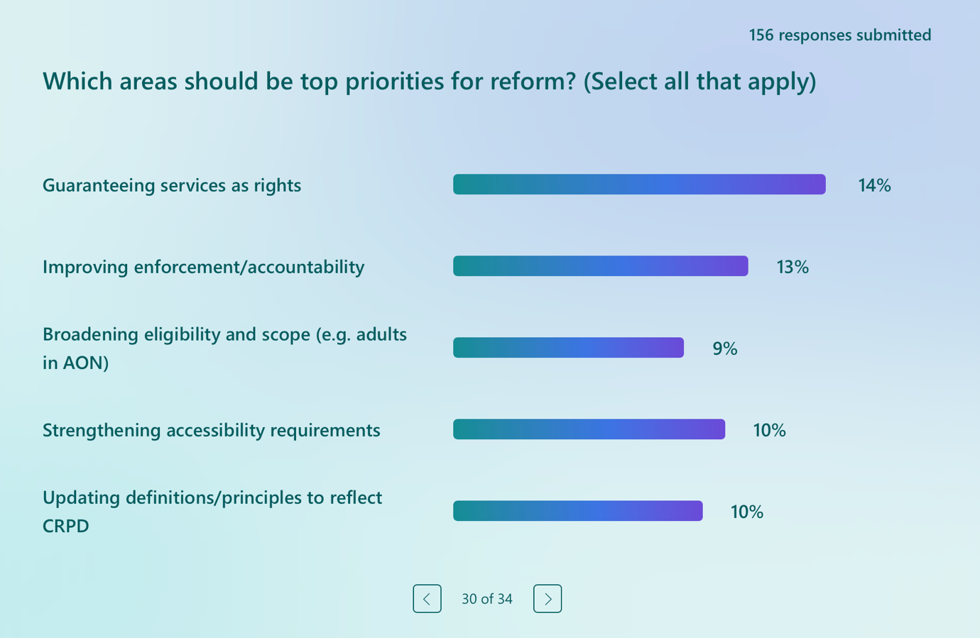

This question asked respondents to identify priority areas for reform, with the option to select multiple responses. The pattern of responses shows a very strong and consistent message about the direction reform should take. The most frequently selected priority was guaranteeing services as enforceable rights, chosen by 127 respondents. This reinforces a central theme that emerged throughout the survey, namely dissatisfaction with a framework that provides assessments, duties, or aspirations without corresponding legal entitlements to services and supports. Closely aligned with this, 114 respondents identified improving enforcement and accountability as a top priority, underscoring the widespread view that the Act lacks “teeth” and that obligations on public bodies are rarely translated into practice. A similarly strong emphasis was placed on inclusion and participation. Enhancing inclusion in employment was selected by 111 respondents, while 103 identified inclusion in education as a priority. These responses indicate that respondents view employment and education as core pathways to equality and social participation, and areas where the Disability Act has fallen short in delivering meaningful change. The right to live and be included in the community was also identified by a large majority of respondents (116), highlighting the importance of independent living, community based supports, and alignment with Article 19 of the CRPD.

Accessibility and conceptual reform were also prominent. Strengthening accessibility requirements was selected by 93 respondents, reflecting continued concern about barriers in the built environment, services, and information etc. Updating definitions and principles to reflect the CRPD was chosen by 86 respondents, signalling strong support for moving away from medicalised or deficit based understandings of disability towards a social and human rights model. Finally, 80 respondents identified broadening eligibility and scope, such as extending Assessment of Need beyond young children, as a priority. This suggests significant concern about age based exclusions and gaps across the life course. These responses reinforce earlier findings in the survey: respondents are calling for a shift from a discretionary, process focused framework towards a rights based, enforceable, and inclusive model grounded in the CRPD.

Section 8 of the Survey: Review and Reform of the Disability Act 2005

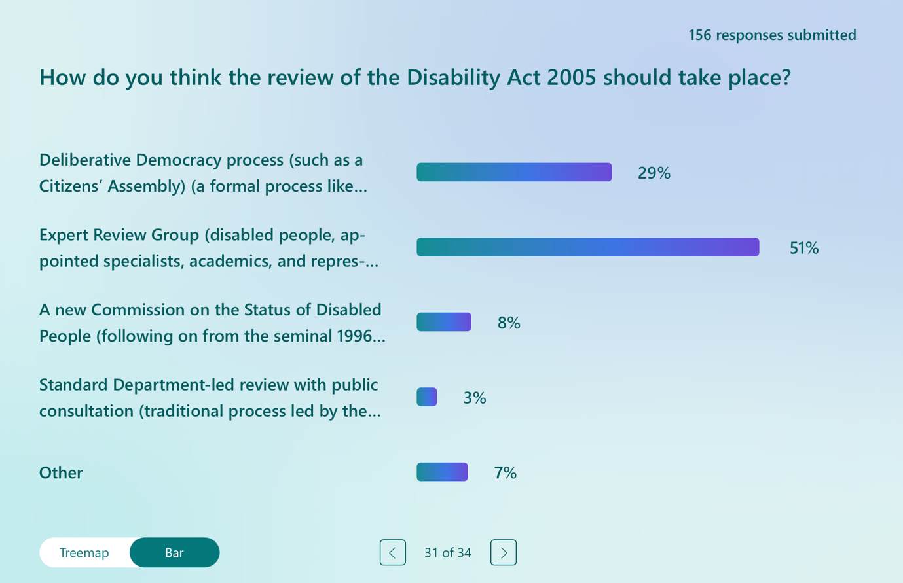

The first question in this section of the survey asked participants as to their view as to how the review of the Disability Act 2005 should take place. Responses to this question indicate a clear preference for inclusive, expertise driven, and participatory approaches to reviewing the Disability Act 2005, rather than traditional, department led processes. The most frequently selected option was an Expert Review Group, chosen by 80 respondents. This option explicitly centred disabled people, disabled persons’ organisations, academics, and appointed specialists. This indicates strong support for a structured process grounded in lived experience, rights based expertise, and independent analysis. This preference aligns closely with the CRPD’s requirements on participation and consultation, particularly Articles 4(3) and 33(3). A Deliberative Democracy process, such as a Citizens’ Assembly, was selected by 46 respondents. This indicates notable support for a transparent and publicly visible process that would place disability rights within broader societal deliberation, similar to previous constitutional and policy reforms in Ireland. Respondents’ earlier qualitative comments suggest that such a process is seen as a way of building political momentum and public understanding, rather than relying solely on technical reform. Far fewer respondents supported more traditional or government led mechanisms. Only 5 respondents favoured a standard Department led review with public consultation, signalling low confidence in conventional consultation models to deliver meaningful reform. Similarly, just 13 respondents selected the option of establishing a new Commission on the Status of Disabled People, despite the historic significance of the 1996 Commission. A further 12 respondents selected “Other”, indicating that some participants envisaged alternative or hybrid models, potentially combining expert led processes with deliberative or participatory mechanisms. The responses demonstrate a strong appetite for a review process that is independent of government, grounded in disability rights expertise, and meaningfully inclusive of disabled people and their representative organisations. There was no appetite for a narrow, administrative review driven by a single Department.

Qualitative Analysis of Open-Ended Responses: What Role Should Disabled People Play in the Review of the Disability Act 2005?

This open-ended question generated a very high level of engagement, with 149 of the 156 respondents taking the time to answer this question. Across short and extended answers alike, there was near-universal agreement that disabled people must occupy a central and decisive role in the review process.

Theme 1: Leadership, Not Tokenistic Consultation

The most dominant and consistent message across responses was that disabled people should not just be consulted but should lead the review process. Respondents frequently used emphatic language such as “central”, “front and centre”, “lead”, and “control”. Many explicitly rejected what they described as tokenistic or symbolic participation. Leadership was framed as a matter of legitimacy. Respondents argued that those directly affected by the legislation should shape its reform, and that decision-making authority should not rest solely with civil servants, academics, or service providers. Several suggested that review bodies should be chaired by disabled people and that disabled participants should hold substantive positions within any expert or advisory group. This theme reflects a clear shift from advisory participation to shared or primary governance.

“Nothing about us, without us.” Respondent 129

“Disabled people must be at the centre of the review of the Disability Act 2005 – not just consulted, but meaningfully involved at every stage of the process.” Respondent 155

Theme 2: Co-Creation and Genuine Decision-Making Power

Closely related to leadership was the demand for co-production. Respondents distinguished between consultation after proposals are drafted and involvement in shaping the process itself. Many stressed that disabled people should influence agenda-setting, priority identification, evidence assessment, drafting, and implementation planning. Therefore, participation was described as both structural and procedural. Respondents rejected models in which disabled people are asked for views on decisions already taken. Disabled people emphasised the importance of shared authorship of reform and equal representation on review panels alongside policymakers and experts. Several responses also referenced deliberative democracy models or citizens’ assemblies, although some cautioned that random selection mechanisms must not dilute disabled majority representation. Respondents made clear that how the review is conducted will itself demonstrate whether the State is serious about adopting a human rights based approach to disability law.

“Disabled people should be front and centre as we are the ones who have first-hand daily lived experience.” Respondent 83

Theme 3: Recognition of Lived Experience as Expertise

Across the dataset, respondents repeatedly described lived experience as a form of expertise. Disabled people explained that they are uniquely positioned to identify practical barriers, implementation failures, and gaps between statutory language and how the law operates in practice. The phrase “experts by experience” recurred in multiple responses. Several respondents contrasted lived knowledge with what they described as abstract, political, or industry-driven perspectives. There was also explicit concern about historical patterns in which disability policy in Ireland has been shaped by service providers or professional bodies rather than disabled people themselves. This theme reinforces the argument that participation is not only a democratic principle but a substantive contribution to better legislative design.

“The review should be led by disabled people. Even organisations that represent disabled people are often led by those without disabilities. Disabled people are the experts in our experiences. Nothing for us without us.” Respondent 71

Theme 4: Inclusion, Accessibility, and Representation of Diverse Voices

While there was strong consensus on leadership and co-production, many respondents also emphasised that participation must be inclusive and properly supported. This included calls for accessible materials, Irish Sign Language interpretation, Easy Read formats, personal assistance, remuneration for disabled people for their expertise, and sufficient time to review materials and prepare contributions to the process. Respondents highlighted the importance of ensuring representation across disability types, including intellectual disability, psychosocial disability, Deaf communities, visually impaired people, and those with complex support needs. Many respondents placed emphasis on including people who cannot easily self-advocate and on ensuring that children and young people’s perspectives are heard. Some respondents also referenced the role of families and carers, particularly where people rely on advocacy support, while maintaining that disabled people’s voices must remain primary. Respondents also emphasised the need to reflect the diversity of disabled people, including people with intellectual disabilities, psychosocial disabilities, Deaf and visually impaired people, children and young people, older persons, those with complex support needs, and those who communicate non-verbally.

“The discussion needs to be led by disabled people who are experts by experience. People who need more support to participate need to be facilitated.” Respondent 45

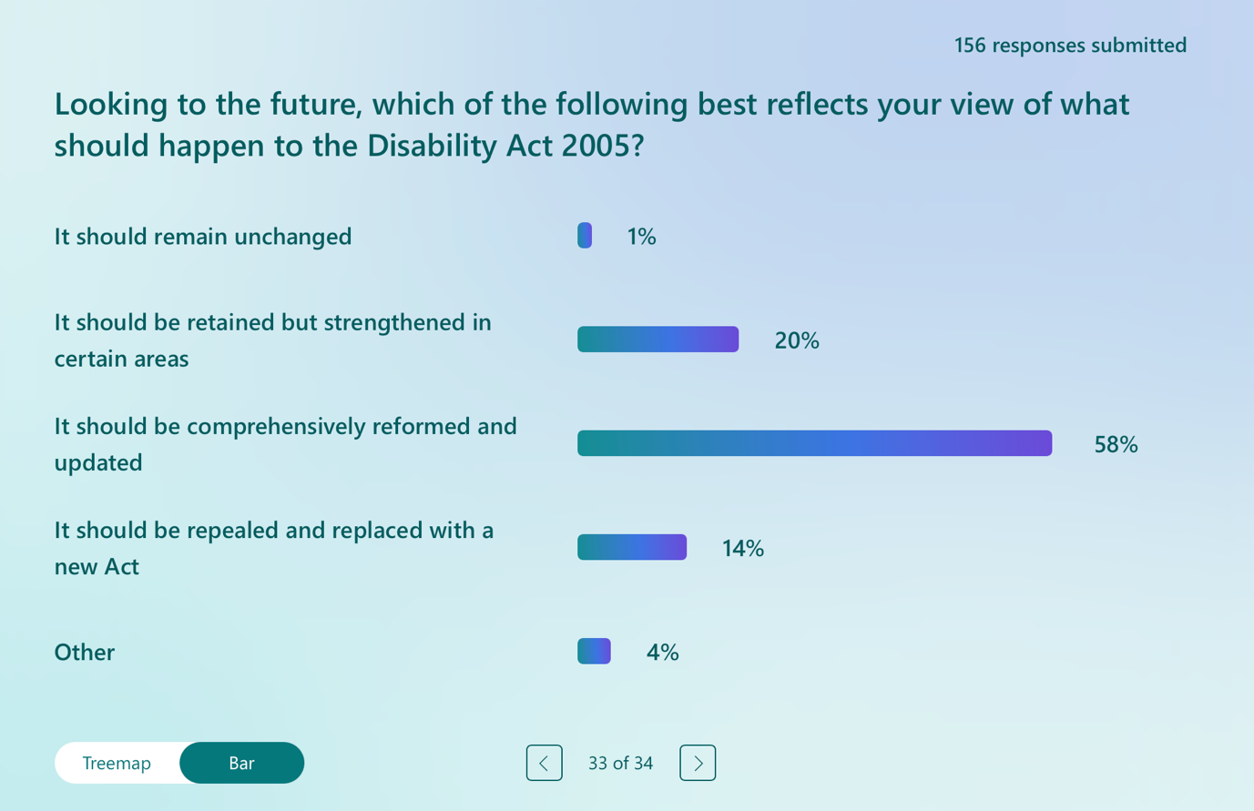

Responses to this question show an overwhelming consensus that the Disability Act 2005, in its current form, is not fit for purpose and must change in a substantial way. Only 3 respondents believed the Act should remain unchanged, indicating virtually no support for retaining the status quo. A further 32 respondents favoured retaining the Act but strengthening it in certain areas. These two positions represent a clear minority of views and suggest that incremental or technical reform alone would not meet respondents’ expectations. The dominant view is that the Act requires major structural reform. The largest group by a wide margin, 92 respondents, indicated that the Act should be comprehensively reformed and updated. This points to a strong belief that while the Act may provide a foundation, its underlying framework, principles, and mechanisms require significant revision to reflect contemporary understandings of disability, human rights, and Ireland’s obligations under the CRPD. A substantial minority went further, with 22 respondents indicating that the Act should be repealed and replaced with a new Act. This view suggests frustration with the limitations of the existing legislative architecture and a belief that its core design is too closely tied to outdated, service based or discretionary models to be effectively retrofitted into a rights based framework. The small number of “other” responses (7) likely reflects nuanced or conditional positions, but even when these are included, the overall pattern remains clear. Across the sample, there is a decisive rejection of minimal reform and strong support for either comprehensive overhaul or wholesale replacement. These findings indicate that respondents want decisive legislative action rather than incremental change. Whether through comprehensive reform or replacement, the clear message is that the Disability Act 2005 must be fundamentally reworked to deliver enforceable rights, align with the CRPD, and meaningfully improve the lived experience of disabled people in Ireland.

Qualitative Analysis of Open-Ended Responses: Final Comments on the Review of the Disability Act 2005

A total of 54 respondents out of 156 provided additional written comments in response to this optional question. The responses reinforce earlier findings in the survey. Respondents do not view the review as a routine legislative update. Respondents see the commitment in the Programme for Government as a once in a generation opportunity to deliver enforceable rights, close the implementation gap, reform assessment structures, and ensure that disability law reflects evolved human rights standards.

Theme 1: The Review as a Moment for Structural, Rights-Based Reform

Many respondents characterised the Disability Act 2005 as outdated, overly administrative, and insufficiently aligned with human rights standards. The review was widely described as an opportunity to move beyond procedural obligations toward enforceable rights, measurable outcomes, and robust accountability mechanisms. Respondents called for a fundamental reframing of the Act as a modern, rights-based instrument capable of ensuring inclusion of disabled people in society. Several emphasised the need to align with the CRPD, the ISL Act, and the Public Sector Equality and Human Rights Duty, while others warned that superficial amendment would fail to address long-standing structural inequities.

“The Act… is now outdated, overly administrative, and weak on enforcement, and it has not delivered the transformative change envisaged in 2005.” Respondent 1

“Simply amending the existing Act will not achieve meaningful change.” Respondent 54

Theme 2: Enforcement, Accountability, and the Gap Between Law and Practice

Echoing earlier responses a dominant theme across responses concerned weak enforcement and the persistent gap between statutory commitments and lived experience. Respondents expressed frustration at what they described as symbolic compliance, delay, and lack of consequences for non-compliance. There were repeated calls for independent oversight, meaningful sanctions, monitoring structures, and practical implementation mechanisms. Several responses conveyed anger at exclusion from employment, inaccessible buildings, or protracted administrative processes in accessing services. This reflects a clear view that legislative reform must be accompanied by enforceable obligations and institutional accountability.

“Less lip service, more effective interventions.” Respondent 20

Theme 3: Reforming Assessment of Need and Moving Beyond the Medical Model of Disability

Echoing earlier responses a number of responses focused specifically on the Assessment of Need framework and broader service structures. Respondents described the need for clearer timelines, follow-up obligations, named coordinators, and periodic review mechanisms. There was concern that supports remain diagnosis-driven rather than person-centred, and that rigid assessment processes can exclude those without specific labels. At a broader level, some respondents cautioned against the medical model of disability by embedding clinical models too rigidly in legislation, arguing that disability law should focus on rights, inclusion, and participation rather than “fixing” individuals. Others called for the Act to reflect the social and human rights model of disability more clearly.

“Clinical… services should not under any circumstances be enshrined in law… It also focuses on ‘fixing’ the disabled person rather than focussing on acceptance and the rights of the person.” Respondent 9

“The Assessment of Need should be a living document – one that evolves as the child or person’s circumstances change…. There should be a clear timeline for implementing recommendations from the Assessment of Need, and those actions should be followed up and carried out within that timeframe.” Respondent 33

Theme 4: Process Integrity, Urgency, and Inclusive Reform

A number of respondents revisited the importance of how the review itself is to be conducted. Several warned against prolonged or politically diluted processes and called for transparency, wide public communication about the review process, and accessible engagement mechanisms. Again, respondents called for co-production, inclusive consultation formats, and improved communication so that disabled people understand both the current Act and proposed changes. Some respondents framed the review as urgent, noting that delays in reform have real consequences for families and disabled people trying to navigate and access services and supports.

“It is good that this review is taking place, it must not become a long drawn not process, that is still being discussed in years to come. It must be inclusive, robust, fit for the future”. Respondent 29

“Urgent action is required.” Respondent 40

Conclusion

The findings of the national survey contain a clear message. Across the quantitative findings and qualitative accounts, respondents consistently describe a gap between the Disability Act 2005’s procedural commitments, particularly assessment and access duties, and the timely delivery of the services and supports those commitments were intended to facilitate. While certain elements of the Act, particularly in the area of accessibility and universal design, are acknowledged as important provisions, the dominant assessment is that the legislative framework is procedurally focused, weakly enforced, and undermined in practice by administrative discretion exercised within a context of persistent scarcity of resources.

Respondents identified the Assessment of Need regime as the key example to illustrate this structural weakness. Respondents described a system that guarantees assessment but not support, generates reports without delivery, and often produces delay rather than timely intervention. The employment quota is perceived as symbolic rather than transformative for access to employment for disabled people. The Access Officer role is regarded as under-resourced and inconsistently implemented. Enforcement mechanisms are seen as fragmented, slow, and lacking meaningful consequences. Across each part of the Act as surveyed, the same pattern emerges from respondents: obligations without enforceable outcomes, commitments without accountability, and procedural guarantees without corresponding entitlements to services and supports.

While many responses share frustration, disappointment, and at times distress, they do not reflect apathy. On the contrary, the emotional intensity of many of the submissions underscores how deeply the issues matter to respondents and how strongly they wish to see meaningful reform. 156 people participated in the survey, and a striking proportion provided detailed written responses. The qualitative data is extensive, reflective, and deeply considered. Respondents articulated a coherent and rights-based vision for reform. There is overwhelming support for transforming the Disability Act 2005 into an enforceable human rights statute aligned with the CRPD. Respondents call for binding timelines, independent oversight, meaningful sanctions for non-compliance, structural reform of the Assessment of Need framework, strengthened accessibility duties, and employment measures that move beyond numerical compliance toward substantive equality. Disabled people expect to lead the review process, not merely contribute to it.

The data reveals a decisive rejection of taking an incremental approach to reform. Very few respondents support retaining the Act in its current form. The dominant position is that comprehensive reform is required. Therefore, the Programme for Government’s commitment to review the Disability Act 2005 cannot be a technical exercise. Respondents see it as an opportunity to close the persistent gap between statutory promise and lived experience, particularly in relation to the right to live independently and be included in the community, access appropriate housing, secure personalised budgets and adequately resourced supports, and participate fully in education, employment, and public life. The findings of this survey identify that the central challenge facing disability law in Ireland is not the absence of legislative text, but the absence of enforceable rights and effective implementation. If the review of the Disability Act 2005 is to respond to the evidence presented here, it must confront the structural weaknesses identified by respondents and reimagine the Act as a rights-based framework capable of delivering practical, measurable, and enforceable equality for disabled people in Ireland.

Chapter 4: The Disability Act 2005 at 20: Report of the National Conference and Key Reform Themes

1. Introduction

On the 3rd of December 2025, a national conference entitled The Disability Act at 20: Reflecting and Reforming was held at the ILAS Building, University of Galway. The 3rd of December is International Day of Persons with Disabilities. The event marked twenty years since the enactment of the Disability Act 2005 and took place at a key moment. The Programme for Government 2025 contains a commitment to review and reform the Act in consultation with stakeholders. The conference was expressly designed to inform that review by bringing together disabled people, Disabled Persons’ Organisations, academics, legal practitioners, policymakers and policy makers for a structured, reflective and forward looking dialogue. The programme of the conference was carefully designed and sequenced. The programme was structured to build momentum across the day, with each session informing and shaping the next, rather than functioning as a set of stand-alone presentations.

The day opened with historical and legislative reflection in order to situate the Disability Act 2005 within its original political, social and normative context. This grounding was essential as reform must begin with an understanding of the Act’s origins, its ambitions, its compromises and the concerns raised at the time of enactment. Professor Shivaun Quinlivan revisited the legislative debates and the wider equality agenda of the late 1990s and early 2000s, which was an important reference point for the subsequent discussion.

The second phase of the conference focused on the presentation of findings from a national survey conducted in advance of the event. This empirical component was deliberately positioned early in the programme so that the voices of disabled people, families, professionals foregrounding lived experience and stakeholder perceptions re the 2005 Act. The third part of the conference moved to roundtable discussions centred on lived experience and implementation. These sessions were designed to bridge the gap between statutory text and how the 2005 Act operated in practice. Contributors reflected on Assessment of Need processes, accessibility provisions, enforcement mechanisms and the practical consequences of was the 2005 Act was designed. The programme was structured in this way to ensure that reform conversations were informed by analysis of law and policy and also by lived experience.

The fourth part of the conference addressed policy and institutional perspectives. Representatives of state bodies, oversight institutions and advocacy organisations were invited to respond to the themes emerging from earlier sessions. This sequencing allowed key actors to engage directly with the concerns articulated by disabled people and survey respondents. The aim here was not to stage adversarial debate, but to foster constructive engagement around the structural reform needed and to inform the pending review. The fifth part of the programme widened the lens to include European and international perspectives. This comparative framing was essential in light of Ireland’s obligations under the CRPD and the evolving role of European Union law in disability equality. This part of the conference highlighted that reform of the Disability Act 2005 is a domestic law reform process, but this process needs to be informed by consideration of Ireland’s obligations having ratified the CRPD in 2018.

The conference concluded with a synthesis of key themes and a call to action. This final part of the conference drew together historical reflection, empirical findings, lived experience, institutional response and comparative insight into a coherent set of reform imperatives.

The conference was not confined to formal presentations and panel discussions. There was rich contributions from the audience, spontaneous commentary and exchanges following panel contributions, which significantly informed the discussion on the 2005 Act. These contributions often sharpened emerging themes, grounded theoretical arguments in lived experience, and identified tensions between rights rhetoric and administrative practice under the 2005 Act. The conference structure deliberately allowed space for these interventions. Reform of the Disability Act 2005 cannot be undertaken in a credible or legitimate way without the central involvement of those most directly affected by it. Presenters, panellists and audience members were clear that the lived experience of disabled people cannot be treated as supplementary to legal or policy analysis, but rather as foundational to it. Representatives of Disabled Persons’ Organisations, self-advocates, and family members consistently emphasised that any review of the Act must embody the principle of “nothing about us without us”. This was not invoked as a slogan, but as a constitutional and democratic imperative for the review of the 2005 Act.

This chapter provides an overview of the themes that emerged across all sessions of the conference. It integrates formal presentations and panel discussions with audience contributions.

2. Opening Reflections: Legislative Memory, Legislative Compromise and Structural Gaps

Professor Shivaun Quinlivan opened the conference by situating the Disability Act 2005 within a longer trajectory of disability policy and equality reform in Ireland. She started in 1996, with the establishment of the Commission on the Status of People with Disabilities and the publication of its landmark report, A Strategy for Equality. That report, she reminded the audience, was strikingly ambitious both in scope and in conceptual framing. It addressed housing, transport, cost of living, employment, training, insurance, accessibility, health, education, technology, political participation, law reform, women and disability, sexuality and relationships, regional disparities, sport, leisure and cultural participation. It adopted a life cycle approach, recognising that disability policy must respond to the evolving needs of people across childhood, adulthood and older age. The Commission’s Report contained over 400 recommendations.

Among those recommendations was a proposal for a Disabilities Act that would explicitly set out the rights of persons with disabilities and provide mechanisms of redress where those rights were denied. The emphasis on enforceability was central to the Commission’s vision. The proposed Act was not conceived as a purely administrative framework for service coordination. Professor Quinlivan noted it was envisaged as a rights affirming instrument, one that would prohibit discrimination, require reasonable accommodation across sectors, and provide legal remedies when obligations were not met.

Professor Quinlivan situated this recommendation within its legislative context. The late 1990s and early 2000s saw the enactment of the Employment Equality Act 1998 and the Equal Status Act 2000, which prohibited discrimination in employment and in the provision of goods and services and imposed duties of reasonable accommodation. The proposed Disability Act was intended to “complete the picture” of equality protections. Anti-discrimination law alone was not considered sufficient. The broader equality agenda required structural measures addressing accessibility, public service delivery, sectoral planning and participation. In that sense, the Disability Act 2005 was originally conceived as part of an integrated equality architecture rather than as a stand-alone service statute.

However, the historical framing did not stop at aspiration. Professor Quinlivan then revisited the parliamentary debates that accompanied the introduction and passage of the Disability Bill. She described those debates as deeply contested. While the Bill was introduced with considerable political fanfare and positive media coverage, significant concerns were articulated at the time in Dáil Éireann. Critics warned that the definition of disability was unduly restrictive, that the scope of the Act was limited in critical respects, that the rights framework was weak or diluted, and that enforcement mechanisms were insufficiently robust. In addition she noted that administrative discretion remained too powerful and insufficiently constrained by enforceable entitlements.

Professor Quinlivan noted that many of the structural problems visible in 2025 had been explicitly predicted in 2005. The gap between those who viewed the Bill as a landmark achievement and those who believed it fell short of a rights based model never narrowed during the legislative process. The concerns raised in debate were not subsequently resolved through amendment or implementation. In that sense, she noted the difficulties identified twenty years later are not accidental, but rather the manifestation of design choices embedded in the Act at the time of enactment.

A central tension in the 2005 debates concerned the question of rights. The government of the day resisted framing the legislation as explicitly rights based. She noted that Government at the time were concerned that enforceable rights would lead to increased litigation and divert resources to legal proceedings rather than service provision. Professor Quinlivan addressed this historical critique directly. She observed that people do not go to court lightly. Litigation is rarely a preferred or easy option. It is typically pursued when administrative processes fail, when statutory duties are not fulfilled, and when disabled people or their families are left without meaningful alternatives. The framing of rights as a threat to public resources obscures the fact that enforceability is a mechanism of accountability. Without it, statutory promises risk becoming aspirational rather than tangible and accessible.

This discussion of enforceability provided a bridge to the present. Professor Quinlivan contrasted the celebratory media reception of the Act in 2005 with contemporary headlines. At the time of enactment, the Disability Act was heralded as a defining moment for disabled people and as evidence that disability services would no longer be “at the back of the queue”. It was described as part of a joined up National Disability Strategy and as a major step towards equality. Twenty years later, the dominant media narratives concern waiting lists, systemic dysfunction in the Assessment of Need process, and ministerial acknowledgements that delivery models require fundamental reform. The shift in public discourse underscores the central tension explored throughout the conference – how did legislation introduced with such optimism become associated with frustration, delay and ineffectiveness?

Professor Quinlivan’s reflections also implicitly anticipated later discussions on Ireland’s ratification of the CRPD. Although the Disability Act 2005 predated Ireland’s ratification of the CRPD by more than a decade, the principles of participation, accessibility, accountability and non-discrimination that underpin the Convention provide a contemporary benchmark against which the Act can now be assessed. Therefore, the conference framed the 20th anniversary as an opportunity to evaluate whether the Act aligns with Ireland’s obligations under international human rights law.

In setting the context in this way, Professor Quinlivan noted that the Disability Act 2005 was presented neither as an unqualified failure nor as a completed equality framework. Rather, she suggested that it should be understood as a product of its time, shaped by political compromise, framed within a pre CRPD environment, and marked by unresolved tensions between service provision and enforceable rights. The task facing participants she noted was to critique, but also to consider how those historical tensions might now be addressed in light of twenty years of implementation experience and in light of the new human rights obligations under the CRPD.

3. National Survey Findings

Dr Charles O’Mahony presented an overview of findings from the national survey entitled Disability Rights and the Review of the Disability Act 2005: Your Views, Your Voice. The survey, which was conducted in advance of the conference, was structured across eight sections and thirty three questions and was open to disabled people, family members, professionals, educators, legal practitioners, policymakers and advocates. It explored familiarity with the Disability Act 2005, perceptions of its effectiveness, experiences of Assessment of Need, accessibility provisions, awareness of Access Officers, enforcement and complaints mechanisms, public service employment obligations, universal design, and priorities for reform. For the purposes of the conference, Dr O’Mahony presented a preliminary analysis of the data in order to inform and stimulate discussion across the remainder of the day. The findings were not presented as a finalised research report. A full and detailed analysis of the survey findings is provided in Chapter 3 of this Report (see above).

4. Key Note Address Professor Anna Lawson

The session began with an introduction from Professor Shivaun Quinlivan, who noted that Professor Anna Lawson is the leading voice in international disability law and policy. Professor Quinlivan noted Professor Lawson’s longstanding work across international, European and domestic legal systems, her leadership of major multinational research projects, and her engagement with governments and disabled people’s organisations.

Professor Anna Lawson’s keynote address provided the normative and comparative context of the morning session. Her central message was that reform of the Disability Act 2005 must be approached within a multilayered legal framework that extends beyond domestic statute. It must be understood in light of Ireland’s obligations under international human rights law, particularly the CRPD, and within the evolving legal and policy landscape of the European Union. To examine the Act in isolation, she suggested, would risk reproducing the narrowness that has limited its transformative capacity over the past twenty years.

A key analytical contribution of Professor Lawson’s address was her discussion of the relationship between social and human rights models of disability. Drawing on her scholarship, she explained that the social model of disability, while transformative in challenging medicalised understandings of impairment, does not automatically translate into enforceable legal entitlements. The human rights model, as articulated in the CRPD, goes further. It grounds disability equality in inherent dignity, autonomy, participation, accessibility, equality before the law and access to justice. In other words, it is not just concerned with removing barriers but with restructuring legal and institutional frameworks so that disabled people are recognised as rights holders in every sphere of life.

In that context, she suggested that any reform of the Disability Act must confront a fundamental question: is the Act structured around administrative provision of services, or around recognition of enforceable rights? The distinction is not semantic. It determines the location of discretion, the nature of accountability and the pathways to redress. A rights based framework shifts the burden from people proving entitlement within constrained administrative schemes to the State demonstrating compliance with binding obligations.

Professor Lawson then turned to the European dimension. She emphasised that the European Union is itself a party to the CRPD. This means that EU institutions, when developing directives, regulations and policy frameworks, must interpret and apply their competences consistently with the Convention. The legal status of the CRPD within EU law is therefore significant. While it does not rank above the EU Treaties, it sits above secondary legislation, meaning that directives and regulations must be interpreted, where possible, in light of the Convention’s principles. The Court of Justice of the European Union has increasingly engaged with the CRPD in its jurisprudence, thereby embedding its principles into the interpretation of EU law.

This dynamic, she argued, creates important opportunities for Member States. EU level initiatives such as the European Disability Strategy, the European Pillar of Social Rights, accessibility legislation and sector specific directives increasingly integrate disability rights into mainstream policy areas. Accessibility, in particular, is no longer treated as an optional add on but is being mainstreamed across regulatory domains. This integration matters because it transforms disability equality from a marginalised policy concern into a cross cutting structural obligation.

Professor Lawson highlighted the difference between the United Nations and the European Union in operational terms. The UN, through the CRPD Committee, provides high level guidance, periodic review and interpretative general comments. However, its enforcement mechanisms are limited. The EU, by contrast, possesses regulatory, funding and judicial capacities that can operationalise rights commitments more concretely. EU funding streams can incorporate disability conditionality. Directives can impose binding obligations on Member States. Courts can reinterpret domestic measures in light of EU law informed by the CRPD.

In this light, she suggested that Ireland’s reform of the Disability Act 2005 should not be conceived as a purely national legislative revision. Rather, it should be framed as part of Ireland’s role within a broader European and international human rights order. EU commitments to independent living, accessibility and inclusion provide normative benchmarks. They also offer advocacy tools. Engagement with NGOs such as the European Disability Forum, monitoring developments in EU legislation, and invoking EU standards in domestic debate can strengthen reform efforts.

Professor Lawson also emphasised the importance of participation. The CRPD embeds the principle that disabled people and their representative organisations must be closely consulted and actively involved in decision making processes concerning issues relating to them. This principle she noted is not aspirational. It is legally binding. Therefore, reform of the Disability Act must embody the principle commonly articulated as “nothing about us without us”. Participation is not just procedural she noted, it is a substantive component of human rights compliance.

She concluded by reiterating that reform must avoid technical minimalism. Adjusting definitions, clarifying procedural timelines or refining administrative mechanisms may be necessary, but they are insufficient if the underlying paradigm remains service led rather than rights based. The 20th anniversary of the Disability Act presents an opportunity to align Ireland’s primary disability statute with the CRPD’s human rights model and to situate that alignment within the enabling structures of EU law.

4.1 Discussion Following the Keynote

The discussion that followed Professor Lawson’s keynote address reflected both the richness of her analysis and the practical concerns of those working within disability advocacy and service provision.

One audience member asked how EU level strategies, such as the European Disability Strategy and the European Pillar of Social Rights, might be leveraged in Ireland’s domestic reform process. They queried how advocates could ensure that aspirational EU commitments translate into tangible improvements in Member States, particularly in relation to independent living and access to practical supports.

In responding, Professor Lawson emphasised that EU membership provides multiple accountability pathways. Engagement with European networks allows civil society organisations to shape emerging standards. Once standards are articulated at EU level, they can be used to hold national governments to account. She noted that EU mechanisms, including funding frameworks, can incentivise compliance in ways that complement UN oversight processes.

Professor Quinlivan referenced discussions within the European Parliament identifying independent living, accessibility and education as priority areas. Particular emphasis was placed on the mainstreaming of accessibility into sector specific legislation, including energy efficiency directives. This was presented as evidence that disability rights are increasingly integrated into mainstream policy domains rather than confined to specialised disability instruments.

Another audience member drew on his experience in education, reflected on the Assessment of Need process as generating hope without delivering proportionate capacity. He also highlighted low levels of employer awareness regarding disability law obligations. His remarks illustrated the gap between the framework in the 2005 Act and the reality of its implementation.

Another audience member contributed an example from Canada demonstrating the transformative potential of individualised funding for independent living. Their account reinforced the keynote’s emphasis on autonomy and practical support structures as central to a human rights model.

Professor Lawson’s keynote and the ensuing discussion highlighted that reform of the Disability Act 2005 must be structurally ambitious. It must integrate CRPD principles, leverage EU legal and policy mechanisms, and translate rights language into enforceable and adequately resourced frameworks that enable independent living, accessibility and full participation in society.

5. Roundtable 1: The Disability Act in Practice

Roundtable 1 shifted the focus of the conference from normative and European framing to the lived and practical operation of the Disability Act 2005. This panel was chaired by ProfessorMary Keogh and the panellists were Derval McDonagh, Chief Executive Officer of Inclusion Ireland, Dr Tom Clonan, Independent Senator in Seanad Éireann, and Dr Deirdre McHugh, Universal Design and Accessibility Manager and Access Officer at the University of Galway.

Derval McDonagh: Re-imagining Disability Law from the Ground Up

Derval McDonagh, Chief Executive Officer of Inclusion Ireland, opened the panel by suggesting that the conference title should include a third “R”: not only reflection and reform, but re-imagination. She argued that the review of the Disability Act presents a once-in-a-generation opportunity to fundamentally re-imagine what rights-based disability legislation should look like in contemporary Ireland. She emphasised that reform must be built from the ground up with the “real experts”, disabled children, disabled adults and their families and undertaken in real partnership with Disabled Persons’ Organisations, consistent with Article 4 of the CRPD.

Drawing on recent survey work undertaken by Inclusion Ireland involving approximately 1,000 respondents, she presented stark findings regarding independent living and early years supports. Half of adults with intellectual disabilities identified living independently as their primary concern, yet only a small minority had any meaningful plan to move into their own home. Large proportions of families lacked information about housing options, future planning or personalised budgets. In the early years, one in four families reported receiving no support at all. Delays in accessing therapies were consistently identified as the most pressing concern. Crucially, however, only a very small proportion of respondents prioritised Assessment of Need as an end in itself. Families were not seeking assessment for assessment’s sake; they were seeking practical supports that improve daily life.

Ms McDonagh characterised the Assessment of Need framework as a “red herring” in the broader debate. She noted that it attracts attention because it is the only legally enforceable entitlement under the Act. Families therefore pursue it vigorously, sometimes at considerable emotional and financial cost. Yet Assessment of Need is not, in her view, the gateway to a good life. It does not secure independent living, community connection, advocacy, home support or meaningful participation. The system, she suggested, channels families into a narrow, medically framed pathway focused on diagnosis and therapy, while neglecting broader rights under Article 19 of the CRPD, including the right to live independently and be included in the community.

She further argued that Ireland’s approach continues to reflect a paternalistic and charity-based model. Despite significant public expenditure, projected to reach €3.8 billion on specialist disability services and over €3 billion on special education, there is limited disaggregated data on outcomes for disabled people. Increased spending, she cautioned, does not automatically produce inclusion. Reform must move beyond incremental expansion of existing structures and instead redirect resources towards enforceable rights, personalised budgets, advocacy supports, data transparency and cross-departmental accountability. She noted that without this transformation Ireland risks perpetuating institutionalisation in new forms.

Senator Tom Clonan: Personal Experience and Structural Resistance

Senator Tom Clonan followed with a personal and political reflection on the operation of the Disability Act. Speaking as both an independent senator and a parent of a son with a neuro-muscular condition, he described the lived experience of navigating services since the mid-2000s. He characterised the Disability Act as providing only one meaningful legal entitlement, the right to an Assessment of Need, and noted that even that right operates within a context of chronic under-provision.

He described prolonged absence of access to physiotherapy, speech and language therapy and occupational therapy for his son, particularly following the financial crisis. He highlighted instances where families were asked to fundraise privately for essential supports such as voice banking. In his view, the objective living conditions of disabled citizens have deteriorated over the lifetime of the Act, placing Ireland as an outlier in the European context.

Senator Clonan argued that Ireland lacks first-principles, enforceable socio-economic rights for disabled people. He referred to the 2024 Care Referendum as evidence of governmental reluctance to constitutionalise such obligations. He further described attempts to amend the Disability Act through his Disability Miscellaneous Provisions Bill, which would have made entitlements identified in an Assessment of Need legally enforceable within the therapeutic window. Despite initial progress and cross-party support in the Seanad, he reported that Cabinet directed that the Bill be struck out. Similar resistance was described in relation to proposed legislation on personalised budgets, developed in collaboration with external legal experts.

His central contention was that disabled citizens in Ireland are structurally subordinated within a system that treats disability primarily as a cost centre. He further argued that without enforceable legal rights, senior administrators retain discretion to refuse supports on a case-by-case basis. He acknowledged that legislation would not transform practice overnight, but it would fundamentally alter power relationships.

Dr Deirdre McHugh: Universal Design and Institutional Practice

Dr Deirdre McHugh offered a perspective grounded in Parts 3, 4 and 6 of the Disability Act. While acknowledging the Act’s limitations, particularly in relation to Part 2, she highlighted Ireland’s distinctive commitment to universal design in primary legislation and the establishment of the Centre for Excellence in Universal Design within the National Disability Authority.

She outlined the statutory responsibilities under section 26 of the 2005 Act concerning access to services and the role of Access Officers in facilitating integrated provision and resolving barriers. Her contribution emphasised the social model of disability is embedded in these provisions, which locates deficits in the environment rather than in the individual. She described practical steps taken within the University of Galway, including improving step-free access, installing power-assisted doors, upgrading evacuation facilities and embedding universal design into institutional strategies and master planning.

Dr McHugh stressed the importance of lived experience in shaping accessibility initiatives. The University established a Physical Accessibility Forum comprising students with disabilities, senior leaders and technical staff to identify barriers and prioritise change. However, she acknowledged significant funding constraints and the incremental nature of structural reform. Universal design, she argued, is a long-term cultural shift requiring integration across governance.

5.1 Audience Led Discussion

The question session revealed the complexity of balancing medical and social models within the current legislative framework. One parent described the paradox of successfully vindicating the right to an Assessment of Need through court proceedings, only to face repeated re-diagnosis requirements at each educational transition point. She asked how parents can pursue necessary supports without reinforcing a deficit-based system or enabling austerity-driven retrenchment under the guise of the social model.

Ms McDonagh responded that scarcity drives families to pursue the only enforceable entitlement available. She reiterated the need to re-imagine early years support so that families are not forced into narrow therapeutic pathways. Reform must broaden the concept of support beyond assessment and therapy, while maintaining expectations of high-quality health provision. Senator Clonan added that without enforceable rights, administrators retain discretion to deny supports. A rights-based framework, he argued, would rebalance power relationships.

Another intervention expressed frustration at the absence of government representatives and described a sense of regression in disability rights. The speaker questioned how civil society might compel legislative change. Senator Clonan emphasised the need for unity and sustained advocacy, suggesting that the disability community could constitute a powerful political lobby if more cohesive. He cautioned that governmental resistance to enforceable rights remains significant.

Questions were also directed to Dr McHugh regarding the nature of “expertise” in universal design and whether people with lived experience are meaningfully integrated into decision-making. She acknowledged that mandatory professional education in universal design remains limited and agreed that lived experience must inform design processes. She described efforts within the University of Galway to embed student voices directly in governance structures, while recognising that systemic gaps remain.

A final question addressed how advocates can use policy shifts, such as the new National Disability Strategy, to leverage broader legislative reform. Ms McDonagh suggested that alignment between strategy and legislation offers opportunities to press for coherence with the CRPD. Senator Clonan concluded that policy language must be matched by enforceable legal rights and sustained political pressure.

The discussions at roundtable 1 identified the tension between incremental institutional reform and structural transformation. It highlighted the lived consequences of legislative design, the limits of the discretionary framework provided for under the 2005 Act, the potential of universal design, and the persistent resistance to enforceable socio-economic rights. The discussion spoke to the central theme of the conference: reform of the Disability Act 2005 must move beyond technical amendment towards a comprehensive rights-based framework grounded in participation, accountability and independent living and being included in the community for disabled people.

6. Roundtable 2: Disability Rights and Policy Directions (Chair: Professor Eilionóir Flynn)

Professor Eilionóir Flynn chaired Roundtable 2 on Disability Rights and Policy Directions and framed the session as an opportunity to look beyond operational failures and towards the policy and legal architecture required for rights to be realised in practice. She introduced each speaker in turn and emphasised that contributions should inform a forward looking discussion. The panellists Dr Karen Murphy (Irish Human Rights and Equality Commission)), Ciaran Finlay (National Disability Authority), Adrian Carroll (AsIAm), Professor Mary Keogh (CBM Global).

Dr Karen Murphy: Aligning Domestic Reform with the Human Rights Model of Disability

Dr Karen Murphy, speaking from the Irish Human Rights and Equality Commission’s role as Ireland’s Independent Monitoring Mechanism under the CRPD, argued that reform of the Disability Act must start from the human rights model of disability. She located the discussion in Ireland’s late ratification of the CRPD in 2018 and noted that Ireland will face its first CRPD Committee review in 2027, with IHREC having submitted a baseline monitoring report that found stark and systemic failures across the life course. She highlighted three priority problem areas that any reform agenda must confront: tacit institutionalisation through inadequate community supports and accessible housing, continued exposure to harm in congregated or institutional settings alongside weak safeguarding and oversight, and education systems that perpetuate exclusion, with the assessment of need process not fit for purpose. She linked these concerns to structural deficits including the absence of a coherent regulatory framework for personal assistance, geographic variation in supports, weak complaints mechanisms, limited data, and de facto detention risks. She acknowledged the National Human Rights Strategy for Disabled People as movement in the right direction but expressed concern about the lack of measurable, time bound targets and the omission or under emphasis of areas such as access to justice and inclusive education. She also underlined that progressive realisation requires the State to use maximum available resources and warned against regression in the course of reform.

Ciaran Finlay: Legislative Coherence and Structural Reform

Ciaran Finlay, speaking as a senior policy adviser from the National Disability Authority, presented “overarching considerations” for the Disability Act review as a Programme for Government commitment that must now be interpreted through the CRPD lens. He stressed the need for consistency with the EPSEN Act review, pointing to the long standing non-commencement of key EPSEN provisions and the resulting knock on effects for rights and service pathways. He noted that gaps in the Act’s recognition of autistic people should be addressed, including in provisions dealing with accessible information and communications. He also emphasised that the Act was drafted for a predominantly face to face public service world and needs updating for a digital environment shaped by new technologies and related legal instruments. A recurring theme of his contribution was the challenge of whole of government coordination, noting that the sectoral plans model has weakened in practice, with coordination now pursued through strategies, Cabinet structures, and a disability unit within the Department of the Taoiseach, all of which should be reflected in any revised framework. He used Part 6 to illustrate CRPD misalignment, pointing to the Disability Act’s definition of universal design as excluding assistive devices whereas the CRPD definition expressly does not exclude them, and suggested that universal design thinking may need to be broadened to reflect lived diversity beyond disability alone. He also discussed Part 5 on public sector employment targets, outlining how targets have increased but reporting and compliance remain uneven, especially in the HSE, and he summarised findings from NDA work indicating reluctance to disclose disability status due to fear of adverse consequences and uncertainty about data use. He flagged potential reforms such as stronger compliance mechanisms, expansion of the bodies captured by obligations, and action planning duties.

Adrian Carroll: Enforceability and the Consequences of Legal Gaps

Adrian Carroll, speaking as senior policy officer with AsIAm, focused on how gaps in law translate into sharp practical consequences for autistic people across the life course, particularly when rights are framed narrowly and delivered through gatekeeper systems. He echoed earlier themes about a policy rich environment that fails to deliver in practice and highlighted the vulnerability of statutory rights when bodies seek to dilute or bypass them, citing the pressure around the assessment of need process and the emergence of preliminary assessments. He emphasised that adult autistic people are frequently left without pathways to supports, especially where diagnosis occurs in adulthood and is often privately obtained without follow on services. He argued that the absence of enforceable rights entrenches stigma and inequality and contributes to isolation and exclusion, including through negative education experiences that shape trajectories long into adulthood. Drawing on AsIAm research, he reported strong public support among autistic people and families for legislating rights to access therapies, and for retaining assessment rights as a platform for wider enforceable supports. He also pointed to attitudinal barriers, including polling suggesting continuing discomfort among some members of the public with autistic inclusion in classrooms, as evidence that reform must address structural and cultural conditions, not only service provision.

Professor Mary Keogh: Political Will, Co-Creation and Movement Building

Professor Mary Keogh, speaking from her experience as advocacy director at CBM Global and as someone involved in the consultative process around the original Disability Act, offered a reflective account of how rights aspirations were negotiated down within the “organisation of the State”. She described the consultative process at the time of developing the 2005 Act as more bounded and controlled than contemporary participatory expectations and emphasised that political will was then, and remains now, a central issue, even in conditions of national wealth. She explained that the representative groups ultimately left the negotiations, with assessment of need as the flashpoint, and she revisited the weight and consequences of that decision, including the dilemma of whether staying might have shaped outcomes differently. Looking to reform, she insisted that the opportunity is not constrained by an economic crisis and therefore demands proactive ambition, including scrutiny of whether current expenditure is being spent in ways that realise rights. She proposed three principles for reform:

- meaningful co creation led and governed by disabled people in line with Article 4 of the CRPD,
- putting people at the centre through resourced participation and inclusion of diverse voices, and
- committing resources so that rights become real, with accountability structures and measurable indicators.

She closed by stressing two process issues, namely that “a good life” must be understood beyond narrow disability categories and that reform must move beyond tick box compliance towards adaptive, problem solving methods supported by an ecosystem of actors, because law alone cannot supply day to day tools for good lives.

6.1 Audience Led Discussion

Questions and discussion focused on participation, accountability, and the practical failures of assessment led systems.

The first question from the audience asked how the review process could meaningfully engage disabled children, noting that the earlier 2011 review did not engage children and that participation structures often separate children’s voices from parents’ and adults’ experiences. The core response came from Ciaran Finlay (NDA), who said children must be included because they are central to how Part 2 operates and because children use many public services covered by the Act, including health, social care and education. He said meaningful engagement requires creative and age appropriate methods, and he gave a concrete example from consultation work linked to the National Disability Strategy where skilled facilitation and accessible tools such as pictures and visual supports enabled participation including by children who were non speaking or minimally speaking. He also gave an example from the Irish Sign Language Act review, describing how engagement was pursued through links with relevant organisations and settings connected to children, such as working with the Irish Deaf Society and a deaf school, to ensure children’s perspectives on education supports could be heard. He added that there is no DPO specifically representative of children in Ireland, which makes designing mechanisms for meaningful inclusion even more important. Karen Murphy (IHREC) reinforced this by saying meaningful participation costs money and the State must plan and resource it properly, including the supports that make participation real, rather than treating consultation as a low cost tick box exercise.

The second question, from the audience asked Mary Keogh (CBM Global) whether, when assessment of need was being designed and introduced, the realities of waiting lists and the displacement of therapy provision were considered, they added that the underlying driver is often an economic model rather than simply a medical or social model. Mary’s response was that, during the consultative period, there were papers and warnings circulating about the assessment of need and the risk of “floodgates” arguments being used to resist enforceable rights, and that it was understood early that assessment of need would attract attention because it responded to a genuine demand. Her key point was that the process did not include clinicians around the table, because representation came mainly from disability sector organisations and representative groups rather than professional bodies, so those operational clinical consequences were not directly voiced in that forum. Later, Professor Shivaun Quinlivan added a very direct reflection that there had been an element of naivety, in that people expected additional staffing and did not expect therapists to be pulled from service provision into the assessment process, which worsened matters. Professor Quinlivan also clarified that the services identified as necessary in the assessment of need, were never guaranteed. The service statement was set up to reflect the impact of resources, human and financial. But very few new roles were established to address the new demands of this Act.

The third question picked up on Tom Clonan’s earlier point about fragmentation and asked how disabled people, families and carers could organise collectively, like farming groups, to exert stronger influence, including the possibility of securing a dedicated cabinet level Minister for Disability and delivering rights in practice. Karen Murphy IHREC responded in a way that reframed the issue through participation rights, saying that meaningful inclusion is not only about being consulted but about being at decision making tables, including boards and leadership groups, connecting this to CRPD obligations on awareness raising and political participation. Adrian Caroll (AsIAm) added that building collective advocacy power also requires the State to support and capacity build DPOs, not only inviting people into rooms but resourcing organisations so they can participate as genuine collaborators and have their expertise recognised as expertise. Mary Keogh (CBM Global) responded that the disability movement often unites most effectively when opposing a harmful proposal, and the challenge is translating that unity into an affirmative shared vision of what the community wants, while also acknowledging that getting disparate groups to work together is inherently difficult and that questions of ownership can fracture coalitions.

The final question asked Ciaran Finlay (NDA) what his top considerations were on assessment of need, since he did not reach that part in his prepared remarks due to time constraints. Ciaran replied that NDA had reviewed the operation of Part 2 some years ago and that many issues raised then remain relevant. His principal point was that the non-commencement of EPSEN provisions has created diagnostic gateways in education, which in turn drive a diagnostic led approach through the Disability Act assessment process because parents need diagnoses for access to certain supports such as special classes. He said assessors were aware of eligibility criteria and shaped assessments to help “unlock” supports, which shows a lack of joined up thinking between legal frameworks. He also mentioned inconsistency and variation in practice, including lack of clarity among assessors about legislative requirements and differences in how long assessments took. He noted a key finding that parental satisfaction with assessments depended largely on whether services followed, and that dissatisfaction arose where assessments did not lead to provision.

7. Closing Address: Derval McDonagh, Chief Executive Officer, Inclusion Ireland: Re-imagining Ireland Through Enforceable Rights and Collective Action

Derval McDonagh concluded the conference by setting out key priorities for the reform of the Disability Act 2005, combining retrospective reflection with a forward-looking call to action. Her contribution situated legislative reform within Ireland’s longer history of segregation, institutionalisation and lowered expectations for disabled people.

She began by emphasising that the forthcoming reform presents a rare and critical opportunity. It requires more than technical amendment; it requires the courage to re-imagine Irish society. At its heart, she argued, must be a shift from a medical or charity model to a rights-based framework that guarantees enforceable entitlements to education, housing, personal support and participation. She described how the current system can foster gratitude rather than rights claiming, and how families are often worn down into accepting minimum provision after years of navigating complex administrative processes.

Drawing on Inclusion Ireland’s advocacy experience, she spoke of what she termed “institutionality”, a mindset rooted in Ireland’s long history of institutional segregation. Although large institutions have closed, she argued that institutionalisation has been re-imagined rather than dismantled. People under 65 remain in nursing homes. Disabled children travel long distances daily to access education. Many adults live in smaller residential settings but without genuine choice and control. If individuals lack control over where and how they live, she argued, the hallmarks of institutional living remain, regardless of scale.

She linked these structural patterns to stigma, abuse and systemic vulnerability. Disabled people remain disproportionately exposed to abuse, and safeguarding frameworks alone are insufficient without a robust human rights infrastructure embedded in legislation. She referenced the case of “Grace” as a stark example of the consequences of failing to embed rights to independent advocacy, independent living and access to justice, particularly for non-speaking people. She warned that without structural reform, similar patterns will repeat.

Turning to the future, McDonagh outlined core principles that should guide reform of the Disability Act.

- First, disability supports must be defined as enforceable rights rather than discretionary benefits, with clear statutory duties on public bodies.

- Second, co-production must be embedded throughout the legislative process, in line with Article 4.3 of the UN CRPD, ensuring that Disabled Persons’ Organisations, children and families shape decisions from the outset.

- Third, the Act must include explicit provisions on independent living and community inclusion, including personal assistance and personalised supports, so that legislative commitments match the State’s stated policy objective of moving away from congregated and institutional settings.

- Fourth, inclusive education commitments must be strengthened, whether directly within the Act or through alignment with education legislation.

- Fifth, independent advocacy, including representative advocacy for children and non-speaking people, must be provided for in law.

She also stressed the need for strengthened national monitoring and for consultation processes that are genuinely accessible, resourced and ongoing rather than tokenistic. Accessible formats, payment for disabled people time and expertise, and funding for personal assistance and support needs must be treated as minimum requirements of meaningful engagement.

She called for coalition building across civil society. She noted that fragmentation within the disability sector, can weaken influence and impact. Reform will require coordinated, proactive collaboration rather than reactive engagement once proposals are already drafted. She urged participants to raise expectations collectively and to become “impossible to ignore” in shaping the next phase of disability law in Ireland.

In closing, Derval McDonagh returned to the theme of hope, not as passive optimism but as collective insistence. Reform, she argued, demands sustained connection, shared vision and the courage to demand better together.

8. Conclusion: From Reflection to Structural Transformation

Twenty years after its enactment, the Disability Act 2005 stands at a crossroads. The key question discussed at the conference was whether Ireland is prepared to move from a discretionary, service-led model of disability governance to a rights-based approach grounded in dignity, autonomy and enforceable equality.

Across sessions, several consistent themes emerged. First, the Act was born of compromise. As Professor Quinlivan reminded us, many of the structural tensions visible today were anticipated in 2005. The hesitation to embed enforceable rights, the preference for administrative discretion, and the framing of disability primarily through service coordination rather than legal entitlement were conscious political choices. The problems of 2025 are not accidental failures of implementation alone; they reflect design limits built into the legislative architecture of the 2005 Act.

Second, lived experience consistently revealed the gap between statutory promise and what services and supports people actually receive. The Assessment of Need process, while legally enforceable, has become a lightning rod for frustration precisely because it is the only clearly justiciable entitlement. Families pursue because it is the only legally protected foothold in an otherwise discretionary system. The conference repeatedly returned to the point that assessment without follow-on enforceable support does not constitute a rights framework.

Third, institutionalisation has not disappeared; it has changed form. Large institutions have closed, yet institutional logics persist in smaller residential models, in long-term nursing home placements for younger disabled people, in segregated educational pathways, and in systems that strip people of choice and control. The concept of “institutionality” articulated during the conference captured this shift powerfully. Reform cannot simply reorganise services; it must dismantle the structural conditions that reproduce segregation under new names and guises.

Fourth, international and European obligations now provide a benchmark that did not exist in 2005. Ireland’s ratification of the CRPD and the evolving integration of CRPD principles into EU law fundamentally alter the legal landscape. Reform is no longer a matter of policy preference. It is a matter of compliance with binding human rights obligations, including Article 19 on independent living, Article 12 on equal recognition before the law, Article 24 on inclusive education, and Article 4.3 on participation.

Fifth, participation itself emerged as a structural requirement. The repeated invocation of “nothing about us without us” throughout the conference was not rhetorical. It was a demand for co-creation, resourced engagement, accessible processes, and shared decision-making in the review of the 2005 Act, its reform and implementation. Meaningful participation requires financial commitment, governance reform and recognition of Disabled Persons’ Organisations as rights actors, not stakeholders to be periodically consulted.

Finally, and perhaps most strikingly, the conference revealed a tension between lowered expectations and a refusal to accept these lowered expectations. Multiple speakers and audience members described a system that has normalised delay, scarcity of resources and compromise. However, the closing call of the conference was not one of despair and defeat. It was a call to raise expectations again, to insist that disability supports be framed as rights, not benefits. Key to that the right to independent living should be put on a statutory basis and no longer be regarded as aspirational.

The forthcoming review of the Disability Act 2005 presents a decisive opportunity. It can be approached narrowly, adjusting definitions and timelines while leaving the underlying discretionary architecture intact. Or it can be approached ambitiously, aligning domestic law with the CRPD’s human rights model and restructuring the relationship between disabled people and the State. The central message emerging from the conference is that reform must be structural, and not superficial and cosmetic. It must move from administrative management to enforceable rights. It must embed independent living and community inclusion at its core, and it must provide meaningful avenues of redress. Key to thus it that the new system must be designed and monitored in partnership with disabled people themselves. Twenty years ago, the Disability Act was heralded as a landmark. Twenty years later, the question is no longer whether reform is necessary. It is whether Ireland is prepared to match its rhetorical commitments to equality with the legal and institutional courage required to realise them. The conference closed with a call to collective action. That call now moves beyond the lecture hall. The task ahead is not merely to amend an Act, but to re-imagine the architecture of disability rights in Ireland for the next generation.

Chapter 5: Conclusions & Priorities for the Review, Reform and Reimaging of the Disability Act 2005

1. Twenty Years On

Twenty years after its enactment, the Disability Act 2005 stands at a legislative and political crossroads. Enacted in a pre-CRPD era, the Act represented a significant moment in Irish disability law. It introduced a statutory framework for Assessment of Need, sectoral planning, accessibility obligations, a public service employment target, and regulation of genetic testing. At the time, it was presented as a landmark reform. Yet the analysis across Chapters 2 to 4 reveals a persistent structural tension: the Act reflects a model of administrative commitment rather than enforceable rights. It operates largely within a paradigm of policy responsibility “for” disabled people rather than legal responsibility “to” disabled people. That distinction, articulated in disability scholarship based on the human rights model of disability, captures the central reform challenge facing Ireland in 2026. The findings of the national survey, structured around effectiveness, accessibility, enforcement, and alignment with the CRPD, tell us that stakeholders are no longer asking whether reform is needed. The question is what form that reform should take. This chapter synthesises the doctrinal, comparative, and stakeholder findings and sets out a roadmap of key issues that need to be visited as part of the legislative reform.

2 Key Findings Across the Chapters

2.1 The Assessment of Need: A Right Without a Remedy

The Assessment of Need provisions were the centrepiece of the Act. However, the research shows that the statutory right to assessment is not matched by an enforceable right to services. Service Statements are constrained by resources, and redress mechanisms remain procedurally complex and substantively limited. This creates what might be called a “diagnostic right”, meaning the Act identifies need but does not guarantee fulfilment. Comparative experience and international standards demonstrate that this gap undermines the transformative potential of the 2005 legislation.

2.2 Accessibility: Progress Without Effective Enforcement

Part 3 of the Act introduced accessibility obligations and sectoral plans. While these provisions contributed to cultural change and improved physical access in many areas, enforcement remains weak. The survey questions on accessibility and awareness of Access Officers reflect a broader implementation challenge: obligations exist, but awareness and accountability are uneven. Accessibility duties lack strong monitoring mechanisms and meaningful sanctions. European developments, including the influence of the Employment Equality Framework Directive (2000/78/EC), illustrate how supranational norms have driven stronger equality enforcement in employment. However, accessibility outside employment remains more programmatic than justiciable.

2.3 Employment Targets: Symbolic Commitment, Limited Transformation

The statutory 6 percent public service employment target has normative value. It signals that disabled people belong in public sector employment. Yet evidence suggests that targets alone do not dismantle structural barriers in recruitment, retention, and progression. Without strengthened monitoring, transparency, and reasonable accommodation frameworks, employment targets risk focusing on compliance metrics rather than strategies for inclusion.

2.4 Genetic Testing: A Forward-Looking but Underdeveloped Safeguard

Part 4, regulating genetic testing, was innovative for its time. However, technological developments and evolving international standards now require reassessment. Comparative and Council of Europe developments point toward a more explicit prohibition of discrimination based on genetic characteristics. Reform here presents an opportunity for Ireland to align with contemporary human rights and bioethics standards. In addition, the rapid deployment of artificial intelligence and data-driven decision-making in employment, insurance, health and public administration raises new risks of indirect discrimination for disabled people. Algorithmic systems may rely on health data, proxies for impairment, or predictive analytics in ways that replicate genetic or disability-based bias. Any modernisation of Part 4 should therefore take account not only of genetic testing, but also of the broader regulatory challenges posed by AI and automated decision-making, ensuring transparency, accountability, and safeguards as required under the CRPD.

2.5 Enforcement: The Structural Weakness

One of the most consistent themes across legal analysis and stakeholder engagement concerns enforcement. Respondents have indicated that the Disability Act lacks:

- Direct enforceability of socio-economic entitlements
- Strong and independent monitoring powers
- Effective sanctions for non-compliance
- A clear route to judicial oversight where statutory duties are not fulfilled
- Mechanisms capable of addressing systemic and repeated implementation failures

These deficits reveal a structural reluctance within the current framework to attach meaningful consequences to non-compliance. The Act recognises obligations, but it does not consistently secure their delivery. Without enforceability, rights risk remaining illusionary rather than real and effective.

5.3 The European and International Dimension

Ireland’s ratification of the CRPD in 2018 is a key development. The CRPD reframes disability as a human rights issue. This project’s European focus highlights three key implications:

- EU equality law has strengthened Ireland’s anti-discrimination framework.
- The CRPD requires progressive realisation of economic and social rights.
- International standards increasingly require access to remedies.

The CRPD requires procedural inclusion; and also requires substantive equality and effective remedies. Therefore, reform of the Disability Act 2005 is a necessary alignment exercise.

5.4 From Welfare Architecture to Rights Architecture

A key conclusion of this report is that the Disability Act 2005 occupies an intermediate stage between welfare legislation and full rights-based legislation. It recognises need, it creates administrative duties, and it gestures toward equality but it stops short of embedding enforceable entitlements. Therefore, the key question for the review of the Disability Act 2005 is: Should Ireland complete the transition to a rights-based model? The survey’s questions concerning future direction suggest strong stakeholder appetite for reform and strengthening rights rather than preservation of the status quo.

5.5 Recommendations for Legislative Reform

The following recommendations are structured around principles emerging from the research.

Recommendation 1: Convert Assessment of Need into an Enforceable Entitlement Framework

Legislation should:

- Guarantee timely completion of assessments
- Require Service Statements to specify binding delivery timelines
- Introduce enforceable obligations subject to independent review
- Remove or narrow open-ended resource escape clauses
- Provide structured judicial or quasi-judicial remedies
- Progressive realisation should be embedded, but accompanied by measurable benchmarks.

Recommendation 2: Strengthen Enforcement and Accountability Mechanisms

Reform should:

- Establish an independent Disability Rights Commissioner or strengthen oversight functions within the Irish Human Rights and Equality Commission
- Provide systemic investigation powers
- Introduce compliance notices and graduated sanctions

Recommendation 3: Embed CRPD Principles in the Text of the Act

The reformed Act should:

- Include an explicit interpretative clause referencing the CRPD
- Adopt a definition of disability aligned with evolving social and human rights models
- Incorporate principles of autonomy, participation, and non-discrimination

Recommendation 4: Modernise Accessibility Duties

Reform should:

- Impose clear, time-bound accessibility standards
- Expand digital accessibility obligations
- Strengthen procurement rules to require universal design
- Enhance the statutory role of the Centre for Excellence in Universal Design

Recommendation 5: Reform Public Service Employment Framework

Measures should include:

- Enhanced transparency in reporting on recruitment, retention, and promotion
- Strengthened reasonable accommodation obligations
- Monitoring of intersectional discrimination

Recommendation 6: Update Genetic Testing Protections

Reform should:

- Explicitly prohibit discrimination based on genetic characteristics
- Align with Council of Europe bioethics standards
- Ensure informed consent and counselling safeguards
- Expand scope to cover AI

Recommendation 7: Expand Participation in Governance

Consistent with CRPD Article 4(3), reform of the Disability Act 2005 should:

- Mandate participation of Disabled Persons’ Organisations in monitoring
- Provide funding mechanisms for representative participation
- Embed co-production in policy design

Recommendation 8: Adopt a Progressive Realisation and Benchmarking Model

Ireland should:

- Introduce statutory targets for progressive improvement
- Use comparative EU benchmarks
- Require periodic independent review of implementation

5.6 Process of Reform

Stakeholders identified multiple models for reform.

The research supports:

- An expert review group including disabled people and DPOs
- Structured public consultation
- Transparent publication of draft proposals
- Parliamentary scrutiny with rights impact assessment

5.7 Final Comments: Reflecting, Reforming, Reimaging

What struck us most throughout this project was not just the scale of frustration with the Disability Act 2005, but the extraordinary clarity, insight, and determination of disabled people and their families about what needs to change. Across the research national survey and conference people spoke powerfully about the gap between rights promised and rights realised, between policy commitments and what living in Ireland as a disabled person is like. Participants in the research spoke with hope, ambition, and a vision for a more inclusive and fair Ireland. Twenty years on, this is a once in a generation opportunity to review the Disability Act, and to reflect, reform, and reimagine how Ireland understands disability rights, equality, and belonging.

The challenge now is whether the State is prepared to listen and act in a way that gives meaningful effect to Ireland’s obligations under the CRPD, to the evolving role of European Union law, policy, and the Charter of Fundamental Rights in shaping disability equality across Europe.

Virginia Braun and Victoria Clarke, Thematic Analysis: A Practical Guide (Sage 2021).
Commission on the Status of People with Disabilities, A Strategy for Equality (Stationery Office 1996)
Ibid, recommendation 9
Ibid, para 2.17
A Strategy for Equality, para 4.1
Committee on Economic, Social and Cultural Rights, Concluding observations of the Committee on Economic, Social and Cultural Rights, Ireland E/C.12/1/Add.77, 5 June 2002, para 14. See also Carol Coulter, “UN critical of bias against mental disability” Irish Times, May 22, 2002
Available at - https://www.fedvol.ie/_fileupload/file/equal_citizens.pdf
Minister Fahey 180 Seanad Debates Col.1310
Minister Fahey 180 Seanad Debates Col.1310
180 Seanad Debates Col.1308
Deputy O’Keeffe 600 Dáil Debates Col.1239
Christine Newman, “Interest groups criticise “flawed” disability Bill”, Irish Times, 10 Nov 2004 https://www.irishtimes.com/news/interest-groups-criticise-flawed-disability-bill-1.116
See Deputy Ferris (596 Dáil Debates Col.1454 per Deputy Ferris)
Deputy O’Keeffe, 600 Dáil Debates Col.1239
Minister Fahey, 180 Seanad Debates Col.1314
Minister Fahey, 180 Seanad Debates Cols 1312–1313
Deputy Kelleher, 598 Dáil Debates Col.273
Deputy McHugh 598 Dáil Debates Col.1314
Senator Burke, 180 Seanad Debates Cols 1399–1400
Deputy Ó'Caoláin, 596 Dáil Debates Col.824
Deputy Murphy, 592 Dáil Debates Col.1401
AB v HSE, [2023] IECA para 16
Louise Burne, ‘More than 20,000 children overdue assessment of needs appointment’ The Irish Examiner, Feb 13 2006 - https://www.irishexaminer.com/news/arid-41793239.html (Accessed 19 Feb).
Jürgen De Wispelaere and Judy Walsh, ‘Disability Rights in Ireland: Chronicle of a Missed Opportunity’ in Recognition, Equality and Democracy (1st edn, Routledge 2008).
CTM v HSE and JA v HSE – [2022] IEHC 131
J.N. v. Harraghy [2022] IEHC 407
[2024] IEHC 11
[2025] IESC 26 para 24
[2022] IEHC 131
CTM v HSE and JA v HSE – [2022] IEHC 131
See, CM v. HSE [2021] IECA 283.
See Court of Appeal decision, G (A Minor) v. HSE [2021] IECA 101
CTM v HSE and JA v HSE – [2022] IEHC 152
AB v HSE, [2023] IECA para 125
AB v HSE, [2023] IECA para 112
[2022] IEHC 407
See for example G v HSE ICEA 101
[2025] IESC 26 para 98
ELG v HSE [2022] IESC 14.
Charles O’Mahony and Mary Keogh, Bridging the Gap: Research Summary Report on the Implementation of the United Nations Convention on the Rights of Persons with Disabilities at a Local Level ( Disability Federation of Ireland￼, January 2025). See https://www.disability-federation.ie/assets/files/pdf/dfi_research_summary_ua_.pdf Accessed last on 17th February 2026).
See generally National Disability Authority, An Operational Review of the Effectiveness of Section 25 of the Disability Act 2005 (NDA 2019).
Programme for Government 2025: Securing Ireland’s Future, p 92.
See generally - https://www.gov.ie/en/department-of-children-disability-and-equality/publications/ireland-and-the-uncrpd/ and https://www.gov.ie/en/department-of-children-disability-and-equality/press-releases/government-announces-decision-to-accede-to-the-optional-protocol-to-the-un-convention-on-the-rights-of-persons-with-disabilities/ (Accessed last on 17th of February 2026)
See https://ec.europa.eu/commission/presscorner/detail/en/ip_11_4 (Accessed last on 17th February 2026).
Joined Cases C-335/11 and C-337/11 Ring and Skouboe Werge.
Joined Cases C-335/11 and C-337/11 Ring and Skouboe Werge para 30.
Joined Cases C-335/11 and C-337/11 Ring and Skouboe Werge, para 29.
List of issues in relation to the initial report of Ireland, CRPD/C/IRL/Q/1, September 2025
David Goddard, Making Laws that Work: How law fails and how we can do better (Hart Publishing 2022).
Joint Committee on Disability Matters, Pre-legislative scrutiny of the General Scheme of the Disability (Amendment) Bill 2025 (Houses of the Oireachtas, 18th of March 2026). Available at: https://data.oireachtas.ie/ie/oireachtas/debateRecord/joint_committee_on_disability_matters/2026-03-18/debate/mul@/main.pdf at page 3.
Ibid, at 2.
Ibid, at 3.
Ibid.
Ibid.
Ibid, at 29.
Ibid, at 31.
Ibid, at 4.
Ibid, at 3.
Ibid, at 16.
Ibid, at 14.
Ibid, at 25.
Ibid, at 30.
Ibid
Ibid, at 2.
See Virginia Braun and Victoria Clarke, Thematic Analysis: A Practical Guide (Sage 2021).
See Virginia Braun and Victoria Clarke, Thematic Analysis: A Practical Guide (Sage 2021).

