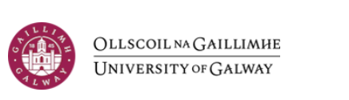
School of Languages, Literatures and Cultures
MA IN TRANSLATION STUDIES SCHOLARSHIP
TERMS AND CONDITIONS
1. The MA in Translation Studies Scholarship, funded by the School of Languages, Literatures and Cultures, will be awarded in the form of a fee waiver equivalent to the EU tuition fee for the MA in Translation Studies at the University of Galway. The scholarship is tenable for one academic year and is not extendable.
2. Applicants must have obtained at least a Second Class Honours Grade I degree or equivalent.
3. Applications are invited from students commencing the MA in Translation Studies in September 2026. Applicants should have already applied through CRM recruit (https://nuigalway.elluciancrmrecruit.com/Apply/Account/Login). The award of the Scholarship is contingent on the student having been accepted to the MA in Translation Studies.
4. The scholarship is open to EU and international applicants. However, international recipients will receive a fee waiver equivalent to the EU tuition fee only and will therefore be responsible for any remaining balance of tuition fees.
5. Applicants must submit a completed application form by email only to the Programme Director of the MA in Translation Studies, Dr Tamara de Inés Antón, tamara.deinesanton@universityofgalway.ie by Friday 17th of July 2026. Incomplete applications or applications received after the closing date will not be considered.
8. Selection of the successful applicant on the basis of the materials supplied will be made by the Programme Director in consultation with a Board of Assessors.
9. Applications will be assessed according to the following criteria:
- Academic achievement;
- The quality of the applicant’s statement of interest.
10. The scholarship will only be awarded where a candidate of sufficient merit is identified.
11. The successful applicant must confirm acceptance of the scholarship within ten days of initial offer.
12. Should the successful applicant receive another scholarship or grant of a similar or greater value, that covers tuition fees, they will be required to forego the award of the MA in Translation Studies Scholarship.

