USP - University Skills Passport Co/Extra Curricular Activity Setup Form
Thank you for engaging with the USP - University Skills Passport. This form will determine the eligibility of your activity for inclusion on the USP - University Skills Passport. You are required to fill out one form per activity that will be awarded a credential. It will capture the basic data required to set up your activity on our central student record system and to set up the credentials that you choose to award your students on completion of your activity. This information will reside on file as part of the governance underpinning the digital credential awarded by the University.
Should you wish to change the setup outside of the annual review process please email USP@universityofgalway.ie.

- Title of activity:
(Note: This title will appear on the credential awarded and on the USP - University Skills Passport)
Student Ambassador – Event Leader

- Hosting Department
Please specify the University department that currently has responsibility for this activity (e.g., Professional Services Department/College/School/Discipline/Student’s Union/Other)
Student Recruitment and Outreach

- Activity Owner Contact Details:

Name:
Email:
Phone:

- “Contact Us” Email address:
(Email Correspondence from students enquiring about your award will be directed to this address)
“Contact us” Email: xxxx@universityofgalway.ie

- Activity Webpage
Please include a URL link to your activity’s web page (If relevant):
https://www.universityofgalway.ie/sap/

- Short Description of Activity to appear on the Skills WEBSITE
Please provide a brief description of your activity, this description will appear on the USP -University Skills Passport activities webpage. Recommended text length: 150 words. A user may be an external user browsing activities OR an existing student exploring activities / badges; the tone of the text should be engaging, open and welcoming. It should describe to someone who knows nothing about the activity, what the activity is about in an informal way. It should conclude with a call to action e.g. Artsoc: Join us to unlock your artistic abilities!!!
Join a team of students and represent your course, college and University while growing both personally and professionally, developing confidence and establishing a strong network of friends and professional relationships with other university personnel.

Are you looking to develop skills that employers seek in today’s world? The Student Ambassador programme offers students the opportunity to work alongside university staff and fellow students in representing their course, college and University. Supporting the Student Recruitment and Outreach Team you will assist in various roles such as Event Support, Event Leader and University Representative.

This is a part-time paid position, with flexible working hours where students will gain invaluable experience in areas such as communication, networking, public speaking, hospitality, tour guiding, leadership, teamwork, adaptability, event planning and logistics among many others and earn a digital badge in the process. A badge is a digital credential that recognises your achievement and outlines the skills that you have developed.

This is the perfect opportunity to tell your story to potential students while also enhancing your CV. So, if you would like to become a part of our Student Ambassador Programme and help support future students as they explore college options then get in touch today to find out more about current opportunities. The Student Ambassador Programme is a great way to develop a variety of skills, make some money along the way and make lots of new friends!

- Description of Activity as Metadata for the DIGITAL BADGE
Please provide a brief formal description of your activity. This description will be recorded on the metadata associated with the digital badge. This should explain to a student and an external partner what the badge is about and what a student has completed in order to achieve the badge (i.e., badge criteria: Attendance, Written reflection, presentation etc,)
Recommended text length: 150 words
The Student Ambassador works alongside the Student Recruitment & Outreach team assisting with events across the campus. Student Ambassadors are often the first point of contact for prospective students, their families, and many other visitors to the campus.

The student event leader is responsible for the following:

Acting as assigned Zone Leader at our Undergraduate Open Days, responsible for managing a group of ambassadors in a specified area during our on-campus event, acting as the main point of contact for student recruitment staff in that area throughout the event.

Working as part of the registration desk team at on campus events, ensuring the smooth operation of the checking in one hundred to a thousand registrants and assisting with any and all queries from attending guests while preparing promotional packs for attendees.

Check-in area steward facilitating the registration desk team, to manage crowd control and also ensure that the check in process ran as smoothly as possible by replenishing pack materials at the desks and assisting attendees with any queries.

Acting as Health and Safety Officers in specified areas and zones across the campus to ensure that fire regulations are complied with at all times and risks and hazards dealt with accordingly during the event.

- Criteria to earn this DIGITAL BADGE
Please list a brief formal description of how the student earns this badge. This description will be recorded on the metadata associated with the digital badge. This should explain what a student has completed in order to achieve the badge (i.e., badge criteria: Attendance, Written reflection, presentation etc,)

To earn this badge the student must:

- Attend scheduled training on specified dates.
- Complete a minimum of 16 hours work.

- Target Cohort
Undergraduate | Yes/No
Postgraduate | Yes/No
All | Yes

- Location of this activity (e.g. University of Galway, Shannon College, Online, Burren College)
Various Locations

- Is participation in the activity Paid or Unpaid?
Yes

- Duration of the Activity:
Duration that the activity typically spans in weeks and how frequently you typically recognise completion of this activity (e.g., once per semester, per academic year, ad hoc)
Per academic year OR Per Semester

- Time Commitment in Hours (Min)
What is the usual time commitment associated with this badge? If a range of hours is likely, please indicate what the minimum time commitment is?
16

- Student Enrolment Practise
How are students currently enrolled on your activity? (Opt-in, Auto-enrol, elected, other)
Application and Interview

- Verification
Describe the validation process used to verify that this activity has been satisfactorily completed by the student?
Each activity requires students to sign in and out, and other activities require post activity feedback/reports.

- Tracking and Administration Tools
What system(s) do you use currently to administer your award? (Yourspace, Excel, Blackboard, Other)
Excel

- Expiry
Do credentials associated with your activity have an expiry? If yes, please specify details:
No

- Current Activity Visual Identity – icon for the centre of the Digital Badge
Please include an image of your activity's logo / existing digital badge (If Relevant). Please attach high quality image of png / svg file to email if available
Note : We can work with you to generate an image from a university approved template.

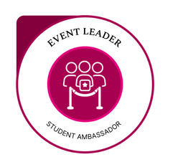

- Image for your Activity for the Website
We will need an image 696x312px that will represent your activity on the USP website. Please attach high quality image of png / jpeg file to email
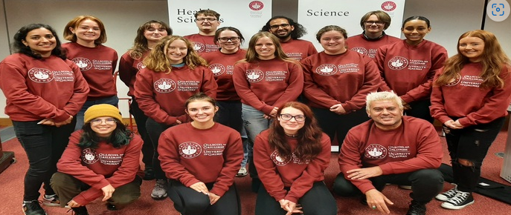

- Skills and Dispositions
- Please select up to 5 skills and/or dispositions in the Designing Futures Framework that the student will develop upon completion of this activity.
- For each skill stated please identify at least one specific example of how the student will develop this skill/disposition. The example should clearly outline what the student did in this context to develop the skill highlighted.
- Please find the Skills Framework and associated examples available for your reference here.

Note: In the skills/disposition description area below please describe how the student developed their skill /disposition by undertaking this activity.
Skill / Disposition | Skill/Disposition Description: Give specific examples of how this skill/disposition was acquired while undertaking this activity:
1.Empathy | Developed key listening skills when dealing with queries from attendees and developed an open mind when providing solutions to problems that arose during the event.
2.Ethical Awareness | Learned to incorporate respect, one of the universities four pillars, into action as a leader during on campus events for team members and attendees, i.e., exercised inclusivity, cultural awareness, understanding and non-judgement.
3.Leadership | Learned to lead teams and developed interpersonal and intra-personal skills to ensure high levels of teamwork and buy in from all members of the team to assist in the successful delivery of the events.
4.Lifelong Learning | Received certification for fire marshalling and manual handling, a crucial element of the training for this role.
5.Negotiation | Developed, as part of the leadership role, negotiation skills in assigning tasks to team members. Navigated dealing with new student excitement and anxiousness and with parent’s questions and demands.

