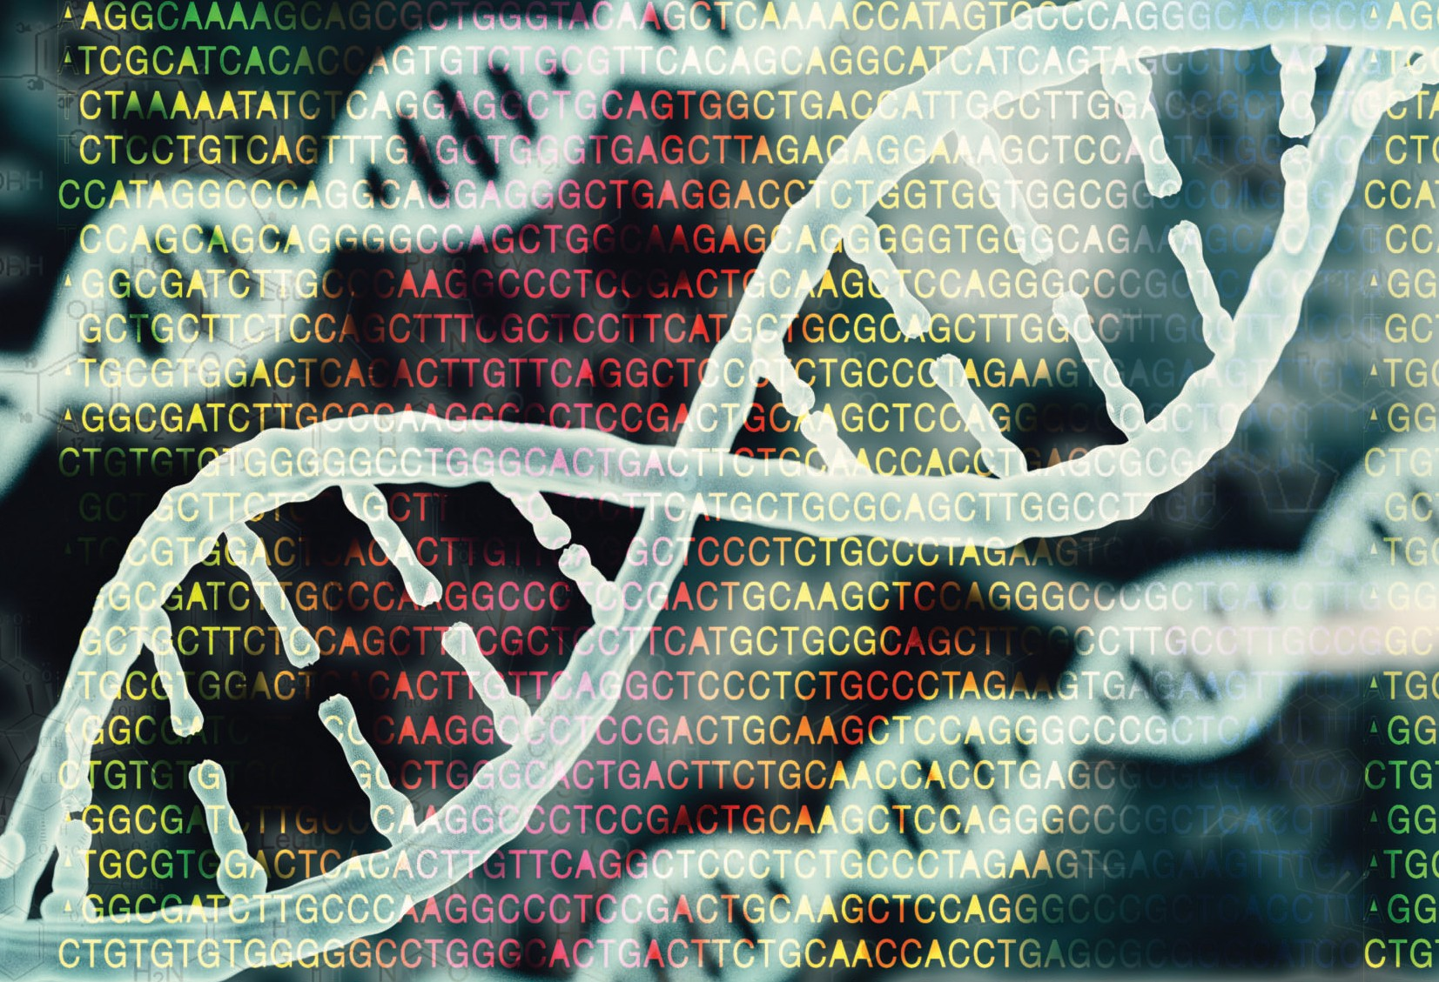

MSc in Genomics Data Science

Rapid advancement in high-throughput DNA sequencing methods has led to an unprecedented increase in the avail- ability and use of genomic data, leading to groundbreaking discoveries in important areas ranging from the life sciences to clinical applications in genomic and precision medicine.
The analysis of large and complex datasets generated using these cutting-edge techniques requires a new generation of well-trained scientists, who possess not only the necessary quantitative and computational skills but also a sound un- derstanding of the underlying biological principles.
Combining elements of genetics, statistics, machine learning, data analytics, and computational biology, this exciting pro- gramme will provide students with a highly marketable and transferable set of big data science skills, as well as specialist knowledge of and practical experience in the application of these skills to genomic data.

Genomics Data Science (MSc)
Course level: Level 9
Duration: 1 year
Prerequisites: Applicants must have achieved a First or strong Second Class Honours degree in a quantitative discipline.
Qualifying degrees include, but are not limited to, mathematics, statistics, physics, computer science, computational biology, and biomedi- cal, electronic, and computer engineering.
Fees: See universityofgalway.ie/courses/fees- and-funding/fees.html for more information.
Applying: Applications are made through the University of Galway postgraduate portal, see universityofgalway.ie/courses/how-to-apply/
Course Code: MSC-GDS
Closing date: Places will be allocated on a rol- ling basis, so candidates are advised to apply as early as possible.

Enquiries to:
Dr. Lars Jermiin
School of Mathematical & Statistical Sciences T +353 91 49 28 96
E lars.jermiin@universityofgalway.ie
http://www.universityofgalway.ie/courses/taught-postgraduate-courses/genomics-data-science.html

Why study this programme?
This course will provide advanced postgraduate training in the use and development of computational techniques to analyse and un- derstand genomic data, allowing them to enter the emerging field of genomic medicine.

Programme Outline
The course comprises 90 credits, with 60 credits obtained from taught modules, and the remaining 30 credits from a research project, which is done on an individual basis under the supervision of an academic.
During Semester I, students take several accelerated-format modules covering molecular and cellular biology, statistics for health science data, statistical computing for biomedical data, Bayesian modelling, machine learning and deep learning for genomics, genomics techni- ques, medical genomics, genomics data analysis, and programming. Students will also take part in a weekly seminar series, which introdu- ces them to the latest developments in genomics data science. During the semester, students choose the topic of their research project and begin to engage with the relevant scientific literature.
During Semester II, students take three core modules: pathogen geno- mic epidemiology and surveillance, genomics research methods, and genomics at scale. Students will also enroll in optional modules from a range of topics, such as medical genomics, genomics data analysis, bioinformatics, mathematical molecular biology, probabilistic models
for molecular biology, data visualisation, networks, and applied and advanced immunology. During this semester students complete the poster component of their research project.
Following Semester II exams, students begin the research phase of their MSc, where they work full-time on their research project. At the end of this period, each student submits a manuscript based on their research and gives an oral presentation.

Career opportunities
Graduates of this programme will be well placed to seek employment in a wide range of growing industries that employ genomics technologies, including biotechnological and pharmaceutical research and develop- ment, as well as in clinical healthcare. In addition, graduates will have the option to pursue PhD research. Given the highly transferable and sought-after skills in big data analytics learned during the programme, graduates may also select to enter data analyst or data scientist roles in non-genomics domains.

Core Modules
- Genomics at Scale
- Genomics Techniques I
- Genomics Research Methods
- Pathogen Genomic Epidemiology & Surveillance
- Genomics Project

Optional Modules
- Introduction to Molecular & Cellular Biology
- Graduate Course in Basic & Advanced Immunology
- Medical Genomics I: Genomics of Common & Rare Diseases
- Medical Genomics II
- Genomics Data Analysis I
- Genomics Data Analysis II
- Genomics Professional Experience
- Mathematical Molecular Biology II
- Introduction to Bioinformatics
- Probabilistic Models for Molecular Biology
- Statistics for Health Science Data
- Statistical Computing for Biomedical Data
- Introduction to Bayesian Modelling
- Machine Learning & Deep Learning for Genomics
- Introduction to Programming
- Networks
- Data visualization
- Web and Network Science
Alan Barnicle,
University of Galway graduate and R&D Scientist at Cambridge Epige- netix, Cambridge, U.K.

“I was recruited by Cambridge Epi- genetix in the U.K., a start-up gen- omics company backed by Google Ventures, just after completing my
Ph.D. in Bioinformatics at University of Galway. It's an exciting place to be, as we are working at the frontier of technology development. My job as an R&D scientist covers a range of activities, from working on innovative genomics techniques used to study individual samples, to the development of new bioinformatics tools needed to interpret the resulting data.
The new Masters programme at NUI Galway provides exactly the sort of skill set that genomics scientists need in this highly dynamic and hugely rewarding career — particularly for those graduates, who may have no for- mal prior experience of molecular biology, but whose computational/mathematical skills will see them in high demand.”



http://www.universityofgalway.ie/courses/taught-postgraduate-courses/genomics-data-science.html

Enquiries should be directed to:
Dr. Lars Jermiin
School of Mathematical & Statistical Sciences T +353 91 49 28 96
E lars.jermiin@universityofgalway.ie

