


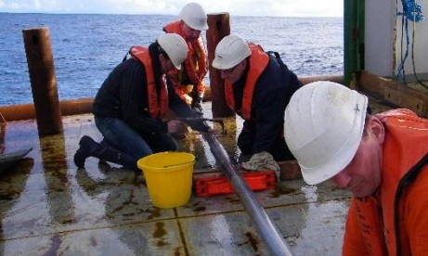

MSc (Coastal & Marine Environments: Physical Processes, Policy & Practice)

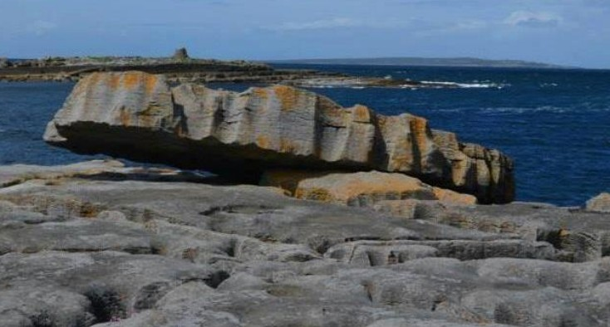
Course
Overview

Programme Details
Course Level: Master’s of Science
Duration: 12 Months, Sept – August
Entry Requirements: Undergraduate Degree Second Class Honours Grade 1, or Bachelor’s Equivalent GPA 3.0
Fees 26/27: EU fees €8,290/Non EU fees €19,440
Admissions: Rolling Admissions; Average intake of 15 students per year. Applications are now open and awarded on a rolling basis.

Course Outline
Coastal and marine environments are critical to local and national economies, support diverse habitats and communities, and provide a suite of ecosystem services.
This field-intensive postgraduate programme examines emerging discourses surrounding the long-term health, use, and management of coastal and marine systems.

This MSc programme is directed at graduates from Geography, Natural Sciences and other related disciplines in the social and natural sciences, and at professionals in the field who are interested in furthering their knowledge of the field.

Key Features of the Programme:

Field-intensive programme
Engages scientifically and critically for sustainable management & planning
Expertise across palaeo-climate, coastal geomorphology, habitat restoration, drone & geospatial technologies Excellent connections with industry, leading to employment


Find Out More
Dr. Kevin Lynch, Programme Director E: kevin.lynch@universityofgalway.ie

