Top Banner
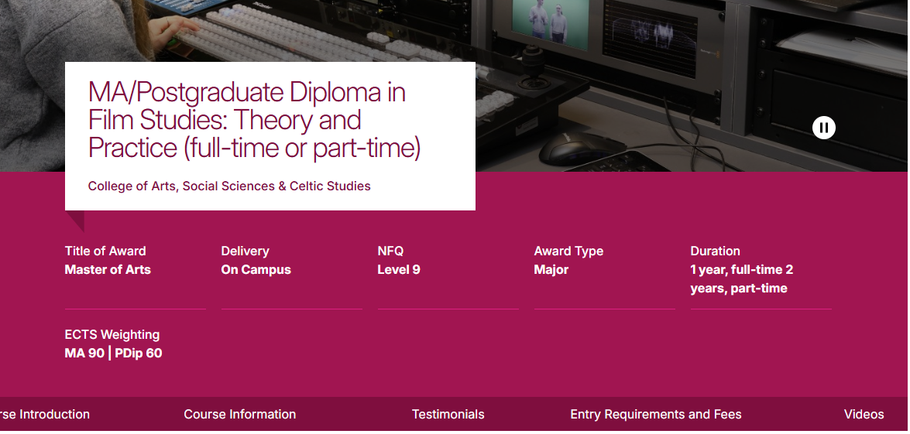

Image/Videos | You can provide images and or/video to play on a carousel on your course page.  Videos: provide URLs below for the videos on YouTube you would like to use.  Images:  Attach images to the accompanying email.  Image sizes desktop 1280x350 and mobile 375x500.  If you do not have an image or a video to use, we will use a generic image representing the broad subject area.
  https://www.youtube.com/watch?v=mPSTYNU-_KA&t=45s
Course Name | MSc in Marine and Freshwater Resources: Management
College or School Name | COSE: College of Science and Engineering
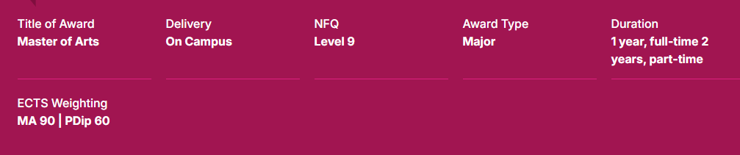

Title of Award | MSc in Marine and Freshwater Resources: Management
ECTS | 90 ECTS (60 taught; 30 project-based)
Average Intake | Insert
Delivery | Choose one of the following:  - On-campus
Attendance | Choose one of the following:  - Full-time
NFQ | Insert Level of the programme. E.G. “Level 9”
Award Type | Choose from one of the following:  - Major
Next Intake | September 2026
Duration | Examples:  1 year, full-time
Closing Date | Insert closing date for upcoming intake.  Rolling Basis

Introduction
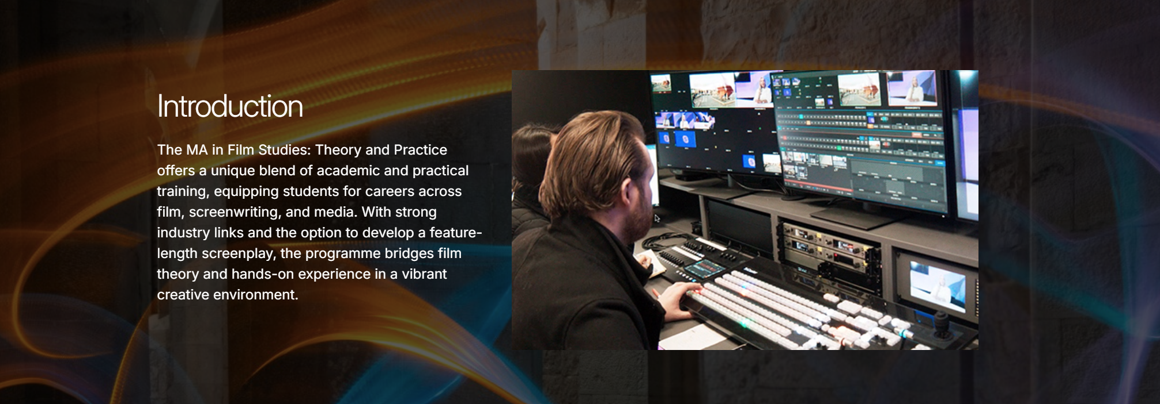

Template Instructions | Sample text which you can overwrite
Introduction (fixed heading)  Subheading (max 55 characters with spaces)  This is a short and snappy introduction to your course. It will be very prominent on the course page and probably the first piece of text students will read. (max 400 characters with spaces)  It should engage the student and spark their curiosity to learn more. It should encapsulate the key unique selling point of the course and is the ‘opening chapter’ in the story of their future studies and future career.  Use the full title instead of ‘this programme’ in the text as it is more concrete and gets the title fixed in a reader’s head, especially if they are readying multiple descriptions. | Introduction (fixed heading)  Addressing 21st Century Water Challenges  (replace with your introductory text, max 400 characters with spaces)  The Marine and Freshwater Resources: Management Master's program combines marine and freshwater resources management, assessing the vital land-to-sea pathway. You will gain advanced knowledge and skills to address critical 21st-century challenges like population expansion, climate change, and environmental pollution. It examines the impacts that both human and natural causes have on water quality and various contaminants and pathways. The course helps society manage water quality for future generations to come.
Brochure | Delete as appropriate
There is an option is this section to add a link to a programme/school/college brochure. It is not necessary to provide a brochure. The course webpage is the authority source of course information and all efforts should go into making the course page as complete as possible. However if you do have a brochure you would like to link to, this is the place to do it!  PDF document  Max size 3.2MB  Please see instructions from ISS on accessibility of PDF documents. | I would like to add a brochure. I will attach the brochure to the email accompanying this document.  MSc-Marine-and-Freshwater-Resources-Management.pdf
Image | Delete as appropriate
565x340 | I have attached an image called ‘xxx’ to the accompanying email.  I do not have an image for this section.

Why Choose This Course?
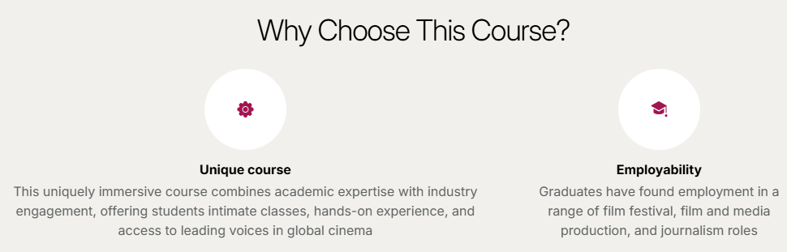

Template Instructions | Sample text which you can overwrite
Why Choose This Course? (fixed heading)  This section highlights key features of the programme using icons. Please pick up to four key features to appear on your page.  Choose from the following fixed list of key features to appear:  - Accreditation  - Employability  - Scholarships  - Top ranked  - Unique course  - Award winning  - Study abroad  - Work placement  - Clinical placement  - Field work  - Practical training  For each of the key features you decide to include, you can provide a supporting sentence with additional detail. See some samples for ‘Employability’ adjacent.  (max 120 characters including spaces for the description of each key feature) | Why Choose This Course?  Unique Course: Combines both the marine and freshwater environments and assesses the holistic land-to-sea pathway.  Practical Training: Get lots of hands-on practical experience in the laboratory and in the field.  Employability: Graduates gain key knowledge and transferable skills for immediate meaningful employment in academia or industry.  Field work: Students participate in fieldtrips to Water and Wastewater Treatment Plants, Fish Farms, Seaweed Processing Plants and Aquaculture Facilities.

Course Information
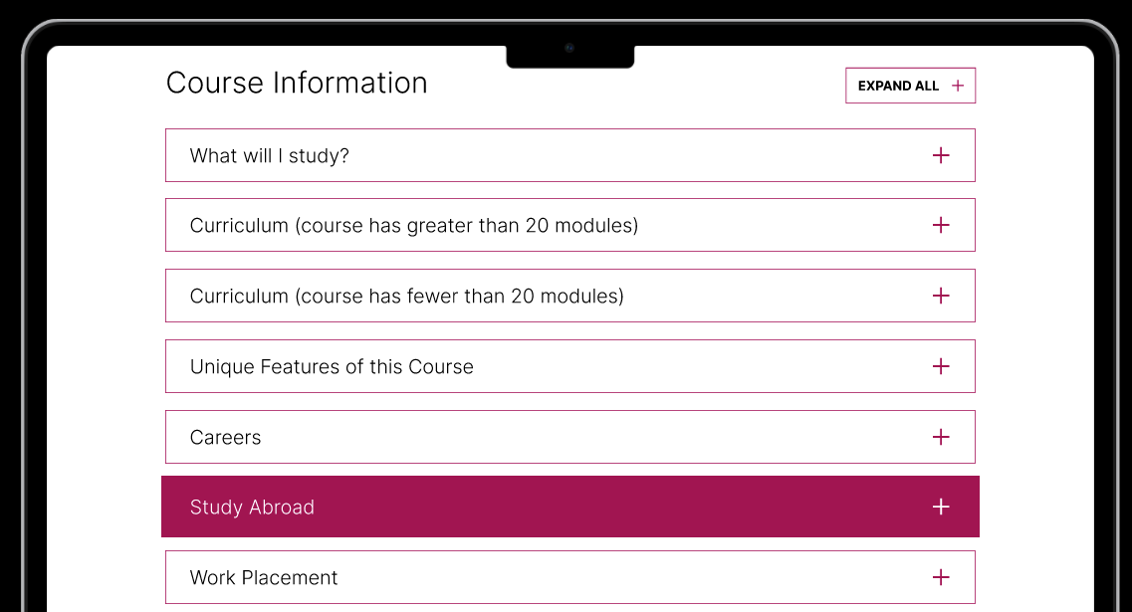

This component will appear as an accordion on the course page. If you leave a section blank (e.g. Study Abroad), that section will not appear in the accordion.

What will I study?
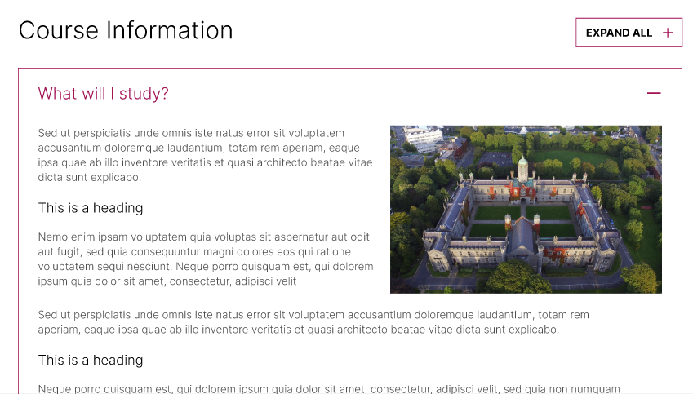

Please use this section to outline the programme structure and how studies advance throughout the duration of the programme. Curriculum information will be displayed in the following section and will be exported directly from AKARI. So this ‘Course Information’ section acts as the general overview on the course. Please draw attention to pathways, specialisations, optional and compulsory modules and the overall structure of the programme.

In this section you can also provide text to answer the question ‘Who is this course for?’ which allows you to provide an informal learner profile. This section will show prospective students why they are suited and give them the confidence that are the right fit for the course.

There is no character limit for the section.

You can add headings, bullet points and tables if you wish.

Sample text which you can overwrite
Course Information
Who is this course for?
This course is ideally suited for graduates with a degree in science, engineering, or geography, or those with relevant work experience. It is also targeted at professionals in industry, government, and the regulatory sector who wish to upskill or further develop their resources and knowledge base. Realistically, anyone who has a passion for water or an interest in the topic is suited to this course. The course aims to equip students with the skills required to start addressing some of the critical challenges society will face regarding human impact on the aquatic environment during the 21st century.
What will I study?
The MSc is a 90 ECTS programme, based on a model that includes 60 ECTS from taught modules and a 30 ECTS research project in Semester 3.
The 60 ECTS taught component is comprised of 40 credits from core modules and 20 credits from optional modules, split across Semesters 1 and 2. Modules are delivered via lectures, seminars, workshops, teaching technologies, online participation, and individual research.
Core modules:
- Environmental Problems in Marine and Freshwater Environments: Methodological Aspects and Applications
- Environmental Problems & Solutions from Land to Sea
- Operational Oceanography
- Water Framework Directive (WFD)
- Environmental and Human Health
- Communicating Research
- Green Labs Principles & Practice

Optional modules:
- Sustainability Planning and Policy for Marine Environments
- Global Change
- Introduction to Data Analysis Tools for Earth and Ocean studies
- Invasive Species and Biodiversity
- Ecosystem Science
- Project Management
- Programming for Data Science
- Geospatial Techniques
- Data Analysis for Sustainability Research
- Legislation for Environmental Scientists

Students complete an individual research project (30 ECTS) in Semester 3, which involves preparing a literature review, identifying research questions, and writing a final report. This project offers an opportunity to conduct independent research and apply learning from the course content to original work.

Curriculum
Explanatory text

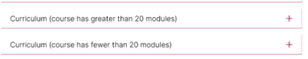

This ‘Curriculum Information’ is an automatic sync with Akari and displays the current academic year curriculum as represented in AKARI. The next update to this will take place in Aug/Sept 2025 when the new academic year information is rolled over on AKARI. There are a couple of important notes on this:
- The information that was inputted into AKARI by the Apr 2024 deadline is what is currently appearing on the course pages. This will carry over to the new template.
- Any changes that are made throughout the year on Quercus are fed into Blackboard but not AKARI, therefore will not be presented on the course page of the website. Manual updates are not possible to the curriculum information that is synced between Akari and website.
- You may notice that the AKARI Curriculum Information is not displaying at all on your course page. Please advise us of this and the sync can be turned back ‘on’.
- There are some courses where the AKARI feed is not suitable for display (due to complex course structures etc.). For these courses, the previous section ‘What will I study?’ will be the place where detail should be added.
- In time this will be replaced with CourseLeaf content.

Template Instructions | Sample text which you can overwrite
Unique Features of this Course (fixed heading)  This section provides a snapshot of selling points that set it apart from other courses. In this section you may like to:  - Emphasise distinctive work placement or employability opportunities.  - Draw out particular curriculum details that you would like to stand out.  - Describe any specialism/specialisation options that would be potentially attractive.  - Outline details of industry collaboration, lab work, fieldwork, class trips or other experiences that stand out.  - Highlight specialist skills or expertise developed as part of the studies.  - Explain industry exposure or real-life application of studies.  - Mention any features regarding how the course supports sustainability.  Use a short snappy easily read style bullet points with bold text to draw the reader down through the list. | Unique Features of this Course (fixed heading)  - Unique Combined Focus: This Master’s is unique because it combines both the marine environment and the freshwater environment, taking a holistic approach to the source-to-sea (land-to-sea) pathways.  - Industry-Informed Design: The course structure was developed based on a feasibility study and survey findings from prospective employers in both the private and public water science sectors.  - Cross-Sector Employability: The program provides training in cross-sector skills and competences that support national and international occupational mobility and enable graduates to work in and lead multidisciplinary teams.  - Practical & Field Experience: Students receive hands-on practical experience, including laboratory work, environmental sensitivity mapping, and time sampling on boats.  - Policy and Legislation: Training provides comprehensive knowledge regarding international directives and national legislation related to marine and freshwater resources, and the legal frameworks that underpin them.  - Scientific Leadership: The curriculum is designed to develop the capacity and capability for scientific leadership and solution-based approaches relevant to graduates' career trajectories.

Template Instructions | Sample text which you can overwrite
Careers (fixed heading)  This section is self-explanatory! Career opportunities and career-related outcomes have a huge impact on prospective students’ decision-making; therefore it is worth spending a little time in providing comprehensive detail in this section.  Consider including the following:  - Sectors and industries where graduates are in demand. Sample of employers, regional, national and international.  - Examples of roles that new graduates can expect to be eligible for.  - Descriptions of how careers might progress in the relevant field (careers that graduates could grow into).  - Skills, knowledge, and expertise that employers are looking for and how studying the course prepares the student for the employment market.  - This is a good space to describe emerging trends in the field, growth areas, skills shortages, etc. to demonstrate the employability opportunities that graduates can expect.  - Progression options for PhD or career opportunities in academia.  If there are additional qualifications or further study typically required to practise in this field/industry, you should refer to it here. There is a section further in the template on ‘Accreditation’; however, it would be good to identify next steps (as they relate to careers after graduation) in this section. | Careers (fixed heading)  See below some samples of text from Irish and UK course pages (mix of disciplines). This is the most important section of the webpage so spend some time to elaborate as much as possible on the career opportunities.  The MSc in Marine and Freshwater Resources: Management will produce well-rounded, dynamic problem-solvers and leaders who can work in any area related to the marine and freshwater environments and associated industry. Graduates often gain meaningful employment immediately in the sector.  Sectors and Employers: Opportunities exist in sectors such as government, NGOs, and private companies, all driven to meet environmental targets set within international agreements. The course is relevant to professionals in Local Authorities, regulatory sectors, and environmental consultancy firms.  Examples of Roles: Graduates acquire multidisciplinary skills in science, communication, and management. Career paths include roles such as project managers, consultants, and advisors within public and private sectors in Ireland and internationally.  Further Study: The course provides a strong foundation and a portfolio of generic skills that help graduates compete for PhD programmes and improve their ability for other research roles in academia. The subject knowledge, transferable skills, and thesis elements are designed to provide the opportunity to carry out further research.

Template Instructions | Sample text which you can overwrite
Study Abroad (fixed heading)  This is an optional section. If you do not complete it, Study Abroad will not appear in the accordion menu. For the vast majority of PG courses no study abroad option is available so you can leave this section blank. However, if there is an international field trip available as part of the masters programme please include some text | Study Abroad (fixed heading)  International Field Trip  As part of the MA Film programme, students have the opportunity to take part in an international field trip that bridges theory and practice while exploring Europe’s dynamic screen culture. This hands-on experience offers exclusive access to leading film institutions, production companies, and creative hubs across the continent.  Over the course of the trip, students connect with industry professionals, visit film archives, and gain first-hand insight into the day-to-day work of filmmakers, producers, and screenwriters. Highlights also include guided visits to filming locations used in major productions, providing a deeper understanding of location scouting, production design, and the storytelling power of place.  The trip typically lasts three days and includes an additional cost to cover flights and accommodation, which is kept as affordable as possible.
Work Placements

While there is no fixed work placement, the program involves a research thesis (30 ECTS). Students are envisaged to conduct this research thesis component in the disciplines, industry, or associated collaborating national or international institutions or organisations. Furthermore, students are encouraged to carry out their research project in partnership with a community group or relevant public or commercial partner, providing opportunities for service learning and civic engagement.
Work Placement (General) | Sample text which you can overwrite or leave blank
Work Placement (fixed heading)  Work placement is another very attractive element of a course particularly at postgraduate level. Students will likely be comparing work placement opportunities between courses and universities so it’s important to include detail on the breadth of opportunity available to students.  Specific detail you should provide here includes:  - Duration of placement and timing (e.g. Semester 1 in Year 3)  - Sample/current work placement partners  - Possible locations  - Type of work/roles  - Whether it is paid  It’s important to detail whether it is an opportunity available to all students on the course, compulsory or available to only some students (and in this case whether it is competitive, based on merit, requires an application, etc.).  Outline the skills, knowledge and expertise that students can expect to develop.  Sometimes work placements can lead to employment opportunities post-graduation with the same company—outline examples of this.  There is no character limit for this section. Please be as complete as possible. Feel free to adjust the subheadings to suit the text being presented. | Work Placement (fixed heading)
Work Placement (professional/clinical/practice placement) | Sample text which you can overwrite or leave blank
Work Placement (fixed heading)  The Quality Office has provided guidelines on completing this section to ensure that the detail is compliant with the International Education Mark criteria (the relevant national standard for providing information to prospective students). Please ensure this section includes detail on the following if relevant:  • The number of hours required in a placement.  • The location of the placement, flagging if it is possible or likely that the placement will take place outside of Galway (this is particularly important for prospective international students).  See sample text adjacent for the BSc Occupational Therapy. Feel free to adjust the sub headings to suit the text being presented.  There is no character limit for this section. Please be as complete as possible. | Work Placement (fixed heading)

Template Instructions | Sample text which you can overwrite or leave blank
Accreditation (fixed heading)  This is an optional section for your course page. If you do not complete it, the heading will not appear.  This section informs students of professional accreditation details that are relevant to studying this course and future careers. The Quality Office has provided guidelines on completing this section to ensure that the detail is compliant with the International Education Mark criteria (the relevant national standard for providing information to prospective students). Please ensure this section includes detail on the following if relevant:  • Details of accreditation body and what is required to gain this accreditation.  • What opportunities are presented to graduates as a result of the accreditation status.  • Recognition of the accreditation outside of Ireland.  • Additional exams or qualifications required to gain accreditation (post-graduation).  See sample text adjacent for the BSc Occupational Therapy. Feel free to adjust the subheadings to suit the text being presented.  There is no character limit for this section. Please be as complete as possible. | Accreditation (fixed heading)  International Opportunities

Template Instructions | To be completed
Who Teaches This Course? (fixed heading)  In time, we will be displaying the research profile from RIMS in this section. Therefore you can add the list of lecturers whose RIMS profile should be displayed in the section. | List of RIMS profiles to include at a future date:  Provide a list of names here  - Dr Liam Morrison  - Dr Gesche Kindermann  - Dr Caitriona Carlin  - Dr Robert Kennedy  - Prof. Peter Croot  - Dr Una FitzGerald  - Dr Oisín Callery  - Dr Kathryn Cormican  - Dr Rónán Kennedy  - Dr Napron Popattanachai  - Dr Karl Mason  - Dr Liam Carr  And also a series of Guest Lecturers

Template Instructions | Sample text which you can overwrite
Learning and Assessment (fixed heading)  Increasingly we are finding that prospective students would like to understand in greater detail what the teaching and learning environment would look like and how they will be assessed.  We are often asked for sample timetables, contact hours per week, sample classwork and the mix of exams/continuous assessment. The curriculum detail coming from AKARI provides this at module level. This section allows space for you to provide a high-level explanation of teaching, learning, and assessment. | Learning and Assessment (fixed heading)  How will I learn? (fixed heading)  You will learn through a mix of lectures, seminars, workshops, teaching technologies, online participation, and individual research. Students get lots of hands-on practical experience, including intensive laboratory work and fieldwork such as sampling on boats and environmental sensitivity mapping. The program fosters the development of advanced problem solving, analytical, and management skills necessary for scientific leadership.  How Will I Be Assessed?  Assessment is module specific but is primarily conducted through continual assessment, assignment, and project work. The overall combination of coursework and assessments provides a rational balance for students to excel. The major assessment component is the 30 ECTS Research Project in Semester 3.

Template Instructions | Add your text here
Course News (fixed heading)  This is an optional section for your course page. If you do not complete it, the heading will not appear.  This section provides an opportunity to highlight course news that might be of interest to prospective students.  Potentially including:  - New accreditation status  - Course awards and accolades  - Student awards and success  - New scholarships  - High-profile academic appointments  - New industry partners | Course News (fixed heading)

Template Instructions | Add your text here or leave blank
Research Excellence (fixed heading)  This is an optional section for your course page. If you do not complete it, the heading will not appear.  We currently do not present research-related content on the course pages. This section is a ‘future-proofing’ section to the course page in case we wish to add this detail to the course pages over time. If you have research-related content you wish to add now, please do so in this section. Otherwise you can come back to this section in the future. | https://www.universityofgalway.ie/science-engineering/school-of-natural-sciences/

Template Instructions | Sample text which you can overwrite or leave blank
Recognition of Prior Learning (fixed heading)  This is an optional section. If you do not complete it, the section will not appear in the accordion.  As part of the RPL in Higher Education project the RPL team in the University is encouraging Programme Directors provide RPL information. If you have any questions about RPL, please contact:  Suzanne Golden  Recognition of Prior Learning Project Lead/ Flexible Learning Development Officer  suzanne.golden@universityofgalway.ie | Recognition of Prior Learning (fixed heading)  University of Galway recognises that knowledge and skills can be acquired from a range of learning experiences. This is in line with the National Framework of Qualifications (NFQ) goals which aim to recognise all learning achievements by supporting the development of alternative pathways to qualifications (or awards) and by facilitating the recognition of prior learning (RPL).  The Programme Board for Marine and Freshwater Resources: Management will consider non-standard applications, where both the appropriate discipline and required relevant experience are at the discretion of the Programme Board.  Further information is available on the University’s Recognition of Prior Learning website

Template Instructions | Sample text which you can overwrite or leave blank
Transferable Skills (fixed heading)  This is an optional section. If you do not complete it, the section will not appear in the accordion.  This section provides an opportunity to address FAQs and hopefully reduce the number of queries that came into your Discipline/School. | Transferable Skills (fixed heading)  Graduates of the MSc in Marine and Freshwater Resources Management will acquire key knowledge and transferable skills that they can utilize in any workplace, whether in academia or industry. Graduates develop the capacity for scientific leadership and solution-based approaches. Key skills include:  - Advanced problem solving, management, analytical and communication skills.  - The ability to apply analytical and technical skills required for research and application in marine and freshwater systems.  - Planning, organising and controlling activities to ensure successful project completion.  - Data assessment skills necessary to inform decision-making and management.  - Communicating results of monitoring, research and innovation, and engaging the public on ocean literacy.  - Transversal and multidisciplinary skills essential for national and international occupational mobility.

Template Instructions | Sample text which you can overwrite
Contact Us (fixed heading)  This is a compulsory section.  Course queries:  Here you can add an email address for course queries. For some this will be the direct email of the programme director and for others it will be an agreed course/discipline/school/college email address. Please ensure it is an active and agreed email address, that is checked regularly for queries from the general public.  Programme Director(s):  Here you can add details of the programme director and contact details if you wish. Most prospective students will use the ‘course queries’ email address to get in touch. However, prospective students appreciate being able to contact a Programme Director or named programme contact directly for more complex queries. | Contact Us (fixed heading)  Course queries:  lorna.larkin@universityofgalway.ie  Programme Director(s):  Dr Liam Morrison  School of Natural Sciences and the Ryan Institute  College of Science and Engineering  E: liam.morrison@universityofgalway.ie  T: 091 493 200

Template Instructions | Sample text which you can overwrite or leave blank
FAQs (fixed heading)  This is an optional section. If you do not complete it, the section will not appear in the accordion.  This section provides an opportunity to address FAQs and hopefully reduce the number of queries that came into your Discipline/School. | FAQs (fixed heading)

Accreditation & Awards
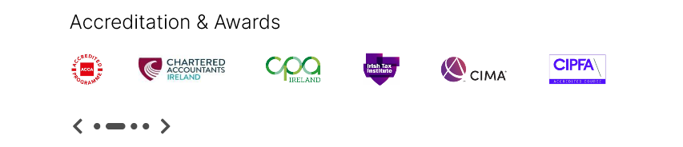
Here you can add logos and badges relevant to your course. For example logos from accreditation bodies, award badges, ranking badges etc.

Images:
Max 12 logos.
Recommended height of 70px with a variable width.

Please list below the logos you have attached (to the accompanying email) and the preferred order for them to display.

Logo 1
Logo 2
Logo 3
Logo 4

SDGs: Please identify the 3 SDGs that are most relevant to your course. Full list of 17 SDGs available here. We will include the SDG logos here also for each course.

SDG | SDG 6: Clean Water and sanitation
SDG | SDG 14: Life Below Water
SDG | SDG 13: Climate Action

Testimonials
Short Testimonial


You can add multiple ‘short testimonials’ if you wish. They will appear as a carousel which the prospective student can scroll through. It is recommend to have a minimum of one short testimonial.

Short Testimonial 1 | Please complete
Student/Graduate Name: | Moya O’ Donnell
Title and Company Name: | Complete Laboratory Solutions
Quote:  (max 150 characters including spaces) | This particular Master's course provides a unique opportunity to study such interactions and their impacts across multiple disciplines for both freshwater and marine environments.
Image:  Size (desktop 1280x600 and mobile 375x600) | Moya O Donnell

Short Testimonial 2 (optional) | Please complete
Student/Graduate Name: | Delon Earle
Title and Company Name: | PhD Student, University of Galway
Quote:  (max 150 characters including spaces) | One of my most profound academic experiences was the year I studied for my MSc in Marine and Freshwater Resources: Management and Monitoring at the University of Galway.
Image:  Size (desktop 1280x600 and mobile 375x600) | Delon Earle

Short Testimonial 3 (optional) | Please complete
Student/Graduate Name: | Daniel McGuire
Title and Company Name: | UISCE Eireann
Quote:  (max 150 characters including spaces) | This program exceeded my expectations, and was not only comprehensive, but incredibly up to date on issues and techniques being covered.
Image:  Size (desktop 1280x600 and mobile 375x600) | Daniel McGuire

Meet our Employers

In this section you can add logos of your placement partners and graduate employers.

Images:
Max 12 logos.
Recommended height of 70px with a variable width.

Please list below the logos you have attached (to the accompanying email) and the preferred order for them to display.

Logo 1 | Environment Protection Agency (EPA)
Logo 2 | Marine Institute (MI)
Logo 3 | Irish Water
Logo 4 | Local Authorities Waters Programme (LAWPRO)
 | Geological Survey of Ireland (GSI)
 | Dublin City Council, Sligo Co.Co., Tipperary Co.Co., Wexford Co.Co
 | Ryan Hanley Engineers
 | SLR Consulting
 | ARUP Consultancy
 | Aquafact
 | CDM Smith

Testimonials
Long Testimonial
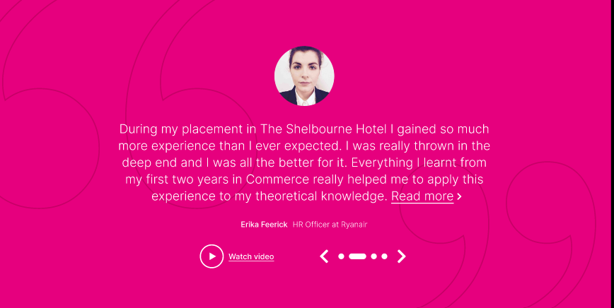

You can add multiple ‘long testimonials’ if you wish. They will appear as a carousel which the prospective student can browse through. It is recommend to have a minimum of one long testimonial.

Long Testimonial 1 | Please complete
Student: | Moya O'Donnell
Title and Company Name: | Complete Laboratory solutions
Quote:  (max 500 characters including spaces) | "I have always had a great interest in the aquatic environment and how our interactions may have an impact on the health of its diverse ecosystems. This particular Master's course provides a unique opportunity to study such interactions and their impacts across multiple disciplines for both freshwater and marine environments. It also provides excellent practical experience both in the field and laboratory, which is hugely beneficial in developing key transferable skills for the workplace. I would highly recommend this Master's course..."
Image:  Size (125x125) | Moya O’ Donnell

Long Testimonial 2 (optional) | Please complete
Student Name: | Daniel McGuire
Title and Company Name: | UISCE Eireann
Quote:  (max 500 characters including spaces) | As someone who previously studied social sciences and watershed science, I was looking to study environmental issues from multiple academic perspectives, and the integration of mutliple fields into this Master's program was a big advantage in my eyes. Even still, this program exceeded my expectations, and was not only comprehensive, but incredibly up to date on issues and techniques being covered. As a newer program, the coursework felt flexible and rewarding as a result of an adaptable approach to learning, and the small but diverse group of fellow students in the program gave a great sense of community. The most invaluable part of the program was the knowledge gained from professors and guest speakers from relavent industries, especially that of the program advisor, Dr. Liam Morrison. His insight and approachability were the driving force behind my confidence in understanding the material. In seeking employment, I was able to confidently discuss issues specific to Ireland during interviews due to the subjects covered in the coursework by Liam; and as a result, I was offered a position with Uisce Eireann before the end of the academic year where I now work. I highly recommend this program for anyone looking for employment within Ireland, the EU, or anywhere else!
Image:  Size (125x125) | Daniel McGuire

Long Testimonial 3 (optional) | Please complete
Student/Graduate Name: | Delon Earle
Title and Company Name: | PhD Student University of Galway
Quote:  (max 500 characters including spaces) | One of my most profound academic experiences was the year I studied for my MSc in Marine and Freshwater Resources: Management and Monitoring at the University of Galway. With a BSc in Chemistry from the University of Guyana and professional experience in environmental regulation, I was eager to pursue advanced research in water resources. I was particularly interested in a programme that linked both freshwater and marine systems — and this MSc provided exactly that. Special thanks to Ireland Fellows Programme for their sponsorship of my study.  The programme had just the right balance of structured lectures and independent research. I especially appreciated the involvement of experts who delivered guest lectures, connecting theory to real-world applications. These opportunities also allowed me to interact with professionals in the field and gain insights into possible career paths. One of the most valuable aspects of the MSc was its alignment with EU best practices and aquatic resource regulations, which gave me an international perspective on water management.  Being a student in Galway was a new and exciting chapter for me, and what made it truly enjoyable were the friendly and supportive lecturers and the welcoming people I encountered daily. During the course, I developed not only technical knowledge but also transferable skills such as flexibility and adaptability. Coming from Guyana, the “land of many waters”, I also valued the chance to engage with EU water directives and see how they compare globally. This experience directly influenced my decision to carry out research into whether the carbon-trapping abilities of cold-water corals should be considered in regional carbon budget models — a question that now forms the foundation of my PhD research.  I would highly recommend this MSc to anyone interested in freshwater or marine resources, or in exploring the vital connections between the two. It is a rigorous, relevant, and rewarding programme that opens doors to both research and professional opportunities.
Image:  Size (125x125) | Delon Earle
Entry Requirements and Fees
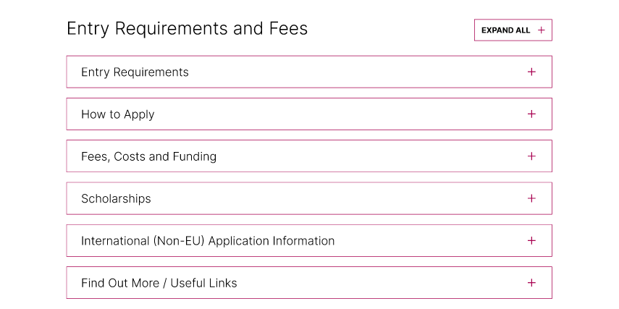

This component will appear as an accordion on the course page. All sections, except for ‘Scholarships’ and ‘Find Out More’ will automatically appear as they are compulsory sections.

Template Instructions | Sample text which you can overwrite
Entry Requirements (fixed heading)  This section should include  - Minimum Entry Requirements  - English Language Entry Requirements  - Supporting Documents (if relevant for your course)  In this section, you should also add any additional information relevant to your course e.g.  - Garda/Police Vetting  - Medical Clearance requirements  - Interviews | Entry Requirements (fixed heading)  Minimum Entry Requirements (replace/edit the text below)  Proposed 2.1 honours (or equivalent) in a related subject area is the minimum academic standard, though 2.2 students (or equivalent) with relevant experience will also be considered. The Programme Board will consider non-standard applications. The appropriate discipline and required relevant experience are at the discretion of the Programme Board.  Academic entry requirements standardised per country are available here.  English Language Entry Requirements (replace/edit the text below)  For applicants whose first language is not English, an English language proficiency of IELTS score of 6.5 is required (with no less than 6.5 in Writing and no less than 6.0 in any other band) or equivalent.  More information on English language test equivalency are available here.  Supporting Documents (replace/edit the text below)  You will be required to provide supporting documentation as part of your application. You can check here what supporting documents are required for this course.  Note, you should add here if there are specific supporting document requirements beyond the ‘normal’ asks of the College.

Template Instructions | Input Not Required
How to Apply  You do not need to provide content for this section. It will be standardised across all postgraduate course pages. | The following information will appear on all PG course pages. Please only edit if the established application process for your programme is different to the below (especially important if you have a fixed closing date)  How to Apply  You can apply online to the University of Galway application portal here.  Please review the entry requirements set out in the section above.  You will be required to upload supporting documentation to your application electronically. See the section above on entry requirements for further information on the supporting documentation required for this course.  Closing Dates  For this programme, there is no specific closing date for receipt of applications. Applications will be accepted on a rolling basis and course quotes will be reviewed continuously throughout the application cycle.  Notes  - You will need an active email account to use the website and you'll be guided through the system, step by step, until you complete the online form.  - Browse the FAQ's section for further guidance.

Template Instructions | Sample text which you can overwrite
Fees, Costs and Funding (fixed heading)  This is a compulsory section in the course page template.  Fees  This section will be automatically populated by the Fees Office and updated once a year.  Costs  The Quality Office has provided guidelines on completing this section to ensure that the detail is compliant with the International Education Mark criteria (the relevant national standard for providing information to prospective students).  Please ensure this section includes detail on indicative costs of studying on the course including:  • Specialised electronic resources  • Specific computer/IT equipment or requirement  • Protective equipment  • Items of uniform  • Costs associated with field work, class trips or other travel.  You can provide approx. costs or actual cost of the current year for illustrative purposes. There is no need to account for costs common to all students (text books, photocopying, laptop etc.). Please only list costs specific to the course.  See sample text adjacent Feel free to adjust the sub headings to suit the text being presented (e.g. Uniforms, Fieldtrips, Equipment).  Funding  If there are specific funding opportunities open to students of this particular course, please provide this detail in this section. | Fees, Costs and Funding (fixed heading)  Fees  Will be automatically populated by the Fees Office. You do not complete this section.
Template Instructions | Sample text which you can overwrite or leave blank
Scholarships (fixed heading)  Postgraduate Excellence Scholarships  In this section we are promoting the Postgraduate Excellence Scholarship which applies to all EU students applying for a full-time master’s programme. If your programme is not available as a full-time master’s please remove this section of text.  Global Scholarships  This section links out to the Global Galway webpage with details of institutional and national schemes for international students.  Programme/Subject Area Scholarships  Use this section to add detail on any relevant scholarship schemes. | Scholarships (fixed heading)  Postgraduate Excellence Scholarships (remove this section if your programme is not available as a full-time masters)  This scholarship is valued at €1,500 for EU students applying for full-time taught master's postgraduate courses. You will be eligible if:  - You have been accepted to a full-time taught master's course at University of Galway,  - You have attained a first class honours (or equivalent) in a Level 8 primary degree.  An application for the scholarship scheme is required (separate to the application for a place on the programme). The application portal for 2025 is now open and available here. Applications will close on the 30th September 2025. Full details available here.  Global Scholarships (standard text for all courses)  University of Galway offers a range of merit-based scholarships to students from a number of countries outside of the EU. Visit here for schemes currently available.  School of Natural Sciences Scholarship  https://stories.universityofgalway.ie/college-of-science-and-engineering-scholarships-overview/index.html
Template Instructions | Input Not Required
International (Non-EU) Application Information  You do not need to provide content for this section. It will be standardised across all postgraduate course pages unless you indicate specific instructions for your course. | The following information will appear on all PG course pages. You do not need to edit unless you have specific instructions relevant to your course.  International (Non-EU) Application Information  Application Process  Students applying for full time postgraduate programmes from outside of the European Union (EU), You can apply online to the University of Galway application portal here.  .  Our application portal opens on the 1st October each year for each the following September.  Further Information  Please visit the postgraduate admissions webpage for further information on closing dates, documentation requirements, application fees and the application process.

Template Instructions | Add your text here (optional)
Find Out More/Useful Links (fixed heading)  This is an optional section. If you do not complete it, the section will not appear in the accordion.  Here you can additional non-core information that may be of interest to students who want to do a deep dive on the course and careers.  Keep the content short and snappy, linking out to potentially:  - Industry developments  - Research and other news  - Publications  - Discipline or School information  Ensure the detail you are linking out to is relevant to prospective students. | Find Out More/Useful Links (fixed heading)  Course Videos Video 1: MSc Marine and Freshwater Resources Management [NEW YOUTUBE SOURCE]  Related Courses The proposed course complements existing MSc programmes at the School of Natural Sciences, including:  - MSc Environmental Leadership  - MSc Biodiversity and Land-Use Planning

Course Videos
https://www.youtube.com/watch?v=mPSTYNU-_KA&t=45s

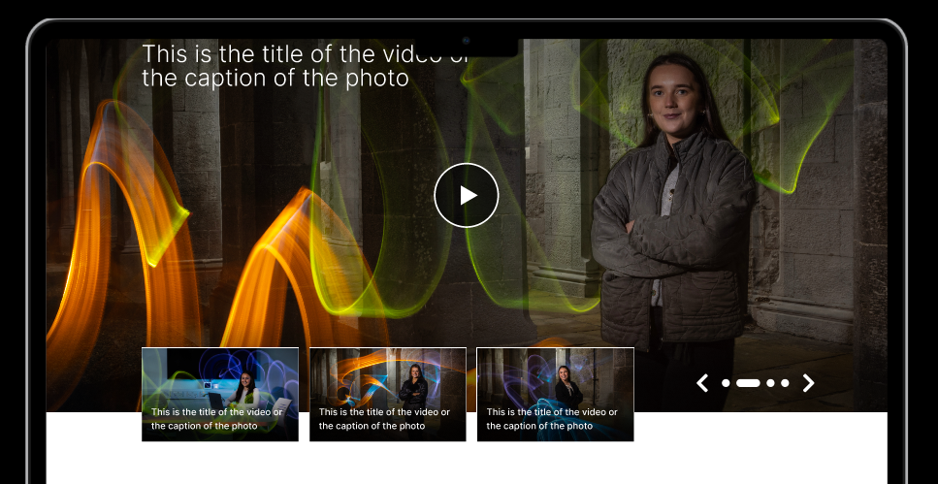

You can add between 1 and 8 videos here which will appear as a carousel. If you don’t have any videos, this component will not appear. Please provide YouTube links below to your videos:

 | YouTube Link | Caption (max 80 characters including spaces)
Video 1 | https://www.youtube.com/watch?v=mPSTYNU-_KA&t=45s
Video 2

Related Courses
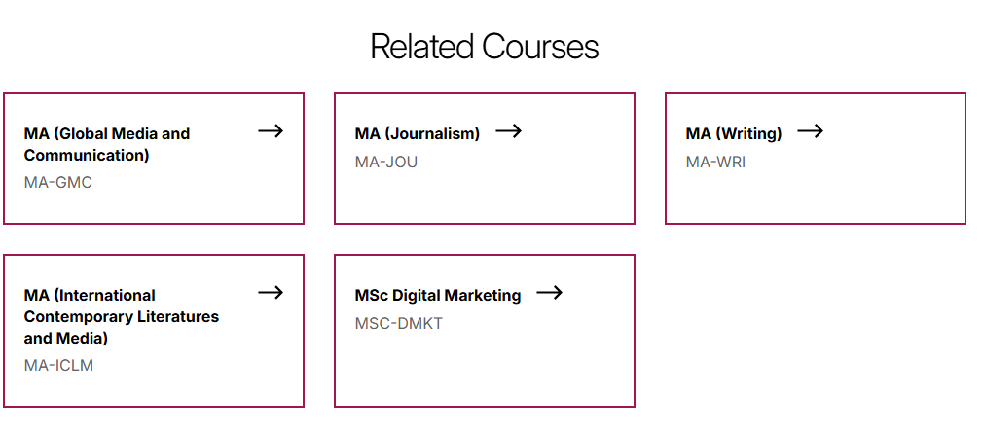

Here you can add links to related postgraduate porgrammes available at University of Galway (between 1 and 6). Please provide list of courses below.
 | GY Code | Course Name
Course 1
Course 2
Course 3
Course 4
Course 5
Course 6

