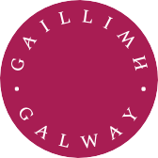Coláiste na hEolaíochta & na hInnealtóireachta

College of Science & Engineering

MSc
Occupational
Health & Safety Top-Up
MSC-MOH

University
ofGalway.ie

MSc
Occupational
Health & Safety Top-Up
MSC-MOH

Why choose this course?
Occupational Health and Safety has become a prominent component of business and society and continues to be a growth area for employment.

Course Overview
This one-year programme has been designed exclusively for graduates of the University of Galway Higher Diploma in Occupational Health and Safety or Occupational Health, Safety and Hygiene who have relevant work experience in Occupational Health and Safety.

Graduates are provided with an opportunity to complete the additional 30 credits (one module) required to upgrade their qualification to the MSc Occupational Health and Safety programme.
This one-year programme has been designed exclusively for
University of Galway graduates only who have completed either of the following two historical programmes specifically titled: “Higher Diploma in Occupational Health and
Safety” or “Higher Diploma in Occupational Health, Safety and Hygiene”. Applicants must also have relevant work experience in Occupational Health and Safety or Occupational Health. Graduates are provided with an opportunity to complete the additional 30 credits (one module) required to upgrade their qualification to the MSc Occupational Health and Safety programme.

University
ofGalway.ie

Career Opportunities
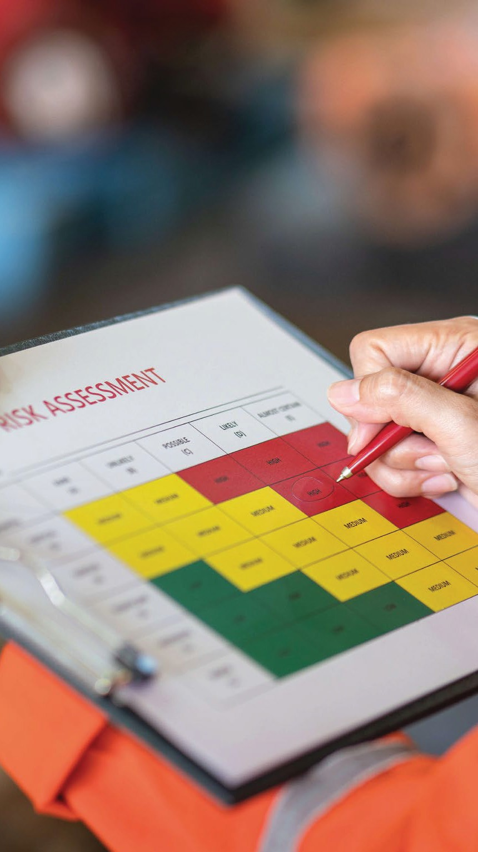Graduates are qualified to apply for a range of roles including, Occupational Health Manager, Occupational Health and Safety professional, Environmental Health and Safety Professional/Manager, Occupational Health Nurse.

Find out more
School of Natural Sciences

Joan Walsh Programme Director

joan.walsh@universityofgalway.ie

Duration
1 year, part-time

Average Intake
6

