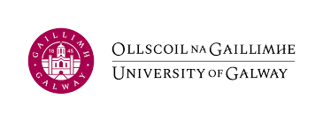 |  | SUPPLIER CHANGE OF BANKING INFORMATION Request Form
Supplier Information – please type details to ensure quick turnaround
Supplier Full Name |  |  |  |  | Supplier ID  For University  use only
VAT Number/Tax Reference Number
Supplier Full Postal Address
Supplier Contact Name
Phone No. |  |  |  | Mobile
Accounts Email Address
Remittance Advice Email Address
Details of outstanding invoices
(if applicable)
This form was completed by: -
Print Name
Supplier must provide a current Bank Statement showing ONLY the top verification data, i.e., Bank Account Name, Address,
Bank Account Number/IBAN and BIC.
Bank Statement must be dated within the last three months and
no transactional data whatsoever is required

Supplier’s NEW Bank Details
Name and Address of Bank Branch
(where bank account is held)
Bank Account Name
Bank Account Number |  |  | BIC/SWIFT Code
Sort Code/Routing Number |  |  | IBAN

Please cc on your response a senior financial manager along with the requested Bank Statement.
Upon receipt of this fully completed form together with Bank Statement, a member of the University’s Finance Office will be in contact to verify all information provided.
We thank you in advance for your co-operation.

Email to: - AccountsPayable@UniversityofGalway.ie 27 June 2024

